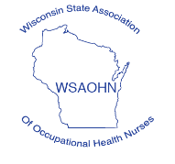

March 26, 2020

Dear WSAOHN Colleagues,

It is with a heavy heart that I announce the cancellation of the Midwest Regional Occupational Health Conference in August 2020. We are living in uncertain times and no one has a crystal ball for the future. We have secured some fabulous speakers. However, like many of you, their work travel is on hold. We fear that will be the climate in August as well. So, it was decided by your Board and Education Committee to cancel this year’s conference. The Board is in discussion now of offering CEUs to its members throughout the year. We will keep you posted.

Please feel free to contact me should you have any comments or questions.

Wishing you safety and good health!

Cindy

Cindy Groves, RN, BSN, COHN-S, FAAOHN

President, WSAOHN

608-751-6002

ggrove225@aol.com