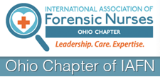

SAVE The DATE

Quarterly Meetings
- April 28th Cleveland – Testimony Training / Jen Markowitz
- June 29th (TBA) IAFN Certification/ Kathleen Maguire
- August 24th (TBA) IAFN Skills Training/ Proof of Competency

Leadership Workshop
- May 25th – Forensic Nurse Leadership workshop 9am-4pm
- July 20th –Forensic Nurse Leadership workshop 9am-4pm
- October19th – Forensic Nurse Leadership Meeting workshop 9am-4pm

Conferences
- September – Monthly Meeting in Palm Springs, CA
- November 9 and 10th Annual Ohio Chapter Conference

