Meet the Candidates

* Add to Favorites

* Share

Voting is open from March 2 until midnight on March 31.

Review each candidate's bio, election statement, and speech by clicking on their name below. Candidates’ responses to the Q&A are presented in their entirety without changes, edits, or corrections. All candidates’ videos were recorded in a single session and are presented without edits.

Expand All / Collapse All

President-elect (One to Be Elected)

* **Holly S. Ervine, MSN, RN, NPD-BC, CNOR**

**Candidate Bio**

[View Candidate Video](http://media.aorn.org/asset-657555fb-1c1d-4f81-9010-34d14d8a2baf/Expo_2020_Candidates_Holly-Ervine-v2.mp4?sv=2017-04-17&sr=c&si=9beb08f2-041f-4c29-bc6d-7c8350f28448&sig=Sd958KpBXrgJuQnF5m%2BdOClxbBVHtYCctd%2Bu%2B%2BMyCM4%3D&se=2021-02-05T20%3A27%3A35Z)

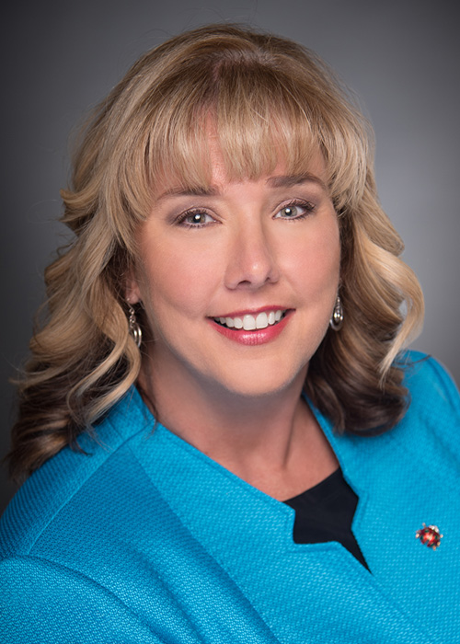

**Holly S. Ervine, MSN, RN, NPD-BC, CNOR**, is a surgical services professional educator, nursing, at WellStar Health System, Atlanta, Georgia. She earned an associate degree in nursing from Georgia Highlands College, Rome; a bachelor of science in nursing from Kennesaw State University, Georgia; and a master of science in nursing from Walden University, Minneapolis, Minnesota.

Ervine has been a perioperative nurse for 19 years and a member of AORN for 19 years. She is a member of:

* + AORN of Northwest Georgia (2010-present),
  + the Georgia Council of Perioperative Registered Nurses (2010-present),
  + the Leadership Specialty Assembly (2010-present), and
  + the Clinical Nurse Educator Specialty Assembly (2015-present).

Ervine has attended Congress 10 times in the past 10 years, each time as a delegate.

Ervine has received:

* + the Northwest Georgia AORN Perioperative Nurse of the Year Award (2010, 2014, 2019),
  + the WellStar Health System Innovations in Professional Practice Award (2018),
  + the Southern Regional Clinical Excellence in Practice Award (2015), and
  + the AORN Award for Outstanding Volunteer Leadership (2014).

Highlights of Ervine’s service to AORN include that she is:

* + Vice President of AORN (2018-present),
  + a member of the AORN Executive Committee (2018-present),
  + chair of the AORN Credentials Committee (2018-present),
  + Board liaison to the Clinical Nurse Educator Specialty Assembly (2018-present), and
  + chair-elect of the Georgia Council of Perioperative Registered Nurses (2019-present).

She has been:

* + Secretary of AORN (2016-2018),
  + a member of the AORN Board of Directors (2014-2016),
  + chair of the Nominating and Leadership Development Committee (2012-2013),
  + a member of the Nominating and Leadership Development Committee (2011-2013), and
  + president of AORN of Northwest Georgia (2019).

In other leadership roles, Ervine is:

* + a member of the American Nurses Association (2019-present),
  + a member of the Georgia Nurses Association West Georgia Chapter (2019-present),
  + a member of the Association for Nursing Professional Development (2017-present), and
  + a member of Sigma Theta Tau Pi Nu Chapter (2013-present).

She has been:

* + co-coordinator of the Clinical Dedicated Education Unit for the Kennesaw State University Perioperative Elective “Foundations for perioperative practice” (2016-2018).

In her community, Ervine is:

* + a member of the Advisory Committee of the University of West Georgia Tanner Health System School of Nursing (2014-present) and
  + a volunteer for the WellStar Day of Service Food Bank (2019-present).

She has been:

* + a member of the Advisory Committee of the Chattahoochee Technical College Surgical Technology Program (2015-2018),
  + a member of the Villa Rica Middle School Parent-Teacher-Student Organization (2016-2019), and
  + a volunteer for Soldiers’ Angels (2010-2013).

**Election Statement**

Colleagues, my vision as your President is best described in these words: relevant, member focused, and a resounding voice for perioperative nursing. My role as Vice President and continual service on your Board has established a solid basis that defines my leadership. To lead effectively, you must be confident in yourself, connected to others, committed to purpose, and emotionally courageous. I am that leader.

I believe that AORN’s President must demonstrate and articulate key initiatives. I will build a solid foundation consisting of a clear mission, a vision for the future, a specific strategy, and a culture conducive to success. We must balance what is best for our members and what is best for the organization. As an AORN leader, we cannot be afraid to address the importance of the business of AORN. We are a membership organization, but it’s our business operations that enable AORN to provide valued resources to the members.

As a health system educator, I routinely work side-by-side with an interprofessional team in the OR communicating, planning, evaluating patient outcomes, and assessing quality initiatives. Surgery is a demanding place. It will push you to your physical and mental limits, but I am passionate about what I am able to contribute. I understand your concerns and challenges: the patient right to an RN circulator, the provision of quality patient care, necessity for evidence-based practice, accelerating technology, and workplace incivility. I will ensure that our boardroom is a place where your views and concerns remain a priority.

During my tenure, members of AORN have benefited from decisions the Board has made including free contact hours, a more user-friendly web site, a leader category for membership, and (coming soon) the educator category for membership. I have been persistent in advocating for a robust AORN app that will continue to engage our members across the spectrum.

I am proud of the decisions I supported in the boardroom that enhanced the business of AORN and produced positive revenues for 10 consecutive years. These decisions include purchasing Pfiedler Enterprise, the acquisition of Outpatient Surgery Magazine, including their annual OR Excellence conference, and the spin-off of Syntegrity into a subsidiary division.

As we enter a new decade, I pledge to ensure the success of AORN for the individual, the membership, and business entities. My dedication remains firm, my commitment unwavering. I will lead with integrity, heart, and a positive vision for our future.

**Candidate’s Q&A**

**1. Member surveys indicate the most common reason they do not vote is they feel they “do not know the candidates”. To help the members get to know you better, describe something you are passionate about outside of your profession as a perioperative nurse.**

For those who know me well, it is no surprise that I am an avid sports fan. I love the Georgia Bulldogs and always look forward to the fall. My Facebook profile shows one of my listed “jobs” as “Georgia Bulldog Fan”. One of my favorite sayings is “HOW BOUT THEM DAWGS!”. Win or lose, I love to watch them. I also enjoy the Atlanta Braves and attended many games this year. I was fortunate to tour SunTrust park before it opened with my son and a few of his teammates. But my favorite team is the Villa Rica Wildcats. I have one son, Logan, who plays for the Wildcat basketball and baseball teams. One of my other listed jobs on my Facebook profile is that of “obnoxious baseball mom” (ask me about my redneck rock shakers). Logan plays on one of the top travel baseball teams in the country and we travel everywhere to watch him play and support him. As a nationally ranked pitcher, it is both rewarding and nerve wracking to watch him play and grow in a sport that he loves. Sports are, to me, a stress reliever after a busy week in the OR.

**2. Describe your most meaningful day in the OR, or in the office, and how it has impacted your current practice, or work, as a nurse.**

As a novice nurse, I recognized the name of my patient as someone who babysat me as a child, but I hadn’t seen in many years. When I walked in, I asked if she knew who I was, but she did not recognize me. When I explained how we knew each other, she immediately remembered me but became teary eyed. As I held her hand, I asked what was wrong. She explained she wanted to have surgery in the OR where my mother worked as the Director because she knew she would be well taken care of and she had been apprehensive about going somewhere else. My patient explained having me there was a relief because she knew she would be in good hands. This experience was meaningful to me because it was then I fully understood what it meant to be a patient advocate, to be their voice when they didn’t have one. Since then, being an advocate for my patients has remained in the forefront of my practice. In my current role, it is the art of being a patient advocate that I share with my colleagues while onboarding new nurses and providing education for existing team members.

**3. Describe what makes you the most qualified candidate for the office of President-elect.**

For the last six consecutive years, I have been in the AORN boardroom collaborating with other AORN leaders to make our Association the best it can be. As your Vice President the last two years, I have been prepared to step in as the President if needed. This time has given me the experience needed to continue to serve the members of AORN. I have grown as a leader, been accountable to the membership, and have a commitment to excellence that will assure a successful Presidency. As a leader, I have faced challenges directly, confronted the issues, asked the tough questions, evaluated all opinions, collaborated with members and voted to enhance the Association. In my daily practice, I serve as a resource for guidelines and other practice questions within my organization but also with other healthcare organizations throughout the country. My active involvement and positive contributions on the local, state and national levels of AORN has uniquely prepared me to serve AORN members and represent them as AORN’s next President. I will be a President who values the opinions of all the members and will work continuously as we go forward to a successful future.

* **Jane Flowers, MSN, RN, CNOR, NEA-BC, CRCST**

**Candidate Bio**

[View Candidate Video](http://media.aorn.org/asset-ae0ea91a-6319-40e6-8f1e-e6c35684e287/Expo_2020_Candidates_Jane-Flowers-v2.mp4?sv=2017-04-17&sr=c&si=2e7241c6-e0c2-433d-8127-669285d197e1&sig=EWoPDuFwVPevm5j%2FqaOFCOF1eJHJuTthU3uKyE4Dc7c%3D&se=2021-02-05T20%3A29%3A10Z)

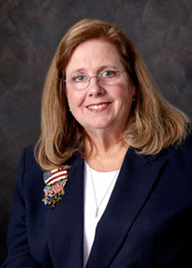

**Jane Flowers, MSN, RN, CNOR, NEA-BC, CRCST**, is an independent perioperative nursing consultant in Cambridge, Maryland. She earned a diploma in nursing from the Macqueen Gibbs Willis School of Nursing, Easton, Maryland; a bachelor of science in nursing from Salisbury University, Maryland; a master of science in nursing from Georgetown University, Washington, DC; and completed RN first assistant coursework at Anne Arundel Community College, Arnold, Maryland.

Flowers has been a perioperative nurse for 38 years and a member of AORN for 38 years. She is a member of:

* + AORN of Baltimore (2010-present),
  + eChapter (2018-present),
  + the Sterile Processing/Supply Chain Management Specialty Assembly (2014-present),
  + the Ambulatory Surgery Specialty Assembly (2010-present),
  + the RNFA Specialty Assembly (2010-present),
  + the Clinical Nurse Educator Specialty Assembly (2010-present), and
  + the Leadership Specialty Assembly (2010-present).

She has been a member of:

* + AORN of the Lower Eastern Shore (2010-2012).
  + the Pediatrics Specialty Assembly (2010-2011).

Flowers has attended Congress eight times in the past 10 years, each time as a delegate.

Flowers has received:

* + an AORN Outstanding Achievement in Mentorship Award, co-recipient (2015); and
  + a Shore Health System Manager of the Year Award (2012).

Highlights of Flowers' service to AORN include that she is:

* + a member of the AORN Golden Gavel (2010-present) and
  + a member of the AORN Foundation Silent Auction Committee (2012-present).

She has been:

* + Treasurer of AORN (2017-2019),
  + chair of the AORN Finance and Audit Committee (2017-2019),
  + a member of the AORN Compensation Committee (2017-2019),
  + a member of the AORN Board of Directors (2015-2017),
  + Board liaison to the Continuing Education Approval Committee (2017-2019),
  + Board liaison to the AORN National Legislative Forum (2017-2018),
  + Board liaison to the Sterile Processing Specialty Assembly (2015-2018), and
  + Board liaison to the AORN Simulation Task Force (2015-2017).

In other leadership roles, Flowers is:

* + a member of the American Nurses Association/Maryland Nurses Association (2010-present),
  + a member of Sigma Theta Tau National Honor Society (2010-present), and
  + a member of the International Association of Healthcare Central Service Materiel Management (2015-present).

She has been:

* + a member of the Chesapeake College Surgical Technician Advisory Committee (2015-2017), and
  + a member of the Competency & Credentialing Institute Certified Surgical Services Manager Exam Committee (2015).

In her community, Flowers is:

* + a volunteer for the Eagleman Triathlon (2016-present),
  + a volunteer for the Ironman Triathlon (2017-present), and
  + a judge for the Family Fun Dog Show benefitting Christ Episcopal Church and The Humane Society (2010-present).

She has been:

* + a volunteer for the Salvation Army (2014-2018) and
  + a volunteer for the Hurlock Lions Club (2014-2018).

**Election Statement**

AORN’s most valuable asset is you—the member. Members are the foundation of why we formed and why we have grown through the decades. Involvement with health care reform and business-to-business endeavors are important to our success but never at the cost of neglecting members. The challenge is to increase our relevance to grassroots perioperative nurses in all settings so that they feel valued and choose to belong. Meaningful communication, prudent utilization of resources, and focus on educational activities in clinical practice are vital.

We must embrace our differences and our similarities and balance them against member needs. Rural, metropolitan, hospital, ambulatory, multicultural, multigenerational, and nontraditional procedural areas, such as Labor & Delivery and physicians’ offices, have common and specific needs. There is great opportunity to recruit and retain members, as AORN’s membership is one-fourth of all perioperative nurses. We must actively engage nonmembers and demonstrate the strengths and value of belonging.

As President, I will reestablish a National Membership Committee with regional and state representatives to focus on recruitment, retention, and recognition. Imagine the benefits of a member-based think tank using their intellectual capital to identify the perceived value of AORN membership and explore the role of delegates for our business meetings. This collaboration enhances our membership’s growth by addressing why membership is important to every perioperative nurse and will explore the significance of our chapter versus independent delegate system. I offer my boundless energy and experience to tap into and mobilize all of our talents as perioperative nurses to partner with other health care providers, thus expanding our circle of influence.

As your President, my goal is simple—timely and transparent communication with you. I will listen to your needs and keep you foremost in all my deliberations and decisions related to the business of AORN. I am committed to supporting and advancing the mission, vision, and strategic plan of our Association. My service on the Nominating Committee, Board of Directors, Secretary, and Treasurer have singularly prepared me to meet this challenge. My publications and presentations on perioperative topics demonstrate my communication skills. My entire career has been as a perioperative nurse, member, and leader of AORN. I am one of you—a member. I am prepared and qualified to lead AORN as President.

I ask for your vote. My focus is on you, the member, as we advance and celebrate AORN’s success and global impact.

**Candidate’s Q&A**

**1. Member surveys indicate the most common reason they do not vote is they feel they “do not know the candidates”. To help the members get to know you better, describe something you are passionate about outside of your profession as a perioperative nurse.**

I am passionate about developing and recognizing colleagues. I formally mentor a young nurse through the ANA mentorship program. This relationship is gratifying for both of us. I suspect that this will become a lifetime relationship. I serve as a resource for many colleagues when they are faced with a challenge or opportunity in their career. They will ask me for advice or what I would do in their case. Together we work toward the best solution.

I believe in recognition of my colleagues. I believe that people should be recognized for a job well done. While I have recognized many of our AORN national award winners, I take the time to recognize many others within my community as well as nationally for formal awards. I am intrigued and explore different award applications, and determine people to nominate. Some of the awards that I have nominated folks for include Community Business Awards, Maryland Nurses Association Awards, March of Dimes Distinguished Nurse of the Year, AONL as well as AST awards. Outside of perioperative nursing I have nominated at least 50 award winners. I pay attention and recognize colleagues for a job well done.

**2. Describe your most meaningful day in the OR, or in the office, and how it has impacted your current practice, or work, as a nurse.**

In the mid-nineties I sent a suggestion to the AORN Board of Directors after Congress, suggesting that during the opening processional that the chapter presidents enter following their state flag instead of coming in a mass group. There is something very special with flags and processionals. President Botsford, sent me back a note, expressing that the Board loved my vision for the future and hoped that I was able to attend the next Congress where this plan would be implemented.

While this example seems simple, the impact to my career was enormous. All of a sudden, I realized that I had a voice and that I could impact the actions of my professional organization. This taught me that my elected leaders were interested in me as a member and what I could bring to the table. I never forgot this experience and take pride as AORN continues processing our Chapter Presidents in under their flag. I know from this that by speaking up I am valued and can contribute to AORN. This has served me well as I advanced in my professional career and also with AORN.

What a gift to realize that my voice is important to AORN.

**3. Describe what makes you the most qualified candidate for the office of President-elect.**

I am totally committed to the grassroots member of AORN because they are the power within AORN. I have formally recognized the talent of many of our members and have mentored many others into leadership roles. As a leader, I am analytical. I process information by asking the difficult questions, fully believing that a leader I needs to understand all sides of the story and its implication on the topic. From this, I will make the best decisions that support the mission and vision of our Association. I am totally committed to AORN and will follow through and work hard to advance AORN into the future. I actively listen so that I can be the voice of our members. I have been a member of AORN since 1980. During this time, I have learned the history of AORN and have proudly supported our practices. I have served AORN as a chapter President multiple times and advanced my leadership abilities not only in the workplace, but as a national elected leader, having served on the Nominating Committee, AORN’s Secretary, Board Member and Treasurer. I am qualified and prepared to lead AORN and would be honored to serve as your President.

Vice President (One to Be Elected)

* **Karen M. Knapp, BSN, RN, CNOR, CRNFA**

**Candidate Bio**

[View Candidate Video](http://media.aorn.org/asset-c0b8eb2c-a997-433b-8640-4928ed1f9de7/Expo_2020_Candidates_Karen-M-Knapp-v2.mp4?sv=2017-04-17&sr=c&si=2539b73f-367e-48c3-8f52-1ba5e7a44c70&sig=J86jvgiEI3q3Tx4ZGDBJaBu0L2KsjvNifhxuAkIDKdU%3D&se=2021-02-05T20%3A30%3A49Z)

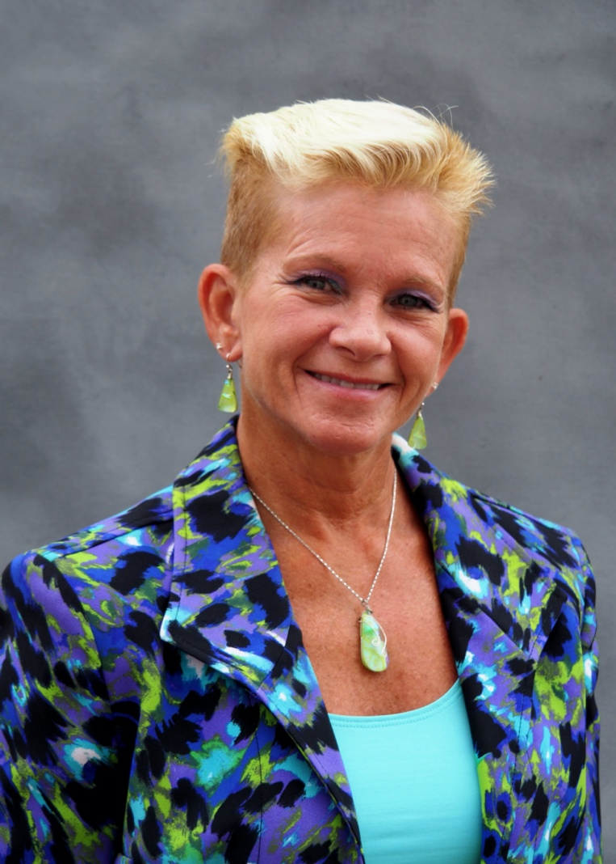

**Karen M. Knapp, BSN, RN, CNOR, CRNFA**, is a CRNFA (locum) at Long Beach Memorial Medical Center, California. She earned a diploma in nursing from Blodgett Memorial Medical Center, Grand Rapids, Michigan; an RNFA certificate from Delaware County Community College, Media, Pennsylvania; and a bachelor of science in nursing from the University of Phoenix.

Knapp has been a perioperative nurse for 35 years and a member of AORN for 34 years. She is a member of :

* + AORN of Western Michigan (2010-present),
  + eChapter (2010-present),
  + the Michigan Council of Perioperative Registered Nurses (2010-present),
  + the RNFA Specialty Assembly (2010-present),
  + the Leadership Specialty Assembly (2010-present),
  + the Perioperative Nursing Informatics Specialty Assembly (2015-present), and
  + the Advanced Practice Nursing Specialty Assembly (2010-present).

Knapp has attended Congress 10 times in the past 10 years, each time as a delegate.

Knapp has received:

* + an International Nurses Association: Worldwide Leaders in Healthcare Award (2015).

Highlights of Knapp’s service to AORN include that she is :

* + the legislative liaison for AORN of Western Michigan (2010-present),
  + chair of the Michigan Council of Perioperative Registered Nurses (2012-present), and
  + a member of the AORN Foundation Silent Auction Committee (2011-present).

She has been:

* + a member of the Nominating Committee (2017-2019);
  + chair of the Nominating Committee (2018-2019);
  + a member of the AORN Board of Directors (2013-2015);
  + coordinator for the AORN National Legislative Committee, Region 4 (2011-2013);
  + chair of the RNFA Specialty Assembly Coordinating Council (2012-2013);
  + chair-elect of the RNFA Specialty Assembly Coordinating Council (2011-2012); and.
  + chair of the RNFA Specialty Assembly Practice Issue Committee (2010-2011).

In other leadership roles, Knapp is:

* + a member of the Coalition of Michigan Organizations of Nursing (2015-present),
  + a member of the ANA Leadership/Mentoring Forum (online) (2018-present), and
  + a member of the National Assistant at Surgery Certification Board of Directors (2019-present).

She has been:

* + a member of the Michigan Nursing Action Coalition Practice Action Team (2015-2018) and
  + a member of the CRNFA Problem Item Notification Committee (2015-2016).

In her community, Knapp is:

* + a member of the Advisory Committee of the University of West Georgia Tanner Health System School of Nursing (2014-present) and
  + a volunteer for the WellStar Day of Service Food Bank (2019-present).

She has been:

* + a volunteer for Ronald McDonald House of Long Beach, California (2018-present); and
  + a volunteer for I-Own-It.Today, Long Beach, California (2018-present).

**Election Statement**

Has your manager recently asked you to cut costs—again? Are you short nurses in your department? Have you been a victim of workplace violence? Have you cared for a patient in an opioid crisis? We work with health care challenges every day, all while caring for our patients … the whole patient. We search our hearts and practices and find the ability and love to continually provide safe, efficient, and quality care. AORN exists to help make those everyday challenges less daunting by providing our members with support.

To strengthen that support, my primary task as Vice President will be improving communication between AORN and our members. You are our most important asset. As expressed by delegates at Expo 2019, we need to find more ways for your voices to be heard. I will advocate for an actively updated web page for volunteers to check routinely when input is desired. We could also better utilize our Specialty Assemblies for specific information when staff or committees need help. We need to be innovative and ingenious, tapping into the many technological opportunities available to garner increased member involvement. Our sound business strategies have netted revenues that can be used to make this happen. We must also ensure that the voices of the membership are heard at the House of Delegates as AORN business and strategy decisions are made. While our amazing industry partnerships support our many educational endeavors, our members have the experience and intellect to help us educate, mentor, and influence future generations of perioperative nurses. Member strength has always been a critical part of AORN’s success, so your involvement is key.

As your Vice President, my role is to lead and continue supporting decisions that enhance our global presence, fiscal success, and member access. To expand our influence, we must continue developing strong partnerships with our surgeon and anesthesia colleagues, industry, other specialty nursing, and quality and safety organizations. We must continue supporting education and research that promotes quality care and improves outcomes so we can validate the critical importance of perioperative nursing care. Promoting our influence also includes expanding advocacy efforts in the legislative and regulatory arenas.

We all have the “power” to serve AORN, work together, and promote increased member involvement … You are the power of AORN. I ask for your vote so I may continue to serve and help AORN realize greater potential. Thank you.

**Candidate’s Q&A**

**1. Member surveys indicate the most common reason they do not vote is they feel they “do not know the candidates”. To help the members get to know you better, describe something you are passionate about outside of your profession as a perioperative nurse.**

I love to travel! I enjoy roaming the world, seeing the beauty of various areas and meeting the people that live there. The United states is truly amazing; you can visit the largest hand-dug well in Kansas, the Lewis & Clark trail in Oregon (where you can still see the wagon-ruts), waterfalls by horseback in the Garden of the Gods, Illinois or national parks in almost every state! Taking time to talk with the locals is a great way to discover new ideas, find great places to eat and learn some of the local history. Sometimes we get so caught up in our lives that we forget that there are other ways of doing things. Travel is a wonderful way to broaden your knowledge and experience the beauty all around us; you simply have to make the effort and go outside your comfort zone. The rewards are a true blessing.

**2. Describe your most meaningful day in the OR, or in the office, and how it has impacted your current practice, or work, as a nurse.**

My most meaningful day occurred about 25 years ago, back in the day when you met your patient at the door of the OR. This particular patient was having his AAA repaired. During the interview, he mentioned that he was feeling great and really wasn’t sure that he wanted to have his surgery that day. To this day, I thank my early mentors that taught me the importance of advocacy. I told the patient that if he wasn’t ready, he could leave, go home, enjoy his family, whatever he felt he needed to do. He smiled and said “Really, I could leave right now?” I replied yes. He thought for a moment but decided to proceed with the procedure; sadly, he did not survive. Yet I was comforted by the knowledge that I had given him the choice to go home. I was his advocate. I will never forget him.

**3. What qualities are needed to be an effective Vice President and how do you know you have them?**

An effective Vice-president is a strong leader who is confident, organized, supportive and responsive to the BOD and the membership; communicates clearly and leads with transparency.

AORN has helped me become a strong leader; my past experience on the BOD, Nominating and other committees has proven my organizational skills, my ability to work with teams, share ideas and support group decisions. I listen, offer suggestions, debate, and make decisions based on information presented, always promoting transparency for the members. I enjoy problem-solving and am able to adapt to change quickly and efficiently.

My experience as a RNFA and perioperative travel nurse has shown me the importance of collaborative efforts and the strength of a team; it starts with mutual trust and respect. My goal and yours is for a strong, vibrant, professional member organization. I am prepared to act, and I want to be your member-voice in the boardroom.

* **Elizabeth S. Pincus, MSN, MBA, RN, ACNS-BC, CNS-CP, CNOR**

**Candidate Bio**

[View Candidate Video](http://media.aorn.org/asset-04ebf2a4-68be-4606-9b20-e7844ef0bd16/Expo_2020_Candidates_Elizabeth-S-Pincus-v2.mp4?sv=2017-04-17&sr=c&si=cf206333-15b0-49fe-a439-703304ff9746&sig=YOkw%2BQ09gQa8Nj%2FimfhNWZQTOQp%2BkDIx8wGT6MY3c%2Bw%3D&se=2021-02-05T20%3A07%3A42Z)

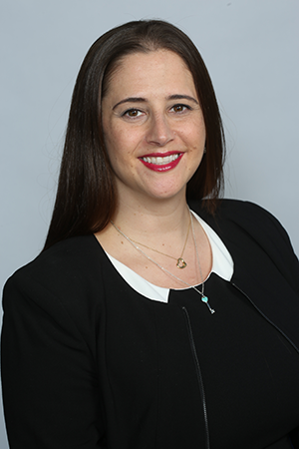

**Elizabeth S. Pincus, MSN, MBA, RN, ACNS-BC, CNS-CP, CNOR**, is a clinical nurse at Regional Medical Center, San Jose, California. She earned a bachelor of arts in psychology from the University of Hartford, West Hartford, Connecticut; a master of business administration in health care administration from City University of New York, Baruch College; a bachelor of science in nursing from Stony Brook University, New York; and a master of science in nursing as an adult health clinical nurse specialist and a post master’s certificate in nursing education from The Johns Hopkins University, Baltimore, Maryland.

Pincus has been a perioperative nurse for 12 years and a member of AORN for 12 years. She is a member of :

* + AORN of San Jose (2019-present),
  + AORN of Long Island New York (2010-present),
  + AORN of New York City (2010-present),
  + the New York State Council (2016-present),
  + the Advanced Practice Nursing Specialty Assembly (2011-present), and
  + the Clinical Nurse Educator Specialty Assembly (2013-present).

Pincus has attended Congress eight times in the past 10 years, six times as a delegate.

Highlights of Pincus’ service to AORN include that she is:

* + Secretary of AORN (2018-present),
  + co-chair of the New York State Council (2018-present),
  + Board liaison to the RNFA Specialty Assembly (2018-present),
  + Board liaison to the Guidelines Advisory Board (2018-present), and
  + a peer reviewer for the AORN Journal (2013-present).

She has been:

* + a member of the AORN Board of Directors (2016-2018),
  + communications chair of the Advanced Practice Nursing Specialty Assembly (2014-2016),
  + chair of the Video Contest Task Force (2015-2016),
  + a member of the Safe Surgery Task Force (2014-2015), and
  + a mentor to AORN undergraduate scholarship recipients (2015-2017).

In other leadership roles, Pincus is:

* + a member of the National Association of Clinical Nurse Specialists Legislative/Regulatory Committee (2018-present) and
  + a member of the Kappa Gamma chapter of Sigma Theta Tau (2010-present).

She has been:

* + a member of the National Association of Clinical Nurse Specialists Education Committee (2014-2018),
  + a member of the Competency & Credentialing Institute CNOR Job Analysis and Ambulatory Branch Analysis Committee (2014), and
  + a member of the Competency & Credentialing Institute Item Writers Committee for the inaugural Clinical Nurse Specialist Perioperative Certification Exam (2013).

In her community, Pincus is:

* + a medical volunteer for the New York Road Runners (2015-present),
  + a volunteer for Alpha Xi Delta’s The Empowerment Network mentorship program (2019-present), and
  + a volunteer for Second Harvest of Silicon Valley (2019-present).

She has been:

* + a medical volunteer for the Global Smile Foundation, Trujillo, Peru (2016-2018) and
  + co-chair for the Relay for Life of Roosevelt Island (2012-2013).

**Election Statement**

Serving the members of AORN over the past four years has been a tremendous honor, as there is no greater privilege than to be trusted by colleagues to serve as their voice in the boardroom. During my tenure, membership continues to increase, we have seen ongoing fiscal success in addition to new products and services based on the needs of our members at various levels of career development.

The strong leadership skills gained during my tenure are essential to the job of Vice President. The insights into the structure and strategy of AORN acquired by representing our Association across the country and at the federal level have prepared me well for this position. This past year, I was proud to lead a team that utilized out-of-the-box thinking and creative strategies to increase Board engagement with chapters. With integrity as my guide, I take each challenge as a new opportunity to lead our Association into the future. I am committed to serving each and every one of you.

We continue to adapt to change as it is the only constant in our ever-evolving profession. Technology continues to advance, patient acuity is increasing, and we struggle with the realities of doing more with less. Yet we always rise to the occasion, giving our patients the best care possible. AORN must continue to provide services even before members realize they need them. My steadfast belief is that the most important part of our Association is our membership, and my priority will be the long-term success and viability of our Association.

As your Vice President, my vision is to focus on succession planning, engage members, and advocate for new perioperative nurses and students. These priorities are critical to ensure AORN’s success for decades to come. Without the experience and knowledge of wise mentors, I would not be where I am today. If we tap into the wealth of experience AORN has and combine it with our next generation, we can make our Association unstoppable and our voices stronger than ever imagined.

My passion, commitment, and tenure on the Board will support the ongoing success of our organization. I will continue to advocate and support our members by putting their needs first. In the boardroom, I have always spoken up and will continue to speak for you. I look forward to serving you and AORN as your next Vice President.

**Candidate’s Q&A**

**1. Member surveys indicate the most common reason they do not vote is they feel they “do not know the candidates”. To help the members get to know you better, describe something you are passionate about outside of your profession as a perioperative nurse.**

My childhood dream was to be on Broadway. I loved dance and theater, which I studied at a performing arts high school. I love watching the ensemble come together and share magic with their audiences. Whether plays or musicals, I enjoy being able to disconnect from the world and make my way thru a story with the actors. Some shows are heartwarming with wise messages, and many provide pearls of wisdom. You can also find these beautiful stories at the movies, the opera and music performances. A powerful song will stay with you and will remind you of that experience.

The arts allow people to step away from rough days in the OR and from personal challenges. They allow us the opportunity to reset and recharge then, return to our caregiver roles to support those who need us most. It’s my favorite way to recharge.

**2. Describe your most meaningful day in the OR, or in the office, and how it has impacted your current practice, or work, as a nurse.**

One day, I met a 6 year old boy who was diagnosed with a DIPG tumor and when we headed to the OR, he brought his "Moose" doll. We replicated our patient’s dressing on Moose. Afterwards, when I went to PACU to follow up on the child and the dad gave me a huge hug. At that moment, I knew I had truly made a difference. His son wasn't going to beat his cancer, but we helped that family deal with a horrific situation. I still think about this family and am reminded to never focus solely on the surgery. We are technically proficient, but we can never forget that what we do impacts lives. These moments with patients are why I became a nurse. Working with so many anesthetized patients, we don't have these moments as often, but ours are extra special. This one changed my life, forever.

**3. What qualities are needed to be an effective Vice President and how do you know you have them?**

Integrity, honesty and effective communication skills are critical for all leaders and set the tone when leading in the board room. The Vice President must have a proven track record of leadership that fosters innovation, flexibility and dependability when tackling difficult decisions affecting members or the Association. These require a critical lens when evaluating all perspectives to promote optimal outcomes and require a keen understanding of the current environment. As second in command, the Vice President must be up-to-date on all issues and at the ready to support or represent the President.

These are qualities I have honed throughout my 4 years on the board. Serving as Secretary, I have demonstrated these skills at every board meeting, chapter visit and assignment I have completed. I have received positive performance feedback during my board tenure and welcome constructive criticism as well because I always want to seek out opportunities for improvement.

Secretary (One to Be Elected)

* **James (Jay) W. Bowers, BSN, RN, CNOR, TNCC**

**Candidate Bio**

[View Candidate Video](http://media.aorn.org/asset-fb0e3696-9fd7-4b7c-a430-149759090572/Expo_2020_Candidates_James-Jay-Bowers-v2.mp4?sv=2017-04-17&sr=c&si=21983561-100e-4515-83cb-ef55d935f019&sig=W%2FbaQpj5sD6jTWVRHdwpA0%2Fk4ulXvlIqS7KUo1RNGSY%3D&se=2021-02-05T20%3A28%3A13Z)

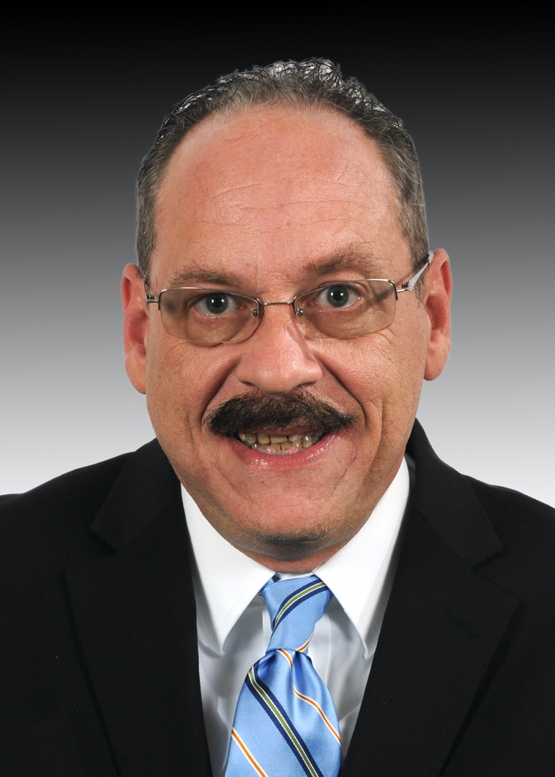

**James (Jay) W. Bowers, BSN, RN, CNOR, TNCC**, is a clinical educator for General Surgery, Trauma, Pediatrics, Surgical-Oncology, and Oral Maxillofacial Surgery and Plastics, West Virginia University Healthcare, Morgantown. He earned a bachelor of science in nursing from West Virginia University, Morgantown.

Bowers has been a perioperative nurse for 27 years and a member of AORN for 26 years. He is a member of :

* + AORN of North Central West Virginia (2010-present),
  + the West Virginia State Council (2010-present),
  + the Leadership Specialty Assembly (2010-present),
  + the Clinical Nurse Educator Specialty Assembly (2010-present), and
  + the Pediatric Specialty Assembly (2010-present).

Bowers has attended Congress 10 times in the past 10 years, each time as a delegate.

Bowers has received:

* + an AORN Outstanding Achievement in Perioperative Clinical Nursing Practice Award (2015),
  + George P. Heffner Medical Staff Member of the Year (2016),
  + an AORN National Volunteer of Year Award (2012), and
  + a Tacna-Peru Mayor Humanitarian Award (2011).

Highlights of Bowers’ service to AORN include that he is:

* + a member of the AORN Global Surgical Conference Education Committee (2018-present),
  + a member of the AORN of North Central West Virginia Board of Directors (2010-present),
  + co-chair of the West Virginia State Council (2011-present), and
  + a member of the AORN Foundation Silent Auction Committee (2011-present).

He has been:

* + a member of the AORN Board of Directors (2015-2018),
  + co-chair of the AORN Task Force for Transition Into Practice (2014-2015),
  + vice president of AORN of North Central West Virginia (2014-2016),
  + a member of the AORN Nominating Leadership and Development Committee (2012-2014),
  + chair of the Trauma Specialty Assembly Professional/Practice Issues (2011-2012), and
  + a member of the AORN National Committee on Education (2011-2014).

In other leadership roles, Bowers is:

* + an item writer for the Competency & Credentialing Institute Certified Surgical Services Manager Exam (2018-present) and
  + secretary for the Diabetes Camp of West Virginia (2010-present).

He has been:

* + a Competency & Credentialing Institute-Surgical Services Educator Reviewer (2014-2015) and
  + a trauma chapter reviewer for Alexander’s Care of the Patient in Surgery, 15th edition (2014).

In his community, Bowers is:

* + an official Red Cross Disaster Relief Nurse (2018-present),
  + a nurse volunteer for Interplast of West Virginia to Lesotho (2012-present), and
  + a perioperative nurse liaison to the National Institute for Occupational Safety and Health on Operating Room Research (2012-present).

He has been:

* + a nurse volunteer for Interplast of West Virginia to Haiti (2017-2019) and
  + a nurse volunteer for Interplast of West Virginia to Nicaragua (2014-2019).

**Election Statement**

Colleagues, my four years of service on AORN’s Board of Directors and extensive involvement on the nation, local, and state level has equipped me for the role of AORN Secretary. I am prepared, efficient, and organized. Additionally, I bring 23 years of experience as Secretary for the Board of Directors of the Diabetic Camp of West Virginia. Having the optimal mix of skills, expertise, experience, and geographical diversity is paramount to ensure that the Board is equipped to guide the business and strategy of AORN.

I am clinical educator at a large teaching hospital system. This provides a frontline and clear-eyed view of how to approach the complex issues facing nursing and health care. Few other professions afford the opportunity to affect lives on such a profound level, not only physically, but also emotionally and spiritually. The year 2020 is being called the year of the nurse. I think that every year is the year of the nurse. AORN and all nursing organizations must use this opportunity to promote nurses and the evidence practice we bring to the table.

Your Secretary must have good interpersonal and negotiation skills and must have the ability to ask and find solutions to difficult questions. Brave leaders are never silent about hard things. I am a brave leader and someone who will find answers to your questions. I am a leader who will acknowledge and respect the opinions of others. I have and will continue to keep our members and mission front and center.

**Candidate’s Q&A**

**1. Member surveys indicate the most common reason they do not vote is they feel they “do not know the candidates”. To help the members get to know you better, describe something you are passionate about outside of your profession as a perioperative nurse.**

Passion for life enriching activities fuels the rejuvenation of an off-duty perioperative nurse. Traveling, reading, and college football are my developed passions to expand my knowledge of international, national, and regional affairs. Most notably, community volunteerism such as Camp Kno-Koma, West Virginia’s Diabetic Camp, is the passion that I am most proud of because it allows me to incorporate professional nursing and teamwork into the creation of fond pediatric memories. I see firsthand childhood dreams become fulfilled as registered nurses serve as camp counselors. Stressed parents appreciate how this camp provides the opportunity for children to learn about diabetic self-care. From the campers’ perspective, it is nice to just be able to focus on just being a kid while in a medical supervised environment. For adolescents, I am honored to be able to help staff an annual fall weekend so that teenagers can learn diabetic survival skills.

**2. Describe your most meaningful day in the OR, or in the office, and how it has impacted your current practice, or work, as a nurse.**

An impactful event forever changed my professional practice. As night nurse, I received a trauma patient with a femur fracture. I asked the patient if he had any questions following the preoperative assessment. He looked at me and said he was not going to make it. I stated you are going to be fine. The patient wanted to wait on his wife. Anesthesia wanted to get the case going. Thinking that the patient’s concerns reflected normal anxiety, I supported anesthesia’s plan to proceed. Much to my display, the patient was right. He had a PE and expired on the table. I decided at that moment never again to let anyone hurry a case along. Now I teach nurses that when a patient is hesitant about surgery, the nurse needs to listen intently. This type of active patient advocacy haves the potential to save the lives of those we serve.

**3. How does the role of Secretary impact the business of AORN and how do your skills contribute to that impact?**

AORN’s Secretary is like an airport controller. The Secretary must use multiple senses to engage in group discussions, record meeting minutes, and take action on board motions. The accuracy of role execution is critical to board business and proposal communications to the AORN membership. The Secretary must manage the comprehensive history of the board’s work ensuring that all required meeting elements are recorded for future referencing. Serving as Secretary of the Diabetes Camp of West Virginia, I have had the opportunity to enhance my secretarial proficiencies. It is with great pride that I act to help manage an organization’s accountability and responsibility to the membership it serves. I am appreciative of AORN’s membership confidence in my leadership abilities as evidenced by my four years on the AORN Board of Directors. My demonstrated integrity, accountability, professional networking, organization, follow-up, and negotiation skills truly position me for success as AORN’s next Secretary.

* **Darlene B. Murdock, BSN, BA, RN, CNOR**

**Candidate Bio**

[View Candidate Video](http://media.aorn.org/asset-dcf19c02-9f55-4c4a-8b45-978f967b6570/Expo_2020_Candidates_Darlene-B-Murdock-v3.mp4?sv=2017-04-17&sr=c&si=65be0ace-d60b-48fa-badf-d129deb252ff&sig=0diV%2FTOUXEG%2BksTLqgGr%2Blyd36SJov%2BsfhNg7rCh9qk%3D&se=2021-02-05T20%3A06%3A40Z)

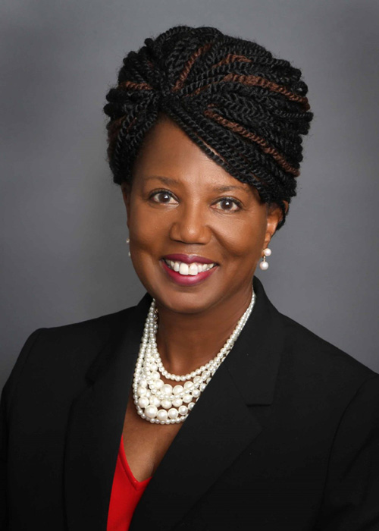

**Darlene B. Murdock, BSN, BA, RN, CNOR**, is a clinical staff nurse IV at Memorial Hermann Health System, Houston, Texas. She earned an associate degree of technology in data processing from Jones County Junior College, Ellisville, Mississippi; a bachelor of arts in business administration from the University of North Carolina at Charlotte; and a bachelor of science in nursing from the University of Texas Health Science Center, Houston.

Murdock has been a perioperative nurse for 27 years and a member of AORN for 25 years. She is a member of:

* + AORN of Greater Houston (2010-present),
  + the Texas Council of Operating Room Nurses (2010-present),
  + the Leadership Specialty Assembly (2012-present),
  + the Pediatric Specialty Assembly (2012-present),
  + the Retired Nurses Specialty Assembly (2018-present), and
  + Sterile Processing/Supply Chain Management Specialty Assembly (2019-present).

She has been a member of:

* + the Trauma Specialty Assembly (2010-2012) and
  + the Neurosurgery, Orthopedics and Trauma Specialty Assembly (2012-2016).

Murdock has attended Congress 10 times in the past 10 years, each time as a delegate.

Murdock has received:

* + the AORN Outstanding Achievement in Perioperative Clinical Nursing Practice Award (2018),
  + the AORN of Greater Houston Star Award for Outstanding Contribution (2017),
  + the Federation of Houston Professional Women of Excellence Award (2014), and
  + the AORN of Greater Houston Perioperative Nurse of the Year Award (2012).

Highlights of Murdock’s service to AORN include that she is:

* + a member of the AORN Board of Directors (2018-present) and
  + a member of the Texas Council of Operating Room Nurses Board of Directors (2015-present).

She has been:

* + chair of the Neurosurgery, Orthopedics and Trauma Specialty Assembly (2012-2013),
  + chair of the Trauma Specialty Assembly (2011-2012),
  + editor of the Neuro, Orthopedics and Trauma Specialty Assembly Newsletter (2012-2014),
  + communication chair of the Trauma Specialty Assembly (2010-2011),
  + president of AORN of Greater Houston (2013-2014),
  + vice president of AORN of Greater Houston (2015-2016),
  + editor of the AORN of Greater Houston Newsletter (2016-2018), and
  + an AORN Journal author (2013).

In other leadership roles, Murdock is:

* + chair of the Professional Nurse Advancement Program at Memorial Hermann Hospital-Texas Medical Center (2017-present),
  + Board liaison to the AORN Continuing Education Approval Committee (2019-present),
  + editor-in-chief of Surgical Sunrise, the monthly newsletter for Memorial Hermann Hospital-Texas Medical Center Surgical Services (2010-present), and
  + editor-in-chief of The PNAP Pride, the quarterly newsletter for Memorial Hermann Hospital-Texas Medical Center (2018-present).

She has been:

* + a member of the Competency & Credentialing Institute CNOR Job Analysis and Ambulatory Surgery Job Analysis Committee (2014-2015).

In her community, Murdock is:

* + a champion for the Live Your DREAMS Injury Prevention Program at Memorial Hermann Hospital, Texas Medical Center, Houston (2015-present);
  + an instructor for Stop the Bleed at Memorial Hermann Hospital, Texas Medical Center (2018-present); and
  + a sort room volunteer for Project C.U.R.E., Houston, Texas (2015-present).

She has been:

* + a Career Day presenter for the Fort Bend School District, Texas (2010-2018); and
  + an organizer for the Houston Food Bank (2012-2017).

**Election Statement**

AORN exists to serve you, setting the standards for excellence in perioperative care. As you know, change is happening at a rapid pace with many potential disruptors. During this time of disruption, our Association must remain true to its mission and vision, keeping member’s needs at the forefront. It is crucial that our Association remains connected and provide clear, collaborative, and supportive communication with our members providing care. For this reason, I am seeking to be your Secretary.

Representing and connecting with you, our members, requires certain skills which I possess. As an expert clinician and Magnet lead, I am comfortable with advocating for excellence. Serving on the Board, I have acquired firsthand knowledge and understanding of the management of AORN business and financial affairs. As an AORN volunteer leader at the local, state, and national levels, I have a keen understanding of our member’s needs. I know the importance of effectively communicating with all members. I have served as editor of local and national newsletters, presented at local and national events, and authored AORN Journal articles. These experiences coupled with my attention to detail, excellent communication skills, and strong organizational skills have equipped me well to serve as your Secretary.

I am passionate about AORN, dedicated to perioperative nursing excellence, and committed to advocating for our patients and members. I will be the voice that speaks for you after communicating with you. It will be my utmost pleasure and esteemed honor to serve as your Secretary.

**Candidate’s Q&A**

**1. Member surveys indicate the most common reason they do not vote is they feel they “do not know the candidates”. To help the members get to know you better, describe something you are passionate about outside of your profession as a perioperative nurse.**

Besides spoiling my dogs, Boots & Buster, with belly rubs and daily long walks, I am passionate about collecting lapel pins. I have a lapel pin from every city and state visited, nursing events, Houston Rodeos, major sports events, recognition and service pins from my 28-year nursing career and a number of various pins from dollar and antique stores. My favorite pin, purchased at a dollar store about fifteen years ago, is a navy-blue circle shaped pin that says “I Am Perfect Just the Way I am”. My most treasured lapel pin is AORN Outstanding Achievement Award (2018). I proudly display most of my pins on my two favorite back packs. There’s a little life story behind every pin. Displaying them has become an awesome source of reflection for me and a great conversation piece with the people who stand behind me.

**2. Describe your most meaningful day in the OR, or in the office, and how it has impacted your current practice, or work, as a nurse.**

The most meaningful day in the OR for me, is when I received my CNOR. I felt a huge sense of pride and relief when I received the notice. I took the exam right at my two-year mark of OR experience. As a fairly new OR nurse, it was extremely important to have documented proof that I had acquired the skills and knowledge to become certified. I felt more confident in my clinical practice which allowed me to feel more comfortable to voice my ideas and concerns. This affirmation of skills and knowledge, along with my sense of confidence, provided me the courage to become an effective change agent for perioperative clinical practice. I relate the receiving my CNOR as the precursor for me receiving AORN Outstanding Achievement in Perioperative Clinical Practice. This signifies to me that I have made a difference in the care of many patients.

**3. How does the role of Secretary impact the business of AORN and how do your skills contribute to that impact?**

Along with assisting the President in expediting agendas by preparing and making appropriate motions, the secretary is the official record keeper of the proceedings of all business meetings. Official record keeping is a form of checks and balance for our Association. Confusion and possible chaos may result if documents lack legitimacy, integrity, and accuracy. Along with impeccable organizational and communication skills, meticulous attention to detail and note taking is crucial. I have those skills and abilities. I am able to convey information clearly and concisely. I have the keen ability to summarize and reflect the importance and urgency of data and information. I have firsthand knowledge of the proceedings of our business meetings as a present Board member. I demonstrate my written and oral communication skills having served as editor-in-chief of multiple newsletters, AORN Journal author, and AORN Surgical Conference podium and poster presenter.

Board of Directors (Three to Be Elected)

* **Rhonda L. Anders, MSM, BSN, RN, CNOR, NE-BC**

**Candidate Bio**

[View Candidate Video](http://media.aorn.org/asset-c9c80eb3-4e23-4666-aa1f-13ca3712df24/Expo_2020_Candidates_Rhonda-L-Anders-v2.mp4?sv=2017-04-17&sr=c&si=3afa52ce-449d-4117-bd59-7c629ed0a2bf&sig=M6g28eWuRWh9FWVPcbXtb%2BFS5RP%2FV1bv%2FTi7d4wMMX8%3D&se=2021-02-06T21%3A07%3A27Z)

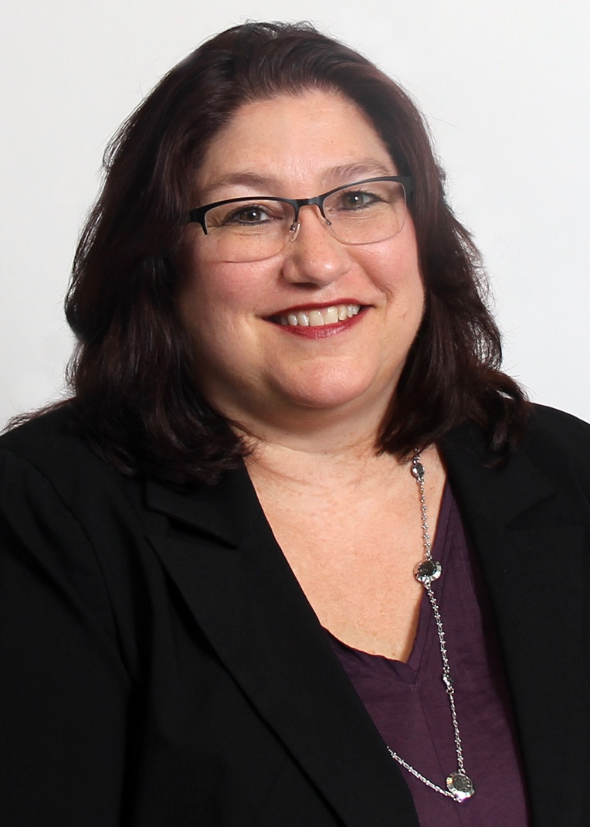

**Rhonda L. Anders, MSM, BSN, RN, CNOR, NE-BC**, is the director of perioperative services at Eskenazi Health, Indianapolis, Indiana. She earned a bachelor of science in nursing from Indiana University, Indianapolis, and a master of science in management from Indiana Wesleyan University, Indianapolis.

Anders has been a perioperative nurse for 30 years and a member of AORN for 23 years. She is a member of:

* + the Indiana Council of Operating Room Nurses (2010-present) and
  + AORN of Greater Indianapolis (2010-present).

She has been a member of:

* + the Clinical Nurse Educator Specialty Assembly (2010-2014).

Anders has attended Congress five times in the past 10 years, three times as a delegate.

Anders has received:

* + a Firestarter Award from Eskenazi Health (2019),
  + a President’s Award from the Association of Surgical Technologists (2011),
  + a Nurse of the Year Award - Transformational Leader (2010), and
  + a Firestarter Award from Franciscan Health (2015).

Highlights of Anders’ service to AORN include that she has been :

* + a member of the AORN Board of Directors (2010-2011),
  + chair of the Indiana Council of Operating Room Nurses (2011-2012),
  + a member of the AORN Global Relations Committee (2012-2013),
  + president of AORN of Greater Indianapolis (2014-2015),
  + president-elect of AORN of Greater Indianapolis (2013-2014),
  + a member of the AORN of Greater Indianapolis Board of Directors (2012-2013),
  + the corresponding secretary for AORN of Greater Indianapolis (2011-2012),
  + the recording secretary for AORN of Greater Indianapolis (2010-2011),
  + a member of the AORN of Greater Indianapolis Nominating Committee (2010), and
  + president of the Indiana Council of Operating Room Nurses (2010).

In other leadership roles, Anders is:

* + a member of the Cardinal Health Perioperative Advisory Board (2015-present),
  + a member of the Radiological Care Solutions Advisory Board (2016-present),
  + a member of the Indianapolis Coalition for Patient Safety (2010-present), and
  + a member of the Stryker Safety Academy (2019-present).

She has been:

* + chair of the Transformational Leadership Team at Franciscan Health (2015-2016).

In her community, Anders is:

* + a team captain for Walk to End Alzheimer’s (2011-present).

She has been:

* + a health care volunteer coordinator for the Indianapolis Monumental Marathon (2011-2013),
  + a volunteer coordinator for the Spotlight on Nursing 5K Run/Walk (2014-2016), and
  + a facility captain for the American Heart Association Run/Walk fundraising campaign (2010).

**Election Statement**

After serving AORN for many years at the national and local levels, I had to take a break to focus on what was happening at home. With two teenage boys and a father with Alzheimer disease, I had to step away from the work that I loved to care for the family that I loved even more. Fast forward eight years to 2019, I am ready, willing, and able to serve again. With one term on the then “National Nominating Committee” and two terms on the national AORN Board of Directors, I have a wealth of experience when it comes to the strengths and weaknesses of our magnificent organization.

My work with Eskenazi Health, a Level I trauma center in downtown Indianapolis established to serve the indigent, vulnerable population in my city, is perhaps the most rewarding work of my career. This year, I discovered the art of rounding on patients and families and how powerful it can be to do something as simple as sit and listen. I speak to folks in preop, in our waiting room, and in postop just before discharge. This simple practice has allowed me to uncover serious safety concerns that I was able to address, and sometimes even fully resolve, before the patient went home. Other days, rounding provided small ways for me to fix a minor service concern, or simply to show compassion. If elected, this “listen first” and “seek to make a difference” approach will apply to my work on the Board.

**Candidate’s Q&A**

**1. Member surveys indicate the most common reason they do not vote is they feel they “do not know the candidates”. To help the members get to know you better, describe something you are passionate about outside of your profession as a perioperative nurse**

Before I was a perioperative registered nurse, I was a wife and a daughter – the roles that defined me then, still define me today. A few years into my career, I added the role of mother to two magnificent boys, Christopher and Matthew. There are many things that I do outside of my professional role, but none which I am more passionate about than being truly connected to my family. I know it isn’t an exceptional thing, worthy of award and distinction, but it’s who I am.

I am incredibly blessed that there has been no divorce in my family, neither on my side, nor my husband’s. I’m grateful that my mother and father loved each other and kept our family close until the day my father passed in 2017. Eddie and I celebrate 30 years as a family in 2020 and without hesitation; this family remains my greatest passion.

**2. Describe your most meaningful day in the OR, or in the office, and how it has impacted your current practice, or work, as a nurse.**

The day that shaped my practice goes back to the summer of 1992. I was circulating a CABG for a boisterous 47 year old truck driver. I heard the surgeon say, “pump on slowly” which was his usual indication that he was ready to connect the lines for going on bypass. The perfusionist didn’t respond, as she had momentarily left the room. In the confusion that followed, another perfusionist came into the room, and the patient was put on bypass. Within seconds, we knew that something was wrong. There was no standardized “pump set-up” in those days, and a huge bolus of air had just been delivered to our patient. He spent the rest of his life in a vegetative state.

The lessons that day were simple. Nothing is more important that providing safe passage for our patients. In our complex environment, communication and standardization are the keys to safety.

**3. What, in your opinion, are the key responsibilities for a member of the Board of Directors and what experience has prepared you for this role?**

The Board of Directors is responsible for conducting the business of AORN in a manner that assures members’ needs are met, and perioperative nursing has a strong voice in healthcare. Why is this important? The United States spends 18% of its economy on healthcare, and the average American family spends $19,615 a year on health insurance – a staggering 31.5% of their annual income. Given the enormous investment, a logical assumption would be that we lead the global community in delivering quality outcomes. But sadly, that isn’t the case. We are not leading the way.

I am prepared to engage in the difficult conversations to come as we address the disparity between healthcare expense and safe patient outcomes in the perioperative setting. My three decades in perioperative nursing and my previous four years as a member of AORN’s national Board of Directors have prepared me to advocate for what is right.

* **J. Stephen Balog, MSN, RN, CNOR**

**Candidate Bio**

[View Candidate Video](http://media.aorn.org/asset-4ae6fb7f-8701-4e73-9602-2059e4d2856d/Expo_2020_Candidates_J-Stephen-Balog-v2.mp4?sv=2017-04-17&sr=c&si=78d21bb7-ca36-4315-802f-ff6152a7e585&sig=NYezB6Fz%2BKr0w1PYkUJuuIC3a%2F3Y78bUidb9ZPNsWjQ%3D&se=2021-02-05T20%3A30%3A16Z)

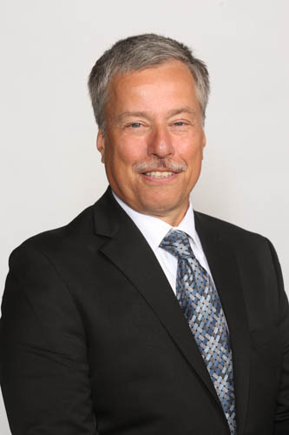

**J. Stephen Balog, MSN, RN, CNOR**, is a staff nurse and RN first assistant at Hilton Head Hospital, South Carolina. He earned an associate degree in nursing from Northern Virginia Community College, Annandale; a bachelor of science in nursing and master of nursing administration from George Mason University, Fairfax, Virginia; a post master’s certificate in nursing education from Walden University, Minneapolis, Minnesota; and an RNFA certificate from Northern New Mexico College, Española.

Balog has been a perioperative nurse for 40 years and a member of AORN for 36 years. He is a member of:

* + the AORN Chapter of the Lowcountry (2014-present),
  + the South Carolina Council of Perioperative Nurses (2014-present),
  + the RNFA Specialty Assembly (2012-present), and
  + the Clinical Nurse Educator Specialty Assembly (2011-present).

Balog has attended Congress 10 times in the past 10 years, each time as a delegate.

Balog has received:

* + an Outstanding Achievement in State Council Leadership Award (2012).

Highlights of Balog’s service to AORN include that he is:

* + a member of the AORN Board of Directors (2018-present),
  + Board liaison to the Legislative Specialty Assembly (2019-present), and
  + Board liaison to the National Legislative Forum (2019-present).

He has been:

* + a member of the AORN Chapter of the Lowcountry Board of Directors (2014-2018),
  + a member of the AORN Chapter of Northern VA Board of Directors (2010-2014),
  + chair of the Virginia Council of periOperative Registered Nurses (2010-2013),
  + chair of the National Legislative Committee (2013-2014),
  + a member of the Nominating and Leadership Development Committee (2014-2016), and
  + a member of the National Educational Committee for the 57th Congress (2010).

In other leadership roles, Balog has been:

* + the clinical lead for Cardiac, Thoracic, Vascular, and Urology Services, Hilton Head Hospital (2015-2018);
  + chair of the Quality and Safety Shared Governance Council, Virginia Hospital Center (2015-2018);
  + chair of the hospital-wide Education Council, Hilton Head Hospital (2010-2014); and
  + co-chair of the Coordinating Council, Virginia Hospital Center (2011-2013).

In his community, Balog is:

* + a member of the South Carolina Lowcountry Master Gardener Association (2018-present).

**Election Statement**

It has been an honor to serve you on the Board of Directors for these past two years. As I have served on the Board, my underlying principle in decision making has been “How does this affect the membership?” and “Is this the best decision for the current situation?''

As health care continues to change, we must strive to meet the needs of our patients and deliver optimal care. More surgery is being performed in the outpatient setting and increasingly sicker patients are in our inpatient ORs with serious issues and complications. We must be ready to employ our knowledge and skills to care for our patients no matter the setting. Acquiring Outpatient Surgery Magazine as part of our Association has provided AORN with a stronger presence in the outpatient surgery specialty arena.

Our Association must remain financially resilient with strong stewardship. AORN must be the leader and voice of perioperative nursing. However, my fellow Board members and I must continue to review new opportunities for growth that fulfills AORN’s mission and values. We need to continually evaluate our web site and ORNurseLink to ensure that it serves our members with easy maneuverability and minimal “clicks.” The web site is our Association’s digital presence and it must look inviting to all who access it.

I am honored to be nominated for a second term on the Board of Directors. I will remain focused on serving you, the members, and our patients. I ask for your continued confidence and your vote.

**Candidate’s Q&A**

**1. Member surveys indicate the most common reason they do not vote is they feel they “do not know the candidates”. To help members get to know you better, describe something you are passionate about outside of your profession as a perioperative nurse.**

There are many things that I enjoy outside of my profession as a perioperative nurse, but the one that brings the most pleasure and peace to me is landscaping and gardening. I have always enjoyed caring for plants, designing gardens and having a vegetable garden. To me, there is nothing better than pulling weeds, trimming plants and harvesting vegetables. The smell of mulch as I spread it around in my gardens is hard work, but the result is worth the effort. When I moved to South Carolina I had the opportunity to enroll in a in a Master Gardener class offered by Clemson University. After many classroom hours and working in the field as an intern, I became a Master Gardener. I now can help others as they design their landscapes, offer advice on why plants are not growing and make suggestions to increase their yield of vegetables.

**2. Describe the most meaningful day in the OR, or in the office, and how it has impacted your practice, or work as a nurse.**

Early in my career, I was working a weekend shift and a trauma patient came into my OR. It was a 15-year-old male who had been run over by a truck. We worked for hours performing a bowel resection, closing his bladder, placing an external fixator on his pelvis and tried to revascularize his legs. Over the next several days he came back to the OR in attempts to save his legs that had been crushed. On Christmas Eve we removed both of his legs at the hip. This was devastating to this young man and me. Over the next few weeks he returned for additional corrective surgeries. The trauma surgeon stayed in touch with his family, who were here from another country. Before they returned to their home country a celebration was held honoring all who had cared for him. I was proud to be a perioperative nurse!

**3. What, in your opinion, are the key responsibilities for a member of the Board of Directors and what experience has prepared you for this role?**

There are 3 responsibilities that I as a Board member need to have to be effective in my role. Open and honest communication in both speaking and listening to the discussion. Being reliable and accountable to all Board members. Being able to collaborate and work as a team to promote our Association. These 3 traits I used when I held Director positions in different organizations. As the leader of the department, I spoke with staff and surgeons daily and needed to be open in my communication with them. I had reports that needed to be generated in a timely fashion. I attended meetings where I needed to prepare information that was clear and concise. I needed to collaborate with not only those in my department, but in other departments, as different initiatives were instituted. Using these skill sets has prepared me to be a contributing member of the Board.

* **DeNene G. Cofield, BSN, RN, CNOR**

**Candidate Bio**

[View Candidate Video](http://media.aorn.org/asset-b26ea6f8-a531-4a3a-9347-a55dfa255a29/Expo_2020_Candidates_DeNene-Cofield-v3.mp4?sv=2017-04-17&sr=c&si=7d7aa715-2e93-4e2c-ab87-ba69a5df0837&sig=dToYgQ%2B2Ewu0HqVdBc7qhYiTIlTp3r85UT%2FVWXuEI%2B4%3D&se=2021-02-05T20%3A18%3A20Z)

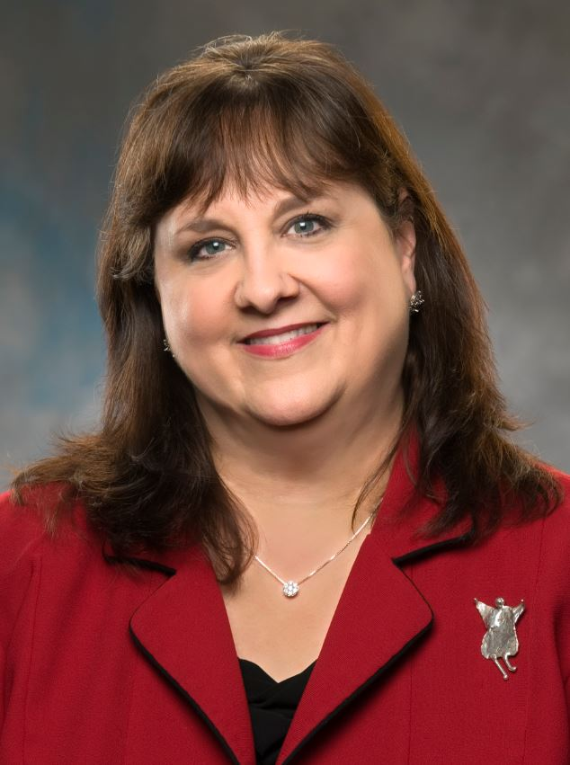

**DeNene G. Cofield, BSN, RN, CNOR**, is the vice president of perioperative services at TriStar Centennial Medical Center, Nashville, Tennessee. She earned a bachelor of science in nursing from the University of Alabama at Birmingham.

Cofield has been a perioperative nurse for 38 years and a member of AORN for 35 years. She is a member of:

* + AORN of Middle Tennessee (2014-present).

Cofield has attended Congress 10 times in the past 10 years, three times as a delegate.

Cofield has received:

* + the University of Alabama at Birmingham Recognized Leader Award (2010).

Highlights of Cofield’s service to AORN include that she is:

* + a member of the AORN of Middle Tennessee Board of Directors (2019-present),
  + a member of the AORN of Middle Tennessee Healing Hands Helping Heroes fundraising committee (2018-present),
  + a member of the AORN Executive Roundtable (2017-present), and
  + a member of the AORN/Cardinal Health Advisory Board (2018-present).

She has been:

* + president of AORN of Middle Tennessee (2018-2019) and
  + a volunteer coordinator at the AORN Global Surgical Conference & Expo, Nashville (2019).

In other leadership roles, Cofield is:

* + a reviewer for Johnson & Johnson Nurses Innovate QuickFire Challenge (2019-present).

In her community, Cofield is:

* + a volunteer for the Needs Of Our Kids organization, Franklin (2018-present).

**Election Statement**

I have been an AORN member and a perioperative nurse for 37 years. Over my career, AORN has provided so many resources allowing me to grow professionally, especially the relationships I have made through our organization. I have been devoted to the promotion of perioperative nursing using evidenced-based practice to improve the lives of patients I have directly or indirectly served. I have also observed the impact of legislative endeavors of AORN to the profession of perioperative nursing and believe this is vital as a focus in the future.

As a perioperative leader for the past 35 years, my mantra has been that we must have joy in the workplace. This only happens when we have an environment of mutual respect, a culture of safety, we have friends at work, and we work as a team in relentless pursuit of the mission. My 35 years in perioperative leadership have helped me cultivate the ability to work with diverse teams in a collaborative manner to develop and execute strategic initiatives.

I support the mission, vision, and values of AORN and am committed to promoting our profession, keeping our workforce safe through smoke/plume legislation, and promoting evidence-based care. I am a career perioperative nurse committed to continuing AORN’s legacy of excellence. It would be an honor and a joy to be elected to serve the membership on the Board of Directors.

**Candidate’s Q&A**

**1. Member surveys indicate the most common reason they do not vote is they feel they “do not know the candidates”. To help the members get to know you better, describe something you are passionate about outside of your profession as a perioperative nurse.**

I am passionate about my family and friends. I am a single mother and have a 13 year old daughter, 3 dogs, and a cat. I have many wonderful friends that keep me well rounded. I love to model my life and choices for my daughter so that she can be the very best version of herself. I try to show her what it means to be a good person, friend, citizen and volunteer in our community whether raising money for good causes or volunteering our time.

One of our favorite groups is Needs of our Kids or the NOOK. This is a group that raises money that is provided to school nurses so that they can provide anything a child may need in their assessment. I hope to make this world a better place by raising an exceptional child and teaching her the joy of giving.

**2. Describe your most meaningful day in the OR, or in the office, and how it has impacted your current practice, or work, as a nurse.**

Each day is a day to make a difference in every life you touch, whether in the operating room or in the office. The most profound clinical experiences were working as a staff RN on the transplant team. This provided me the opportunity to participate in the full circle of the gift of life. Caring for donors who made the most ultimate gift and caring for the recipients who received another chance at life.

Each day as a leader, I have the opportunity to provide mentorship to dozens of colleagues, so that they can find their passion and purpose in their healthcare careers in order for their dreams to come true. I believe this makes a difference in every life I touch. I feel privileged to provide encouragement and resources to help my colleagues reach their full potential.

**3. What, in your opinion, are the key responsibilities for a member of the Board of Directors and what experience has prepared you for this role?**

I have been in a leadership role for over 30 years and have a very positive outlook on life. I have learned how to think strategically in complex systems in order to plan for the future and achieve goals. I believe the key responsibility of the Board of Directors is to provide strategic direction for AORN to ensure a financially sound and relevant future for perioperative nursing. AORN is a premier organization that is respected around the world. As Vice President in a large organization, I utilize systems thinking daily. Keeping AORN on the leading edge of all current and future endeavors will require someone with experience in the Board room working collaboratively with diverse groups. I believe everything I have done over the last 30 years has prepared me for this task if I am privileged to be elected to the Board.

* **Linda K. Connelly, PhD, MSH, ARNP, CNOR**

**Candidate Bio**

[View Candidate Video](http://media.aorn.org/asset-3950ad7a-a6de-4d91-9bde-1896cb039a89/Expo_2020_Candidates_Linda-K-Connelly-v2.mp4?sv=2017-04-17&sr=c&si=8c755e68-d085-4cf7-a46c-99d80f311066&sig=%2B2AqvhWYR9m02hdVPuSr1A6g8GVyGPgdc4IyXR%2BxY64%3D&se=2021-02-06T21%3A04%3A37Z)

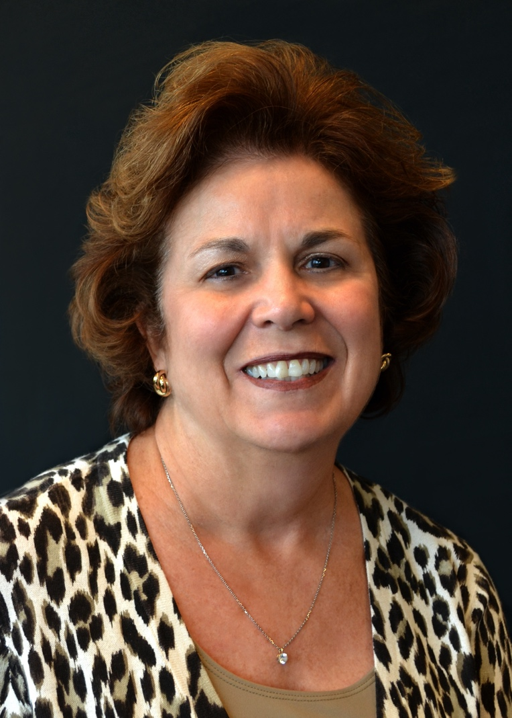

**Linda K. Connelly, PhD, MSH, ARNP, CNOR**, is a nursing professor and researcher at the University of North Florida, Jacksonville. She earned a bachelor of science in nursing, a master of science in health care, and a master of science in nursing from the University of North Florida, Jacksonville; a doctorate in nursing philosophy from Barry University, Miami Shores, Florida; a mastery certificate in health care simulation from Boise State University, Idaho; and a certificate in online teaching from the University of Illinois.

Connelly has been a perioperative nurse for 41 years and a member of AORN for 41 years. She is a member of:

* + AORN of Northeast Florida (2012-present),
  + the Florida Council of Operating Room Nurses (2012-present),
  + the Advanced Practice Nursing Specialty Assembly (2012-present), and
  + the Clinical Nurse Educator Specialty Assembly (2012-present)

Connelly has attended Congress 10 times in the past 10 years, each time as a delegate.

Connelly has received:

* + an Order of Military Medical Merit Medallion from the US Army Medical Department (2011);
  + Perioperative Nurse of the Year from the Florida Council of Operating Room Nurses (2013);
  + an Outstanding Undergraduate Teaching Award, Universiteti për Biznes dhe Teknologji Prishtina, Kosovo (2017); and
  + an AORN Outstanding Achievement in Perioperative Education, Clinical or Academic Award (2018).

Highlights of Connelly's service to AORN include that she is:

* + a peer reviewer for the AORN Journal (2013-present),
  + a member of the AORN of Northeast Florida Board of Directors (2019-present),
  + a member of the Florida Council of Operating Room Nurses Board of Directors (2019- present), and
  + chair of the Florida Council of Operating Room Nurses Student Engagement Committee (2016-present).

She has been:

* + president of AORN of Northeast Florida (2015- 2019),
  + chair of the AORN of Northeast Florida Legislative Committee (2014-2019),
  + chair of the AORN Research Committee (2014-2018),
  + a reviewer for the AORN Journal Writers’ Contest (2015-2016), and
  + chair of the Florida Council of Operating Room Nurses Nominating Committee (2016-2018).

In other leadership roles, Connelly is:

* + president of the Lambda Rho at-Large Chapter, Sigma Theta Tau International (2019-present);
  + a perioperative representative for the Quality and Unity in Nursing Council of the Florida Nurses Association (2016-present);
  + a nurse leader for the Nursing Network Division of the American Red Cross North Florida Region (2018-present);
  + a member of the Competency & Credentialing Institute (2015-present); and
  + a member of the Beaches Emergency Assistance Ministry Advisory Board (2014-present).

In her community, Connelly is:

* + a consultant for the Florida Disaster Disability Integration Team (2016-present) and
  + a consultant for Volunteer Nurses in Wellness (2013-present).

She has been:

* + a volunteer for the University of North Florida Military and Veterans Resource Center (2013-2017),
  + a volunteer for the Jacksonville Independent Living Resource Center (2016-2018), and
  + a nurse liaison for the American Red Cross North Florida Region (2013-2016).

**Election Statement**

It is with professional pride that I place my name with CNOR on the 2019 ballot. AORN is recognized as a unique, complex organization that needs leaders that ask questions aimed at uncovering possibilities, discovering what worked, what did not work, opening the discussion to a range of perspectives. I am a leader that reflects on integrity and speaks the hard truths, encouraging the membership to speak their truth. As a leader, I will focus on our members even as technology continues to gain prominence, working to perceive the membership wants and needs. Serving as part of our Board, I will generate the energy, flow of ideas, and proactively work to maintain a healthy perioperative organization. Leadership is about empowering members to share leadership with the elected Board members for the betterment of our organization. It is about members collaboratively investing in the perioperative environment, ultimately promoting a positive, self-sustaining culture based on safe perioperative care for nurses, patients, and society. My passion, knowledge, and motivation will work as a catalyst to design individual membership experiences, growing through continued membership, leadership, education, and publications. You can depend on me to envision and design individualized memberships with a sustained professional culture that assist the navigation of safe clinical decisions. I will safeguard AORN’s financial strength with innovative use of resources and by building strategic partnerships. I promise to serve AORN membership with diligence and dedication, serving as a liaison to members, committees, task forces, specialty assemblies, and the community. Thank you.

**Candidate’s Q&A**

**1. Member surveys indicate the most common reason they do not vote is they feel they “do not know the candidates”. To help the members get to know you better, describe something you are passionate about outside of your profession as a perioperative nurse.**

I have an undying passion for the poor. My passion began in high school when I made my first trip to an orphanage, to spend time, show love and support the people. Families and friends had abandoned the orphans due to their disabilities. Despite being a high school student with limited time, knowledge and financial support, I felt happier and healthier solidifying my decision to be a nurse. I still have limited time and financial support but I do now have knowledge and talent. I have learned from my continental and global missions that we need to raise the poor to a place where they are personally responsible for their own lives. We must promote independency. I have engaged in acts of charity for my entire life but I now realize my passion is truly to infuse capacity building and empowerment in my passion for the poor.

**2. Describe your most meaningful day in the OR, or in the office, and how it has impacted your current practice, or work, as a nurse.**

My biggest lesson was learning that the needs of patients and families were not always what we, the nurses, thought. One family that influenced my career were standing by the bedside of an ER stretcher praying for their ventilated 3 year old, who had suffered a head injury after falling for her tricycle. My assessment of the child elicited many clinical signs. As a young nurse thirsty for knowledge and experience I, recall how excited I was to be able to complete this clinical treasure trove exam and documentation. Months later, I learned the child had died, I reflected on this experience. I realized how brash and unsympathetic I must have seemed. My attention focused on the assessment, had eliminated the skill of empathy. From that day on, I still focused on the science of nursing but include families in the experience, reach out, and touch all of my patients.

**3. What, in your opinion, are the key responsibilities for a member of the Board of Directors and what experience has prepared you for this role?**

The board members are trustees who steer the organization towards a sustainable future by adopting sound, ethical, legal governance and financial management policies, and make sure the organization has adequate resources to advance its mission. BOD are responsible to take care of AORN by ensuring prudent use of all assets, including facility, people, and good will. However, a BOD does not exist solely to fulfill legal duties and serve as a trustee of the organization’s assets. Board members play very significant roles providing guidance by contributing to the organization’s culture, strategic focus, effectiveness, and financial sustainability, as well as serving as ambassadors and advocates. I am a retired Army Nurse Corps Colonial who served in the Office of the Surgeon General. I have extensive experience on nonprofit BOD; additionally in 2018, I participated in the Florida Center for Nursing Board Service Initiative.

* **Merideth D. Lewis, MSN, RN, CNOR**

**Candidate Bio**

[View Candidate Video](http://media.aorn.org/asset-228c1a25-66f7-49e2-ae2e-1162e7f86706/Expo_2020_Candidates_Merideth-D-Lewis-v2.mp4?sv=2017-04-17&sr=c&si=4fe8f028-5b8e-42c3-b882-704b6eecdb35&sig=vSs%2FH7pX5wNKGTDWx8e4vE6P6cFuiCgUpBupSpDlq18%3D&se=2021-02-06T21%3A06%3A23Z)

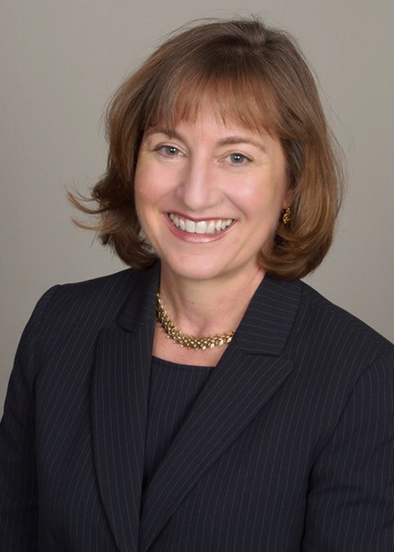

**Merideth D. Lewis, MSN, RN, CNOR**, is a clinical nurse III at California Pacific Medical Center (CPMC), Davies Campus, San Francisco. She earned a bachelor of science in nursing from the University of San Francisco, California, and a master of science in nursing in health policy from the University of California, San Francisco.

Lewis has been a perioperative nurse for 16 years and a member of AORN for 16 years. She is a member of:

* + AORN of San Francisco & Marin (2010-present),
  + eChapter (2016-present),
  + AORN of Northwest Georgia (2013-present),
  + the Clinical Nurse Educator Specialty Assembly (2016-present), and
  + the Leadership Specialty Assembly (2010-present).

Lewis has attended Congress 10 times in the past 10 years, each time as a delegate.

Highlights of Lewis’ service to AORN include that she is:

* + a member of the AORN Global Relations Committee (2019-present),
  + a member of the AORN National Membership Committee (2016-present), and
  + the regional coordinator for the AORN National Membership Committee Forum (2017-present).

She has been:

* + chair of the AORN of San Francisco & Marin Nominating Committee (2017-2018),
  + a member of the AORN Nominating and Leadership Development Committee (2014-2016),
  + co-chair of the AORN Young Professionals Task Force (2013-2014),
  + president of AORN of San Francisco & Marin (2012-2013, 2016-2017), and
  + a preceptor for Periop 101 (2010-2013).

In other leadership roles, Lewis is:

* + a member of Sigma Theta Tau (2010-present),
  + coordinator for Sutter Health’s AORN Guideline Implementation workshops (2017-present), and
  + an inservice coordinator at CPMC, Davies Campus, San Francisco (2017-present).

She has been:

* + a Thoracic Service Line Leader at California Pacific Medical Center (2010-2014) and
  + co-chair of the Innovation & Evidence Based Council at CPMC, Pacific Campus, San Francisco (2010).

In her community, Lewis is:

* + a member of her neighborhood association (2016-present) and
  + a volunteer for the American Red Cross (2017-present).

She has been:

* + a speaker at Mercy High School for Career Days (2017),
  + a member of the Daughters of the American Revolution (2010-2014), and
  + a participant in Walk MS in San Francisco (2017).

**Election Statement**

We, as perioperative nurses, care for our patients by taking in multiple layers of complex information. We then act decisively, as a team, with that knowledge. I love that challenge! These collaborative skills are essential in moving our organization forward, whether we are at the OR table or the policy table. What I bring to AORN is a synthesized and seasoned view of perioperative nursing that encompasses clinical, academic, and leadership experience at the local level and in our global perioperative community. This past summer, I was privileged to serve as an intern at the World Health Organization in Geneva, Switzerland, during my master’s program. There I witnessed and experienced communicating our vision and value as nurses and was able to bring several departments together around a common goal. Capacity building for nursing and surgical care is ongoing.

I am determined, innovative, and tireless when it comes to supporting AORN and global perioperative nursing. I reflect and embody the mission, vision, and values of AORN. I will articulate, promote, and engage in discussion that will ensure your voice is heard. I am perceptive and thoughtful, creative and effective. I listen deeply and am diplomatic and respectful.

Together we have impact. Together we advance not only our Association, but our entire profession. When one of us moves forward, we all move forward! It would be my honor and privilege to continue to contribute a legacy of service, leadership, and excellence to our Association as a member of the Board of Directors.

**Candidate’s Q&A**

**1. Member surveys indicate the most common reason they do not vote is they feel they “do not know the candidates”. To help the members get to know you better, describe something you are passionate about outside of your profession as a perioperative nurse.**

I am passionate about community. Wherever I live, getting to know my neighbors is always important to me. Not only because I enjoy others, but because knowing who lives next door can be life-changing and life-giving. The tradition of the “neighborliness” modeled to me by my parents extended into my adulthood. Some of my neighbors have become some of my dearest friends. Over the years, we have had times to celebrate births, plant trees on our street and protect each other’s homes from disaster. We even put a new fence with a gate between the back yards of our old and new home so my children could visit Aunt Vera & Uncle Lance along with all their memories. We looked after each other’s pets, children and got to know each other’s parents. We celebrated milestones and grieved losses together. Knowing and connecting with those around you is a true blessing!

**2. Describe your most meaningful day in the OR, or in the office, and how it has impacted your current practice, or work, as a nurse.**

When I look back over the years, my most meaningful days have been the days that I know I really made a difference in someone’s life; sometimes a patient, sometimes a colleague. So many days stand out! One of those times was the first time I ever scrubbed in. I was on the moon! Eager to go, yet with a healthy dose of nerves and apprehension, my mentor not only instilled confidence in ME, but in our entire TEAM. Her calm guidance, reassurance and positive attitude allowed me to succeed. I have taken her example of grace, patience and humility with me as I have become a mentor and teacher. There is nothing more wonderful than walking away from a job well done by a new team member, knowing that you helped to launch another perioperative nurse, knowing that you helped someone else succeed. We truly move each other forward!

**3. What, in your opinion, are the key responsibilities for a member of the Board of Directors and what experience has prepared you for this role?**

Key responsibilities are to know our AORN Mission, Vision and Values and be able to use them as a compass to guide and inform our association’s growth and direction. The skills of diplomacy, right action and consensus building are essential. In particular, networking and synthesizing were invaluable during my two-month internship at the World Health Organization. Comments at the end of my tenure included my ability to bring several departments together around a common goal. I have had the opportunity to develop my leadership skills through personal and professional experiences, notably with AORN and as an intern. Being a natural networker who can synthesize complex, multi-layered situations and information gives me the strong foundation required of a leader. My personality, past training and present-day commitment to the Nursing Profession, AORN and my own life goals poise me to be an innovative and collaborative member of the AORN Board of Directors.

* **Brandy L. Miller, MHA, MSN, RN, CNOR**

**Candidate Bio**

[View Candidate Video](http://media.aorn.org/asset-12e01a54-22c4-499e-ad17-6330c03907fb/Expo_2020_Candidates_Brandy-L-Miller-v2.mp4?sv=2017-04-17&sr=c&si=f136dc2a-1965-42d4-9157-eb21ef0a1e36&sig=A0fnhaP3a8B7AYSVSQyZkSvSOywawI%2BT5wyilFP2PhM%3D&se=2021-02-05T20%3A05%3A59Z)

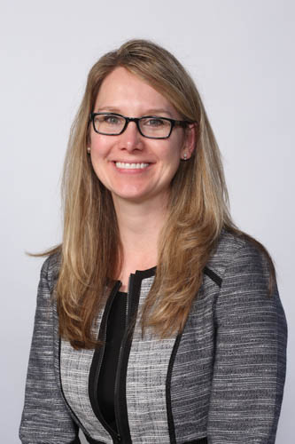

**Brandy L. Miller, MHA, MSN, RN, CNOR**, is the director of The Surgery Center, Fort Wayne, Indiana. She earned an associate’s degree of science in nursing and associate’s degree of arts in psychology from Parkland Community College, Champaign, Illinois; a bachelor of science in nursing from Olivet Nazarene University, Bourbonnais, Illinois; a master of science in nursing from Indiana Wesleyan University, Marion; and a master of business in health care administration from the University of Saint Francis, Fort Wayne, Indiana.

Miller has been a perioperative nurse for 20 years and a member of AORN for 20 years. She is a member of:

* + AORN of Fort Wayne (2010-present),
  + the Ambulatory Surgery Specialty Assembly (2010-present),
  + the Leadership Specialty Assembly (2010-present),
  + the Pediatric Specialty Assembly (2010-present), and
  + the Sterile Processing/Supply Chain Management Specialty Assembly (2011-present).

Miller has attended Congress seven times in the past 10 years, each time as a delegate.

Miller has received:

* + an OR Excellence Award for Financial Management, Outpatient Surgery Magazine (2017).

Highlights of Miller’s service to AORN include that she is:

* + a member of the AORN of Fort Wayne Board of Directors (2019-present).

She has been:

* + chair of the AORN Nominating Committee (2017-2018),
  + a member of the AORN Nominating Committee (2016-2018),
  + a member of the AORN National Leadership Task Force (2015-2016),
  + president of AORN of Fort Wayne (2010-2011, 2016-2017),
  + a member of the AORN of Fort Wayne Board of Directors (2011-2014), and
  + treasurer of AORN of Fort Wayne (2010).

In other leadership roles, Miller has been:

* + a member of the Nurse Advisory Council at the University of Saint Francis, Fort Wayne, Indiana (2013-2014);
  + a member of the American College of Healthcare Executives (2014-2019);
  + a member of the American Nurses Association (2010-2019); and
  + a member of Sigma Theta Tau International (2010-2019).

In her community, Miller is:

* + a member of 100+ Women Who Care Fort Wayne Chapter (2014-present);
  + a volunteer for Redemption House, Fort Wayne, Indiana (2016-present); and
  + a donor for Redemption House, Fort Wayne, Indiana (2016-present).

**Election Statement**

AORN is the cornerstone for excellence in perioperative nursing. Steeped in evidence-based guidelines focused on enhancing perioperative quality of care, membership resources, and opportunities for connectivity, AORN is synonymous with excellence in both patient safety and perioperative professional development.

My 20 years of perioperative experience has positioned me as a highly diverse candidate. My nursing diversity includes experience in both clinical and administrative platforms, travel nursing and permanent work placements, inpatient and ambulatory settings, as well as profit and nonprofit work environments. My career diversity is complemented with such personal skills as intent listener, effective communicator, strategic thinker, creative implementer; I possess a strong work ethic as well as enjoy personal and professional motivation of self and others.

As a new member of the Board, I will first seek to understand on an administrative level our current business initiatives and ventures, product lines, future projections, policy agendas, and how each element aligns with our core focus of meeting membership needs. I will then pursue the best opportunities to collaborate with my peers and fellow Board members to integrate my experience and skill sets for the promotion of our professional Association and meeting membership needs.

I am passionate and committed to AORN. I value and appreciate the opportunity you have provided me to be a candidate for our national Board of Directors, and now ask that you allow me the opportunity to be your advocate; I seek your support and vote as a member of AORN’s national Board of Directors.

**Candidate’s Q&A**

**1. Member surveys indicate the most common reason they do not vote is they feel they “do not know the candidates”. To help the members get to know you better, describe something you are passionate about outside of your profession as a perioperative nurse.**

I am passionate about being engaged with those whom I have a commonality with. For example, three years ago, I moved into my current home/neighborhood. During this time frame, I have intentionally engaged with and met someone from every home within a two block radius of my residence. If someone new moves into ‘my residence radius’, I bring them a bottle of wine with a hand-written note welcoming them into the neighborhood. I hand deliver Christmas cards, Halloween bags and Easter bags to 60 homes, individually acknowledging over 40 children in my neighborhood- wishing each one a happy holiday and letting them know they are seen, valued and appreciated for just being them.

**2. Describe your most meaningful day in the OR, or in the office, and how it has impacted your current practice, or work, as a nurse.**

I have had so many meaningful days in my 20 years of perioperative experience that have shaped and forged me into the professional nurse and leader I am today, choosing one has been difficult- so I will share my most recent. Last week, I was called to recovery to assist one of my nurses. Our joint assessment was patient compensation for internal post-operative bleeding. Through our persistent communication with the surgeon and anesthesia, we were able to get the patient back into surgery in a timely manner where an arterial ooze was identified and corrected. The patient was stabilized with best case scenario outcomes. As I dragged my exhausted self and aching feet home at the end of the unexpected 16-hour day, I went home with the most gratifying and consuming sense of fulfillment, knowing I had advocated and empowered my nurse and for our patient’s highest quality of care.

**3. What, in your opinion, are the key responsibilities for a member of the Board of Directors and what experience has prepared you for this role?**

Key responsibilities for a member of the Board of Directors includes managing the affairs of the Association, strategic planning and communication. All my years as a perioperative nurse delegating resources, advocating for patients, coordinating schedules and communicating with members of the perioperative and interdisciplinary teams have developed a strong foundation to prepare me for the role of Board of Directors. Additionally, effectively applying my formalized education over the last nine years as a perioperative administrator with fiscal responsibilities, enhancing stakeholder engagements, developing, implementing, and achieving strategic and operational plans while concurrently meeting regulatory compliances has provided me with a diversity of administrative professional proficiency. I strive for clear, concise communication and believe listening is the most important component of communication.

* **Kristy P. Simmons, MSN, RN, CNOR**

**Candidate Bio**

[View Candidate Video](http://media.aorn.org/asset-900d0d72-4901-4920-9433-b1b9ef1c1ad5/Expo_2020_Candidates_Kristy-P-Simmons-v2.mp4?sv=2017-04-17&sr=c&si=45f47c32-809d-436c-8769-2e7329aa6acd&sig=3qqGG%2Fqjp6NhzEKikMHqTv61UFZgpvjj9ZfVrq9btk8%3D&se=2021-02-06T21%3A03%3A44Z)

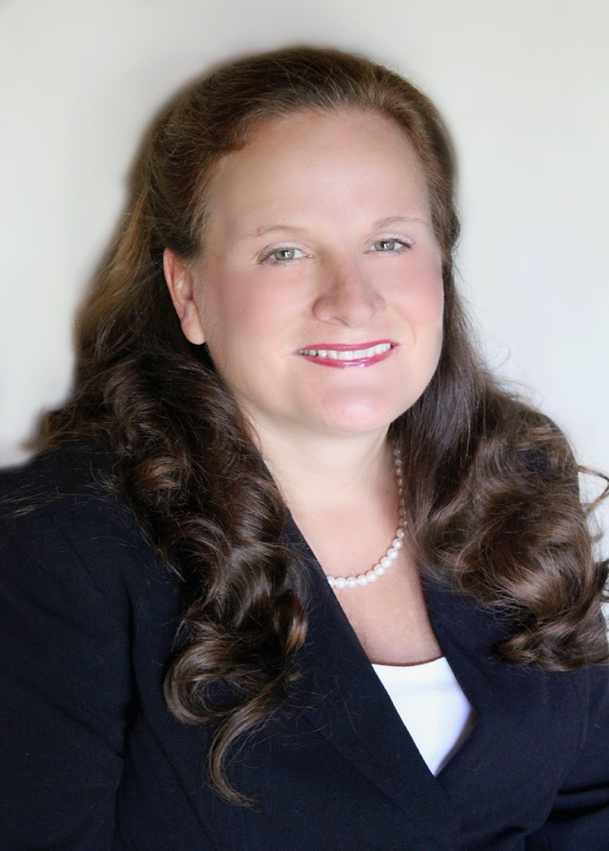

**Kristy P. Simmons, MSN, RN, CNOR**, is the pediatric team leader at Woman’s Hospital, Baton Rouge, Louisiana. She earned a diploma in nursing from Our Lady of the Lake College School of Nursing, Baton Rouge, Louisiana; a bachelor of science in nursing from Loyola University, New Orleans, Louisiana; and a master of science in nursing from Southeastern Louisiana University, Hammond.

Simmons has been a perioperative nurse for 36 years and a member of AORN for 31 years. She is a member of:

* + AORN of Baton Rouge Area (2010-present),
  + the Louisiana State Council (2010-present),
  + the Pediatric Specialty Assembly (2010-present),
  + the Leadership Specialty Assembly (2017-present), and
  + the Ambulatory Surgery Specialty Assembly (2017-present).

Simmons has attended Congress 10 times in the past 10 years, each time as a delegate.

Simmons has received:

* + the ANCC Magnet Nurse of the Year Award for Exemplary Professional Practice (2011),
  + the AORN National Outstanding Volunteer Leadership Award (2014),
  + the AORN National Outstanding Achievement in Perioperative Evidence-Based Practice Award (2014), and
  + the AORN of Baton Rouge Area Perioperative Nurse of the Year Award (2015).

Highlights of Simmons’ service to AORN include that she is:

* + a member of the Pediatric Specialty Assembly Coordinating Council (2010-present),
  + Board liaison to the AORN Awards Committee (2018-present),
  + Board liaison to the Ambulatory Surgery Specialty Assembly (2018-present),
  + a representative for the AORN Silent Auction for Louisiana AORN Chapters (2012-present), and
  + a member of the AORN News Advisory Group (2015-present).

She has been:

* + chair of the Louisiana State Council Governing Council (2015-2017),
  + a member of the Nominating and Leadership Development Committee (2015-2017),
  + chair of the AORN National Membership Committee (2014-2015),
  + a member of the AORN National Taskforce for AORN Access (2010-2013), and
  + president of AORN of Baton Rouge Area (2011-2012, 2015-2016).

In other leadership roles, Simmons is:

* + chair of the ANCC Magnet Champion Committee, Woman’s Hospital, Baton Rouge (2010-present);
  + a member of American Nurses Association (2010-present); and
  + research coordinator for the Surgical Services Research Committee, Woman’s Hospital, Baton Rouge (2018-present).

She has been:

* + a member of the Honor Society of Nursing, Sigma Theta Tau International (2012-2015); and
  + a member of the Louisiana State Nurses Association (2015-2017).

In her community, Simmons is:

* + a volunteer for the Louisiana State University Medical Brigade (2015-present);
  + chair of Race for the Cure annual fundraiser, Woman’s Hospital Surgical Services (2010-present); and
  + chair of the College and Career Day Medical Segment, Corban Junior High School (2010-present).

She has been:

* + president of the Parent Teacher Organization, Central Middle School (2010-2013); and
  + a member of the School Improvement Team Governing Board, Central High School (2011-2013).

**Election Statement**

Experience matters. The past two years I have served as an AORN Board member have been invaluable in my growth as an effective Board member. In my leadership journey, I am constantly working to improve my skills to communicate effectively and to inspire passion in others.

Our local chapters are the foundation of AORN, and we need to continue to support them at the national level. We need to reinforce the need to be passionate, ready to cross boundaries, and embrace innovative ideas as we develop the strategic and tactical plans. The experience I now have at the local, state, and national levels will enable me to represent the interests of the organization as well as the true nucleus of AORN—the individual perioperative professionals.

Each generation, each chapter, and each member of AORN needs something different from our organization. Our 20/20 vision of our future requires leaders who can communicate across boundaries and engage members in ways that they understand and respond to. As a member of the Baby Boomer generation, colleague of Generation X, mother of the Millennial generation, and grandmother of the latest generation, I speak the language and use the methods of each group on a daily basis. We must develop and support new methods and media to educate, inform, and inspire both our newer and our established members. If elected, I can continue to draw upon my unique perspective to synergize these ever-changing wants and needs for the benefit of the individual and the organization.

**Candidate’s Q&A**

**1. Member surveys indicate the most common reason they do not vote is they feel they “do not know the candidates”. To help the members get to know you better, describe something you are passionate about outside of your profession as a perioperative nurse.**

I am a storyteller and treasure collector at heart. My grandparents inspired my interest in collecting old coins and stamps. For some reason my grandparents collected ceramic roosters. Since no one in the family wanted them and I could not part with them, they are now in my dining room. When visitors ask about them it brings back great memories and I smile as I share their story.

I also am a “junkie.” I would rather go to a junk store or find a treasure on the side of the road than go shopping at the grandest mall. Of course, I love to share stories of how I found my treasures, how I brought them back to life and sometimes explain what they are. So if you are ever driving behind me and you see a treasure pile on the side of the road, be aware! I make frequent stops!

**2. Describe your most meaningful day in the OR, or in the office, and how it has impacted your current practice, or work, as a nurse.**

We all have cases that haunt us. The patient care story that has most impacted my perioperative practice occurred in my first year as a perioperative nurse. I was called out with two other orientees for an emergency case. We were all nervous since it was our first “solo.”

During the preop interview my patient stated she was worried she was going to die during surgery. I assured her we would take good care of her and brushed off her worries and intuitions of death. I was worried about getting the OR room ready and making sure we did everything right. During surgery the patient coded and we could not revive her. In the midst of the code I remembered her concerns over impending death. I still feel guilty to this day that I did not take time to listen to her concerns. This experience made me a better listener.

**3. What, in your opinion, are the key responsibilities for a member of the Board of Directors and what experience has prepared you for this role?**

Serving on the board of directors is a call to serve the professional practice needs of our members. From my experience in the past two years serving on the board, I think there is only one key responsibility as a member of the Board of Directors: to remember why you are there in the first place. Our AORN members voted for me to be their representative to fulfill the purpose and mission of our organization; to promote safe patient care by providing practice support and professional development opportunities to all perioperative nurses. I listen to the wants and needs of our members and consider these when I cast my vote on each decision and action of the board. I believe past experience matters and I am not afraid to ask the tough questions that need to be answered and I would like to continue to serve as your board member.

* **Kristy A. Wheeler, MSN, RN, CNOR (self-nominated by petition)**

**Candidate Bio**

[View Candidate Video](http://media.aorn.org/asset-e87ef6af-ec41-4036-84b9-6d48187f2779/Expo_2020_Candidates_Kristy-A-Wheeler-v3.mp4?sv=2017-04-17&sr=c&si=c79be0f3-6f74-4b4a-919b-66d9942ce745&sig=5jHBjfnd2%2F4iUAF06yD8aq9owJJgr4%2BEZS27RphKjY4%3D&se=2021-02-06T21%3A09%3A18Z)

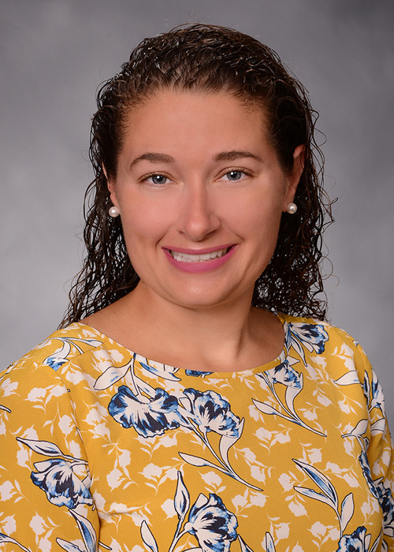

**Kristy A. Wheeler, MSN, RN, CNOR (self-nominated by petition)**, is the OR surgical scheduling coordinator and service line coordinator of Acute Care Emergency Surgery at the University of Maryland Medical Center (UMMC), Baltimore. She earned an associate of arts from the Community College of Baltimore County, Maryland; a bachelor of science in nursing from Coppin State University, Baltimore, Maryland; and a master of science in nursing from the University of Maryland School of Nursing, Baltimore.

Wheeler has been a perioperative nurse for eight years and a member of AORN for seven years. She is a member of:

* + AORN of Baltimore (2012-present),
  + the Leadership Specialty Assembly (2013-present),
  + the Pediatric Specialty Assembly (2016-present), and
  + the Ambulatory Surgery Specialty Assembly (2016-present).

Wheeler has attended Congress seven times in the past 10 years, each time as a delegate.

Wheeler has received:

* + an AORN Forty Under 40 Award (2017),
  + an AORN Young Professional Award (2016),
  + a UMMC Nursing Award of Excellence Service (2015),
  + a Gold Star Award from Mercy Medical Center (2013), and
  + a McCauley Gold Award (2012).

Highlights of Wheeler’s service to AORN include that she is:

* + chair-elect of the Leadership Specialty Assembly (2019-present),
  + co-chair of Communications for the Leadership Specialty Assembly (2019-present),
  + president-elect of AORN of Baltimore (2019-present),
  + a Journal Correspondent for Periop Briefing (2018-present), and
  + chair of AORN of Baltimore Mentorship/School of Nursing Outreach (2015-present).

She has been:

* + a member of the AORN of Baltimore Board of Directors (2017-2019),
  + a mentor for the AORN Foundation (2017-2018),
  + a member of the AORN Journal Next Generation Advisory Board (2017-2018),
  + chair of the Nominating and Leadership Development Committee (2015-2017), and
  + president of AORN of Baltimore (2014-2015).

In other leadership roles, Wheeler is:

* + a member of the UMMC Joint Commission Tracer Committee (2018-present) and
  + a cohort facilitator for UMMC, Baltimore (2019-present).

She has been:

* + a member of the Maryland Association of Surgical Technologists Board of Directors (2012-2014);
  + the facility coordinator for the UMMC AORN Go Clear Program (2018-2019); and
  + chair of the Falls Prevention Committee, Mercy Medical Center (2013-2014).

In her community, Wheeler has been:

* + a large group leader for Mt Kidmore, Mountain Christian Church (2010-2018);
  + a children’s ministry nurse for Mt Kidmore, Mountain Christian Church (2010-2018);
  + a volunteer for a mission trip to Houston, Texas, with Mountain Christian Church (2017);
  + a volunteer for a mission trip to Kenya with Mountain Christian Church (2011, 2013); and
  + a student mentor at Mercy High School (2012-2013).

**Election Statement**

I am excited for the opportunity to run for the Board of Directors. I have experienced the value of AORN resources in the care I deliver every day and feel strongly that AORN is strengthened from the input of those from the work settings. Across the county to across the globe our fellow comrades turn to AORN for guidance and wisdom to provide the best care for our patients. I want to be able to continue to deliver resources for future perioperative nurses to meet today’s needs and tomorrow’s. I have a demonstrated ability to work at the local chapter and national levels as an AORN leader and partner. I really enjoy mentoring nursing students in the OR, so I worked with my chapter to create a successful outreach program with schools of nursing. We go to local schools of nursing to speak about what perioperative nursing is, which has made a big impact in the recruitment of nurses. When elected, I would like to see this program and others spread through AORN and help grow our AORN membership and impact on patient care. At the national level, I was elected to the Nominating Committee and chosen to chair the committee the second year that I served. I continue to serve on both local and national committees as well as specialty assemblies. I am ready, experienced, and excited to work for you as a member of your Board of Directors.

**Candidate’s Q&A**

**1. Member surveys indicate the most common reason they do not vote is they feel they “do not know the candidates”. To help the members get to know you better, describe something you are passionate about outside of your profession as a perioperative nurse.**

Outside of the OR, I am passionate about giving back to those less fortunate. It energizes my soul. In 2011, I had a life changing opportunity to be a part of a mission trip to Kenya. I was working at a school in a poverty-ridden area, providing community health services. The school also had a child sponsorship program. During my time there I decided to sponsor a child named Jeremiah. We were given time to talk via a translator. During the two years that followed we kept in touch by writing letters. In 2013, when I returned to Kenya he appeared to be as happy to see me as I was to see him. I continue to write to him, as helping him brings such joy to my heart. Since then, I have gone on three additional missions. My fifth mission trip is being planned currently for March to Cuba.

**2. Describe your most meaningful day in the OR, or in the office, and how it has impacted your current practice, or work, as a nurse.**

Most days in Shock Trauma were meaningful because I met people on the worst day of their lives. One instance that stood out was when a young man with a spider bite infection on his foot was transferred from an outside hospital. They wanted to amputate his foot. I knew he had been through a lot already so I decided to just hold his hand and let him tell me his story. He had to have serial surgeries in an attempt to save the foot. During one of his trips to the OR, my lunch relief came. I delayed my break so that I could introduce him to my relief and told him I would return. Later that day another nurse stopped me to inform me that when he saw my face she saw all his fears dissipate. Sometimes simple gestures make a huge difference. And we saved his foot.

**3. What, in your opinion, are the key responsibilities for a member of the Board of Directors and what experience has prepared you for this role?**

The key responsibilities of a Board of Director member is to be the voice of the membership, to ask the tough questions, and keep us moving forward as an organization. I have prepared for this role through my education, leadership positions in my organization and my continued growth in AORN. I began my career as a surgical technologist and now I am a Senior Clinical Nurse and Service Coordinator, as well as the Scheduling Coordinator Perioperative Services at a large academic medical center with a master’s degree. I was elected to the NLDC/nominating committee and chose to chair the committee the second year. I facilitated the Go Clear Award for University of Maryland Medical Center and I am involved in leading Maryland to be a smoke free state. I continue to serve on local and national committees and specialty assemblies. My dedication and ambition speak to my commitment to AORN.

Nominating Committee (Three to Be Elected)

* **Sarah Bosserman, MSN, RN, CNOR**

**Candidate Bio**

[View Candidate Video](http://media.aorn.org/asset-044c7de0-78d6-4b41-8561-c5601a359468/Expo_2020_Candidates_Sarah-Bosserman-v2.mp4?sv=2017-04-17&sr=c&si=3abdf1dd-0de7-49fa-b660-c83489cfeb26&sig=RlzoLxHtKmXPdvq8EWFJgK%2BGUGXIADBDqun8VdLiTL0%3D&se=2021-02-06T21%3A07%3A58Z)

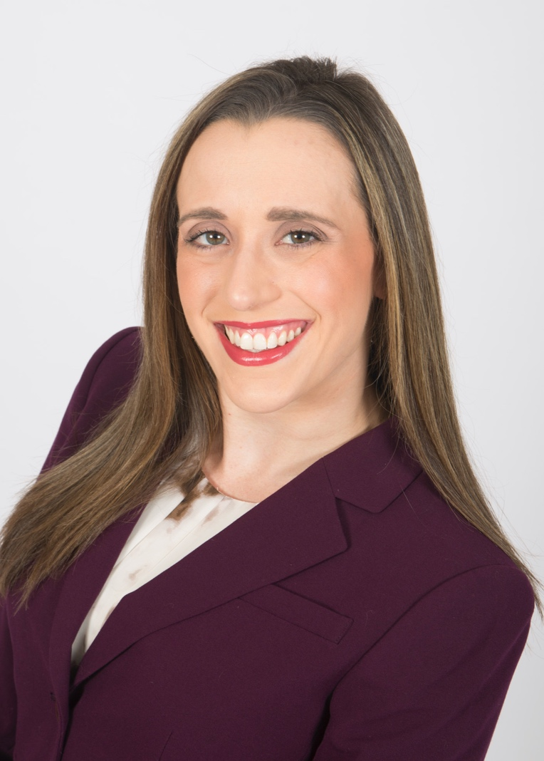

**Sarah Bosserman, MSN, RN, CNOR**, is perioperative clinical nurse educator at WellSpan Health at WellSpan York Hospital, Pennsylvania. She earned a bachelor of science in nursing from York College of Pennsylvania and a master of science in nursing from The Pennsylvania State University, University Park.

Bosserman has been a perioperative nurse for nine years and a member of AORN for nine years. She is a member of:

* + AORN of Central Pennsylvania (2011-present) and
  + the Clinical Nurse Educator Specialty Assembly (2016-present).

Bosserman has attended Congress five times in the past 10 years, one time as a delegate.

Bosserman has received:

* + a Top 40 Under Forty Award (2017) and
  + an AORN Clinical Improvement Poster Award (2019).

Highlights of Bosserman's service to AORN include that she is:

* + a member of the AORN Fellowship Level of Membership Task Force (2018-present),
  + co-chair of the Clinical Nurse Educator Specialty Assembly Professional Practice Issues Committee (2019-present),
  + education chair of AORN of Central Pennsylvania (2017-present), and
  + member of the AORN of Central Pennsylvania Board of Directors (2018-present).

She has been:

* + an instructor for Prep for CNOR Live (2017-2019).

In other leadership roles, Bosserman is:

* + a member of the Governance Committee for the Sigma Eta Chapter (2019-present) and
  + a fellow of the Nurse Leadership Academy for WellSpan Health (2019-present).

She has been:

* + chair of the Leadership Succession Committee for the Sigma Eta Chapter (2017-2019),
  + a CNOR coach for the Competency & Credentialing Institute (2016-2018), and
  + a fellow for Evidence-Based Practice & Research for WellSpan Health (2015-2016).

In her community, Bosserman is:

* + a perioperative professional presenter, York College of Pennsylvania (2013-present);
  + a perioperative presenter, Dallastown Area High School Career Day (2011-present);
  + a ladies auxiliary member of the Veterans of Foreign Wars (2010-present); and
  + a member of the Elks Lodge Benevolent and Protective Order of Elks #213 (2017-present).

She has been:

* + a volunteer for the York County Young Women’s Leadership Conference (2016-present).

**Election Statement**

I am a perioperative clinical nurse educator and a motivated, dynamic, transformative leader. My involvement in health care and the perioperative arena ranges from the local to the national level. Having had the opportunity to travel across the country educating fellow perioperative nurses, I have been able to network with the membership, tackle issues facing our perioperative specialty, and disseminate creative educational methods to enhance quality and safe care methods. I have been raised with the belief that you never leave a job until it is done right. Members—we still have much work to do to improve the care of our patients and that of our perioperative members. It is the responsibility of the Nominating Committee to produce a balanced slate of leaders who are committed to all perioperative members and are representative of the membership. We need all generations, levels of experience, and types of experience to create the diverse team of our future leaders. I will search for the owners who represent you, the mission of perioperative nursing, and are capable of and willing to do the work to enhance our profession.

I am running for the Nominating Committee because I am a great leader, team member, and advocate for our AORN membership. I need your help and your vote to make my dream of positively enhancing the future our profession a reality.

**Candidate’s Q&A**

**1. Member surveys indicate the most common reason they do not vote is they feel they “do not know the candidates.” To help the members get to know you better, describe something you are passionate about outside of your profession as a perioperative nurse.**

My passion is my family. In September of 2018 my mom was diagnosed and underwent surgery for stage 3c melanoma of the head and neck. Through multiple procedures, infections, immunotherapy, testing, and multitude of doctor appointments, we stood together as a family. Being the only child and nurse in the family, I stepped in to interpret the complicated medical jargon, provide wound care for my mom, and advocate for her overall health and personal needs and wishes. Through this journey, I better understood the misconceptions surrounding the causes and diagnosis of melanoma, as well as the lack of educational and medical supply resources in our local community. Alongside my mom, we both became certified melanoma educators and started a charitable organization for our community in order to provide medical supplies to cancer patients, assist in education funding for a local college, and provide melanoma education to the community at large.

**2. Describe your most meaningful day in the OR, or in the office, and how it has impacted your current practice, or work, as a nurse.**

On one memorable day, a fellow colleague decided to divulge his personal medical issues to our surgical team. He begged all of us that in the event of a cardiac arrest, he did not wish to be resuscitated, due to his extensive cardiac history. Staff in the room were insistent that they would like the opportunity to provide him life-saving support. Frustrated, he kept insisting his wishes. I asked him if I could do one thing for him, by holding his hand and hugging him as he passed. I still remember the look of astonishment on his face as he said, “Thank you—you get it!”

This day I recognized how simple gestures can be the most impactful pieces of care I could provide to someone. I share this story with new staff, reminding them to focus more on the patient’s unique needs than the complexities of the workload.

**3. Identify the two most important things you feel need to be part of the candidate selection process.**

The two key features of the candidate selection process should include the candidate’s relatability and their innovation skills. Candidates should be current and professionally relatable to the perioperative specialty. They should be able to speak to current practice trends and opportunities for safer care. However, candidates must have personal relatability with their perioperative colleagues beyond the confines of their local community. Personal relationships of trust and acknowledgement need to be built to ensure the candidate can speak for the membership on national and global levels. Most importantly, the selection process should evaluate a candidate for ability to think outside the box. There should be a focus on quality improvement both through research and evidence-based practice, but also through clinical improvement projects promoting the safety of patients and perioperative staff. A creative, innovative candidate is vital in driving positive transformations in perioperative nursing and our professional organization.

* **Amy Brunson, MSN, RN, CNOR**

**Candidate Bio**

[View Candidate Video](http://media.aorn.org/asset-31478ddb-327f-4ee3-8734-ec89e53fb7e4/Expo_2020_Candidates_Amy-Brunson-v2.mp4?sv=2017-04-17&sr=c&si=fd2be931-522a-47f4-86a2-4fb51f04c75c&sig=5qSvqiTDsm1XRrRzbLQewH0ocZWt7a5xNGv4eK4yVa4%3D&se=2021-02-05T20%3A05%3A11Z)

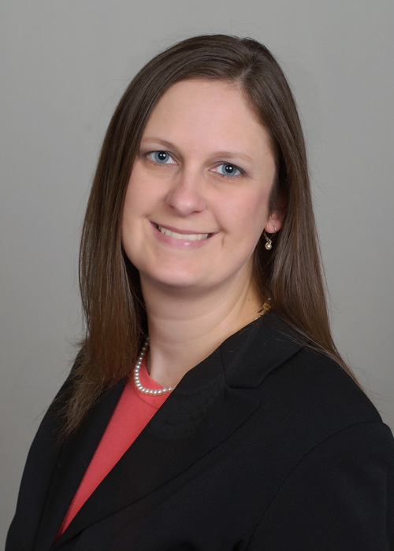

**Amy Brunson, MSN, RN, CNOR**, is an OR nurse manager at Baylor Scott & White Medical Center – Temple, Texas. She earned a bachelor of science in biomedical science and a bachelor of science in nursing from Texas A&M University, College Station, and a master of science in nursing from Western Governors University, Salt Lake City, Utah.

Brunson has been a perioperative nurse for nine years and a member of AORN for seven years. She is a member of:

* + AORN of Central Texas (2015-present),
  + the Leadership Specialty Assembly (2015-present), and
  + the Clinical Nurse Educator Specialty Assembly (2015-present).

Brunson has attended Congress five times in the past 10 years, each time as a delegate.

Brunson has received:

* + a Baylor Scott & White Health Excellence Award (2018),
  + a Western Governors University Excellence Award (2018), and
  + a Baylor Scott & White Central Texas Region Top 25 Nurse Award (2016).

Highlights of Brunson’s service to AORN include that she is:

* + a member of the Clinical Nursing Practice Committee (2019-present) and
  + a member of the AORN of Central Texas Board of Directors (2017-present).

She has been:

* + president of AORN of Central Texas (2015-2017);
  + president-elect of AORN of Central Texas (2014-2015);
  + a member of the AORN of Central Texas Board of Directors (2013-2014); and
  + a poster presenter at the AORN Global Surgical Conference & Expo, Nashville (2019).

In other leadership roles, Brunson is:

* + a member of the Lone Star Organization of Nurse Executives Chapter of the Texas Organization of Nurse Executives (2019-present) and
  + a member of the Psi Upsilon Chapter of the Sigma Theta Tau International Honor Society of Nursing (2018-present).

She has been:

* + chair of the Nursing Excellence Quality & Patient Safety Council at Baylor Scott & White Medical Center – Temple (2017-2018),
  + a member of the Magnet Champion Council at Baylor Scott & White Medical Center – Temple (2016-2018), and
  + chair of the Clinical Practice & Competency Committee for the OR at Baylor Scott & White Medical Center – Temple (2014-2017).

In her community, Brunson is:

* + a volunteer for Katolicka Jednota Zen Texaskych, Junior Society of Saints Cyril & Methodius Catholic Church (2018-present) and
  + a volunteer for the annual picnic fundraiser for Saints Cyril & Methodius Catholic Church (2013-present).

She has been:

* + a coach for the 12 and under softball team, Cameron Girls Softball Association (2013-2014);
  + a coach and co-founder of the 14 and under select softball team, the Central Texas Velocity (2014-2015); and
  + a religious education teacher for Saints Cyril & Methodius Catholic Church (2015-2017).

**Election Statement**

At the core of every perioperative nurse is the desire to provide safe patient care. With AORN’s resources and leadership, perioperative nurses are empowered to speak up as a patient advocate and drive the perioperative team to achieving zero harm. Communication is a key component of patient safety, and a breakdown in communication can adversely affect patients and staff members. As a leader and manager in the OR, I strive to effectively communicate with all team members on patient safety issues. As an AORN leader, I am dedicated to finding new ways to communicate with all members and advocate for patient and workplace safety. I am passionate about caring for others through transparent, authentic, effective communication, which begins with listening.

The AORN core values of communication, innovation, quality, and collaboration are the same values I strive to achieve as I work in my department, facility, and chapter. As a leader, I enjoy working with my team to develop their talents and passions. My commitment to you, the member, is to serve AORN by listening to your concerns, diverse opinions, and suggestions and to fill a full slate of qualified candidates willing to take the members’ ideas and run with them to continue to advance AORN into the future. I am committed to educate and empower nurses by sharing AORN’s resources and opportunities for personal and professional growth. I am honored to be a candidate for the Nominating Committee, and I am devoted to serving you and our Association.

**Candidate’s Q&A**

**1. Member surveys indicate the most common reason they do not vote is they feel they “do not know the candidates”. To help the members get to know you better, describe something you are passionate about outside of your profession as a perioperative nurse.**

I am passionate about spending time with my husband and 3 kiddos. We enjoy outdoor activities and sports, especially softball and baseball. We have spent a great deal of time traveling with my oldest, Madison, for softball and will soon travel with my youngest, Ian, for baseball. We love going out in our travel trailer and finding new campgrounds to hike and explore. We also love to play games and are very competitive, which keeps me on my toes! Lily, the middle child is the game expert and always finds something new to play. Our 2 dogs, Penny & Ellie, love to go walking and often walk my husband, Josh, and I instead of us walking them. With a senior in high school we are trying to make the most out of our time together before she goes to college next year.

**2. Describe your most meaningful day in the OR, or in the office, and how it has impacted your current practice, or work, as a nurse.**

My most meaningful day in the OR was very early in my career just after finishing orientation. I had just started my new shift on evenings and was having a tough day. One of the experienced nurses who was my resource came in to help after realizing I was struggling. Once things calmed down, she told me I was doing a great job and that everyone goes through growing pains as a new nurse. This advice has stuck with me and when working with new staff I try to remember what it was like when I was new. This reflection gives me patience and understanding with novice colleagues who need support. As a nurse it is my job to provide care not just for my patients but also for coworkers and friends.

**3. Identify the two most important things you feel need to be a part of the candidate selection process.**

The two most important things I feel should be a part of the candidate selection process are recommendations from members and clear expectations of what is required for the different office positions. Recommendations in the form of nominations are essential to identify up and coming leaders who have the skill set and experience to serve in a national office position. Recommendations from colleagues also provide the Nominating Committee with the information needed to select qualified candidates. I also feel it is important to set the expectations for each role so that candidates know exactly what they are getting into. By explaining all travel, meeting, and other requirements ahead of time, candidates are able to decided is they are truly willing to serve their organization.

* **Darleen A. Dagey, MSN, RN, NPD-BC, CNOR**

**Candidate Bio**

[View Candidate Video](http://media.aorn.org/asset-3b7ef14d-198a-4003-b857-6192dcae577e/Expo_2020_Candidates_Darleen-Dagey-v2.mp4?sv=2017-04-17&sr=c&si=d1b3a691-b71e-4c14-b88b-c4717c89de5a&sig=kklbNBl7ddwF529QR65Aw8ZZcJTjPZpNKhH8C%2BuZaUc%3D&se=2021-02-06T21%3A01%3A09Z)

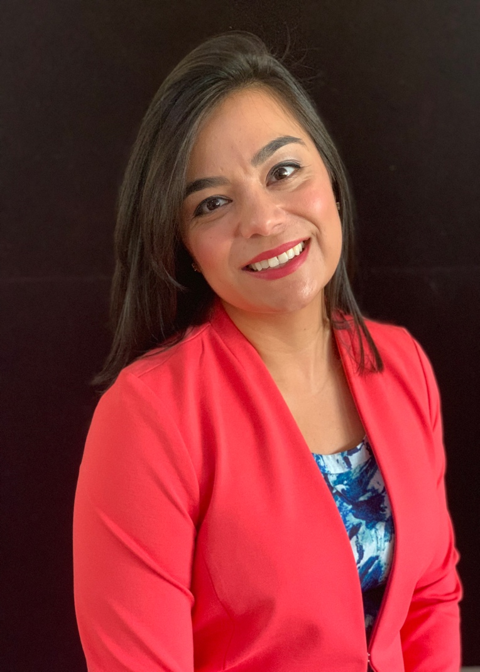

**Darleen A. Dagey, MSN, RN, NPD-BC, CNOR**, is a nursing clinical development specialist in the OR at Sibley Memorial Hospital, Washington, DC. She earned an associate’s degree in nursing from the College of Southern Maryland, La Plata, and a master of science in nursing from Walden University, Minneapolis, Minnesota.

Dagey has been a perioperative nurse for 15 years and a member of AORN for nine years. She is a member of:

* + AORN of Northern Virginia (2013-present),
  + the Clinical Nurse Educator Specialty Assembly (2015-present), and
  + the Leadership Specialty Assembly (2016-present).

She has been a member of:

* + AORN of Greater Washington DC (2010-2012),
  + the Leadership Specialty Assembly (2011-2012), and
  + the General Surgery/Gynecology Specialty Assembly (2011-2012).

Dagey has attended Congress four times in the past 10 years.

Dagey has received:

* + an AORN Forty Under 40 Award (2017),
  + the AORN Attendees’ Choice for Clinical Innovation Poster Award (2016),
  + the Sibley Memorial Hospital Nurse Innovator of the Year Award (2016), and
  + the Johns Hopkins Safety Star Award (2014).

Highlights of Dagey’s service to AORN include that she is:

* + a Journal Correspondent for Periop Briefing (2018-present).

She has been:

* + an author for the AORN Journal (2017);
  + a volunteer instructor at the positioning learning station at the AORN Global Surgical Conference & Expo, Anaheim (2016); and
  + a poster presenter at AORN Expo in Anaheim, Boston, and Nashville (2016, 2017, 2019).

In other leadership roles, Dagey is:

* + co-chair of the Magnet Advisory Committee at Sibley Memorial Hospital (2018-present),
  + site facilitator for the AORN Go Clear project at Sibley Memorial Hospital (2019-present),
  + social media administrator for the Sibley Memorial Hospital Nursing Facebook page (2017-present); and
  + a CNOR Coach for the Competency & Credentialing Institute (2019-present).

She has been:

* + a frontline leadership coach at Sibley Memorial Hospital for The Advisory Board Company (2012-2015).

In her community, Dagey is:

* + a scholarship appraiser for the Daisy Award (2016-present),
  + a volunteer for the Potowmack Elementary School Parent-Teacher Association (2018-present),
  + a fundraiser for the Juvenile Diabetes Research Foundation One Walk (2018-present), and
  + a classroom volunteer for Potowmack Elementary School (2018-present).

She has been:

* + a volunteer for Habitat for Humanity (2018).

**Election Statement**

I have over 15 years of experience in perioperative nursing and am a lifetime member of AORN. I value my membership and hope to serve the organization by being elected to the Nominating Committee. I bring plenty of personality and passion to the table. I believe one of the most important qualities of a Nominating Committee member is being able to connect with people and have meaningful conversations about one’s professional development and commitment to a desired position at a national level.

Being recognized as one of AORN’s Forty Under 40, I have a unique advantage to bridge the gap between nurses in their 20s and 30s and more seasoned nurses to recruit and help them realize their leadership potential. Once I am elected, I would use my experience as a professional development specialist and CNOR Coach to inform, encourage, and support candidates through the election process.

As an emerging leader myself, I have learned from current and past AORN leaders the principles and values it takes to make a difference. I look forward to collaborating and working as a team with other members of the Nominating Committee to select the best candidates for the ballot. If elected, I will do my best to advance the profession of perioperative nursing by recruiting leaders with the skills necessary to create our best future.

I am asking for your vote. Take a chance on an emerging leader; I’ll give it all I’ve got! Thank you.

**Candidate’s Q&A**

**1. Member surveys indicate the most common reason they do not vote is they feel they “do not know the candidates”. To help the members get to know you better, describe something you are passionate about outside of your profession as a perioperative nurse.**

I am passionate about building community. That is why I am an active member of the PTA and volunteer in the schools and surrounding areas. I am also the unofficial activities director of my neighborhood. I coordinate social events throughout the year, such as holiday parades and ice-cream parties. I want my children to have happy memories of growing up surrounded by friends and trusted neighbors. This year two of my neighbors got sick. I organized a meal train so that their families would have one less thing to worry about during a stressful time. I’m grateful to live in a community that rallies to help one another. Building community takes effort, but it’s definitely worth it to love where you live.

**2. Describe your most meaningful day in the OR, or in the office and how it has impacted your current practice, or work, as a nurse.**

My most meaningful day as a perioperative educator was a day that a group of students from a local school came to visit the hospital to learn about different healthcare jobs. I had the opportunity to talk with them about perioperative nursing, teamwork and the roles of circulating and scrubbing in the OR. I brought bouffant caps for everyone and asked for volunteers to help demonstrate donning a gown. I brought a few instruments for show and tell. It was a wonderful afternoon introducing perioperative nursing as a career path. The students had great questions and were very engaged. This experience reignited my passion for perioperative nursing. Even in nursing school, the OR was always a bit of a mystery. It’s important to share the important work that we do every day with the youth to impact our future. It really is a privilege to work in surgery.

**3. Identify the two most important things you feel need to be a part of the candidate selection process.**

The most important thing that should be a part of the candidate selection process is an emphasis on the candidates’ willingness to serve and strength of their character. The candidate must be committed to fulfilling the responsibilities of the selected office. In order for candidates to be selected they must have a reputation of professionalism and demonstrate leadership in order to represent AORN and excellence in perioperative nursing. The next most important thing is transparency about the candidates responsibilities once selected for office. To the best of their ability, the Nominating Committee should be transparent in the scope of the role to include future dates of board meetings, deadlines of requirements, extent of travel, etc., so that candidates can have a healthy work-life balance and prioritize obligations.

* **Sonja W. Furr, BSN, RN, CNOR**

**Candidate Bio**

[View Candidate Video](http://media.aorn.org/asset-3c633704-6d43-4654-aa36-dfa22e9819cb/Expo_2020_Candidates_Sonja-W-Furr-v2.mp4?sv=2017-04-17&sr=c&si=587bb0df-c040-4fe4-aaa5-ddbe984714cc&sig=sJu%2BvuCiXExQZmPHma%2BKfSqvAUnBtgP74632BQCGmDI%3D&se=2021-02-06T21%3A08%3A35Z)

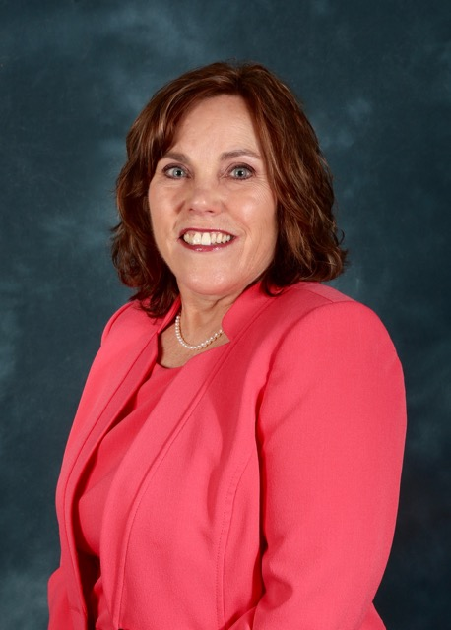

**Sonja W. Furr, BSN, RN, CNOR**, is the facility nurse educator in the OR at Atrium Health Pineville, Charlotte, North Carolina. She earned a diploma in nursing from Mercy Hospital School of Nursing, Charlotte, North Carolina, and a bachelor of science in nursing from Chamberlain University College of Nursing, St Louis, Missouri.

Furr has been a perioperative nurse for 24 years and a member of AORN for 14 years. She is a member of:

* + the AORN Dogwood Chapter (2010-present),
  + the North Carolina Council of Operating Room Nurses (NCCORN) (2012-present),
  + the Clinical Nurse Educator Specialty Assembly (2010-present),
  + the Ambulatory Surgery Specialty Assembly (2010-present), and
  + the Leadership Specialty Assembly (2010-present).

Furr has attended Congress nine times in the past 10 years, each time as a delegate.

Highlights of Furr’s service to AORN include that she is:

* + a member of the AORN Foundation Silent Auction Committee (2016-present),
  + chair of the AORN Foundation Silent Auction Committee (2019-present),
  + a member of the NCCORN Board of Directors (2019-present),
  + a member of the NCCORN Legislative Committee (2016-present), and
  + a member of the AORN Clinical Nurse Practice Council (2019-present).

She has been:

* + president of the AORN Dogwood Chapter (2012-2013, 2018-2019),
  + a member of the AORN Dogwood Chapter Board of Directors (2013-2017),
  + secretary of NCCORN (2013-2015), and
  + chair of NCCORN (2017-2018).

In other leadership roles, Furr is:

* + CNOR certified (2010-present),
  + a member of the American Nurses Association (2016-present), and
  + a member of the North Carolina Nurses Association (2016-present).

She has been:

* + chair of the Carolinas Medical Center Operating Room Preceptor Council (2014-2016) and
  + co-chair of the Education Council, Atrium Health, Pineville (2017-2018).

In her community, Furr is:

* + a co-facilitator for the GriefShare Support Group, Carolina Presbyterian Church (2016-present) and
  + an assistant at the nursery host desk, Carolina Presbyterian Church (2019-present).

She has been:

* + a volunteer for the Safe Alliance Women’s Shelter (2018);
  + an assisting instructor for CPR certification, Carolina Presbyterian School (2016-2018); and
  + a volunteer for Hurricane Matthew relief, Carolina Presbyterian Church (2018).

**Election Statement**

Zig Ziglar says, “You were designed for accomplishment, engineered for success, and endowed with the seeds of greatness.”

My goal as a nurse leader, educator, and colleague is to empower those that come behind me to become the leaders they are meant to be. To encourage growth throughout their careers, for it is continued growth and ability to change as health care changes that strengthens you and builds resiliency in the nurse as he or she follows evidenced-based practices promoting the safety of our patients. Perioperative nursing was the first critical-care specialty of our profession and we should embrace that fact, continue to promote it, and push each other toward excellence every day.

“Success doesn’t come from what you do occasionally, it comes from what you do consistently” (author unknown).

I love this quote because it speaks the truth! During my 34 years as an RN, 11 years in the Cardiovascular Recovery Unit, 23 years as a perioperative nurse, I have consistently been a preceptor, mentor, leader, and educator, both formally and informally. My current role as a facility nurse educator for the OR as well as leadership roles at the state and local AORN level has allowed me to mentor, encourage, and empower others towards growth and leadership within their careers. It would be an honor to serve as a member of the Nominating Committee and continue working with AORN membership at all levels.

**Candidate’s Q&A**

**1. Member surveys indicate the most common reason they do not vote is they feel they “do not know the candidates”. To help the members get to know you better, describe something you are passionate about outside of your profession as a perioperative nurse.**

My passions outside of the OR are many it is hard to narrow them down. I love to help others and do so by volunteering for the nursery ministry and GriefShare at my church. I also love working with other women on improving their skincare as a part time Mary Kay consultant. My husband & I are currently restoring my actual first car which is a ’65 mustang! My biggest passion outside of my perioperative nursing career is my family & close friends. I love to care for them through planning special events for them, preserving our garden by canning or freezing the produce my husband grows, baking goodies and spending time with them!

**2. Describe your most meaningful day in the OR, or in the office, and how it has impacted your current practice, or work, as a nurse.**

Early in my career as a perioperative nurse in the CVOR the case I most remember went bad from the start as the surgeon hit the right atrium going in. At the end of this case our count was correct. The next morning the patient was returned to the OR after his morning X-ray revealed a lap sponge still in his chest. The scrub nurse and I were mortified! I am still not sure how we missed it however I share this story often with the teams I work with in an effort to impart the importance of our surgical counts. I have since sat on committees revising our surgical count policy as well as a multidisciplinary hospital committee that brought in all areas who perform procedures that involve counts including our radiology partners providing them with pictures of countable items so they can compare them to x-ray views.

**3. Identify the two most important things you feel need to be a part of the candidate selection process.**

2 most important things that I feel should be a part of the candidate selection process

1. Seeking those candidates who have shown dedication and commitment to AORN through consistent involvement & leadership at their local chapter and state councils as well as on the national level through volunteering on committees throughout the year and during conference when attending through speaking, poster presentations and/or volunteering to introduce speakers, serve in the silent auction room or mentor first time attendees.

2. Candidates should also show dedication to the profession during their daily practice. They should be actively involved in their unit and/or facilities to improve nursing practice where they work. This can be showcased through their involvement on unit based and hospital-based committees, CNOR certification, leadership roles such as advancement on facility clinical ladders, leadership roles such as coordinators of service lines, clinical supervisors, nurse managers, directors etc.

* **Jeffrey R. Keane, BSN, RN, CNOR**

**Candidate Bio**

[View Candidate Video](http://media.aorn.org/asset-c3f8de4f-6466-426f-8573-55653c428052/Expo_2020_Candidates_Jeffrey-R-Keane-v2.mp4?sv=2017-04-17&sr=c&si=763d8478-18bf-462c-a354-8c1746cffec4&sig=8Kqxoiv2vSRfb4aa9iKKDTc%2FXyYhSooKiGbDh1p9ScM%3D&se=2021-02-05T20%3A29%3A40Z)

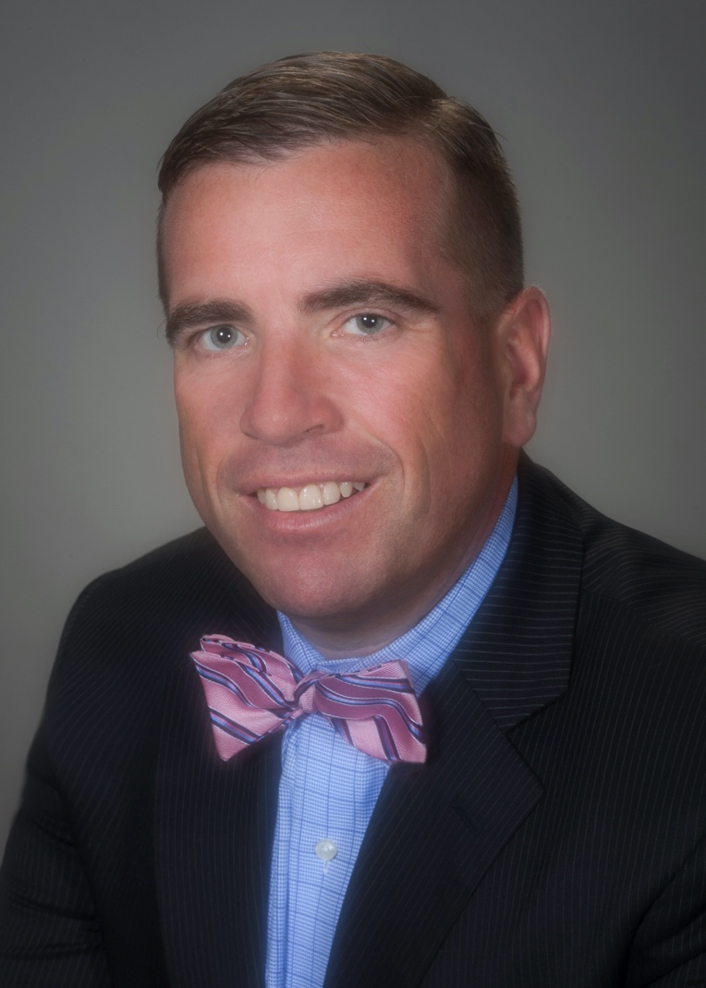

**Jeffrey R. Keane, BSN, RN, CNOR**, is a unit-based educator at Beth Israel Deaconess Medical Center, Boston, Massachusetts. He earned an associate’s degree in nursing from Quincy College, Massachusetts; and a bachelor of science in nursing from the University of Massachusetts, Boston.

Keane has been a perioperative nurse for 12 years and a member of AORN for 12 years. He is a member of:

* + AORN of Massachusetts Chapter 1 (2010-present),
  + the Massachusetts State Council (2013-present),
  + the Clinical Nurse Educator Specialty Assembly (2015-present), and
  + the Leadership Specialty Assembly (2018-present).

Keane has attended Congress nine times in the past 10 years, seven times as a delegate.

Keane has received:

* + a Joseph M. Koufman Foundation and Department of Surgery Annual Award for Excellence in Surgical Nursing (2018),
  + a Department of Anesthesia Faculty Hour Award (2012), and
  + an Edward and Marilyn Schwarz Award for Excellence in Nursing Practice (2011).

Highlights of Keane’s service to AORN include that he is:

* + a member of the AORN Fellowship Level of Membership Task Force (2019-present),
  + a member of the Clinical Nurse Educator Specialty Assembly Communications Committee (2019-present),
  + chair of the Massachusetts State Council Legislative Committee (2015-present),
  + chair of the AORN of Massachusetts Chapter 1 Budget and Finance Committee (2014-present), and
  + a member of the AORN of Massachusetts Chapter 1 Board of Directors (2017-present).

He has been:

* + chair of the AORN Fellowship Level of Membership Task Force (2018-2019),
  + a member of the AORN National Committee for the Development of Simulation Scenarios (2014-2016);
  + a volunteer coordinator at the AORN Global Surgical Conference & Expo, Boston (2015-2017);
  + a member of the Robotics Competency Project, Minimally Invasive Surgery, Laser and Robotics Specialty Assembly (2012-2014); and
  + treasurer of AORN Massachusetts Chapter 1 (2013-2017).

In other leadership roles, Keane is:

* + a member of the Quincy College Surgical Technologist Advisory Committee (2016-present),
  + a member of the Bunker Hill Community College Surgical Technologist Advisory Committee (2016-present), and
  + a faculty member for Region 4c Facilitator Training (2017-present).

He has been:

* + a faculty member for the American College of Surgeons 9th Annual Postgraduate Course “Perfect practice makes perfect” (2016).

In his community, Keane is:

* + chair of the Hollis School Parent-Teacher Organization Fundraising Committee (2016-present);
  + a volunteer for St Paul’s Giving Tree benefitting St Patrick’s Parish, Boston (2017-present); and
  + a team captain for the Daniel Breen Memorial 5K (2016-present).

He has been:

* + a coach for Braintree Babe Ruth Baseball (2010-2014) and
  + a coach for Braintree Youth Baseball U13 Summer League (2010-2013).

**Election Statement**

Colleagues, it takes leaders to do the work of the Nominating Committee. I’m a leader who has a vision for the AORN Nominating Committee to be the voice of the membership to enhance our profession. It’s important the Nominating Committee identifies qualified candidates to run for national office. As we prepare for the “Year of the Nurse,” we need to embrace our 2020 motto of “20/20 Vision: Creating Our Future.” Having practiced as a clinical nurse, service line leader, as a perioperative educator, and serving on several national committees has afforded me valuable experience.

Educating and leading perioperative nurses locally and nationally is my passion. As volunteer coordinator for Expo in Boston and serving for two years as faculty for AORN Guidelines Workshops, I traveled throughout the country meeting with members. Both of these opportunities allowed me the chance to speak with members who care for patients at the bedside and to better understand that your concerns are my concerns.

As an advocate for perioperative nurses, I have been our voice at the Massachusetts State House for the last three years. It’s critical for AORN to partner with the federal and state legislature to influence policy decisions. I have testified in front of the Joint Committee on Health Care in support of safety in the workplace and reimbursement for CRNFAs. I’m dedicated to work tirelessly for you and our Association. I welcome the opportunity to serve as a member of the Nominating Committee and I ask for your vote.

**Candidate’s Q&A**

**1. Member surveys indicate the most common reason they do not vote is they feel they “do not know the candidates”. To help the members get to know you better, describe something you are passionate about outside of your profession as a perioperative nurse.**

Family is an important part of my life outside of the operating room. They have supported me along my perioperative journey from the beginning. As I run for national office I realize the importance of having them at my side. My family and I enjoy traveling together whether it’s a cruise or trips to Orlando Florida. This time away from work allows me to clear my mind and re-energize myself to continue my work. Self-care is very important to maintain a healthy work life balance. It’s important to know who I am and recognize what I can handle to stay focused on the task at hand. Each week I plan something fun to do with my family during the weekend. This gives me something pleasurable to look forward to at the end of the week so I am able to keep my mind clear.

**2. Describe your most meaningful day in the OR, or in the office, and how it has impacted your current practice, or work, as a nurse.**

While working as a bedside nurse in the operating room I was caring for a patient where we had an event that had an impact on my practice. After reflecting on this moment I decided to pursue an educational track to advance my leadership in the operating room. I enjoy the opportunity to teach new nurses whether it’s someone new to the operating room or to my facility. The first thing I explain to a new orientee is to learn one thing a day and build upon it. Perioperative nurse have to deal with many challenges and if we try to take it all on at once we will not be successful. Meaningful to me is when I observe a learner moving through Pat Benner’s novice to expert nursing theory.

**3. Identify the two most important things you feel need to be a part of the candidate selection process.**

As I reflect on the candidate selection process I believe we can improve to engage a larger part of the membership to not only run for office but to vote. We need to prioritize an effort to get out the vote of the membership so their voice is heard. First, the members must be engaged in the spirit of inquiry so they can learn more about each of the candidates running for office. AORN needs to ensure we can reach across all spectrums of the generations of the AORN membership. Secondly, I think we need to update the nominating process to make it more accessible for all. As candidates we need to understand what works best for the members and make these options available to them.

* **Molly Kucera, MBAHC, BSN, BS, RN, CNOR**

**Candidate Bio**

[View Candidate Video](http://media.aorn.org/asset-b031bb5e-ec60-4d62-94c2-194ae379f435/Expo_2020_Candidates_Molly-Kucera-v2.mp4?sv=2017-04-17&sr=c&si=f609fb6a-45b4-4cc6-be18-09d1d1f7cd68&sig=vsyiF7mitYvcETCDwy96oSk0RcpdzwuLlZlgohTUKVk%3D&se=2021-02-06T21%3A06%3A52Z)

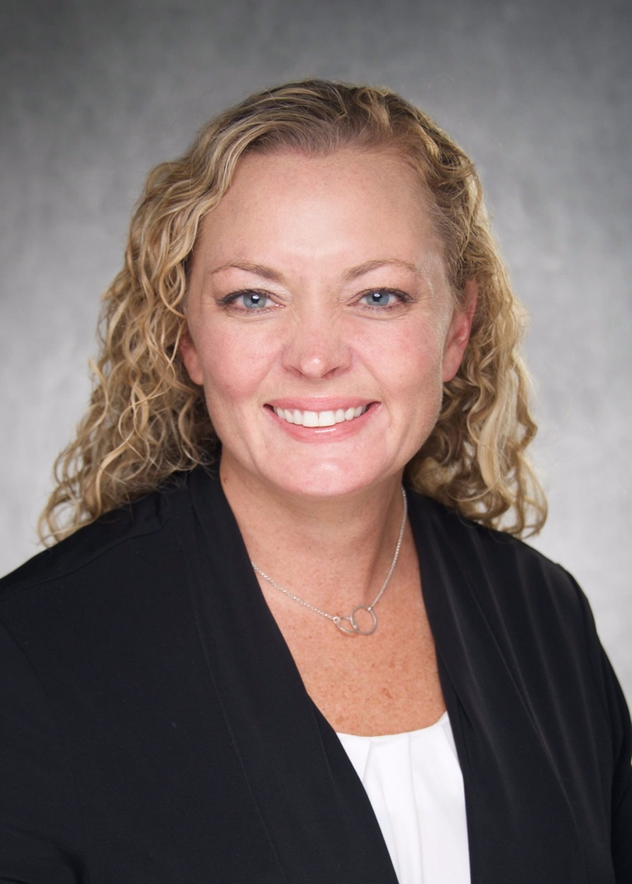

**Molly Kucera, MBAHC, BSN, BS, RN, CNOR**, is the OR nurse manager at the University of Iowa Health Care Ambulatory Surgery Center, Iowa City. She earned an associate’s degree in nursing from Kirkwood Community College, Cedar Rapids, Iowa; a bachelor of science degree in sport health leisure and physical studies from the University of Iowa, Iowa City; and a bachelor of science in nursing and a master of business administration in health care from Western Governors University, Salt Lake City, Utah.

Kucera has been a perioperative nurse for 19 years and a member of AORN for nine years. She is a member of:

* + AORN of Iowa #1 (2012-present),
  + the Ambulatory Surgery Specialty Assembly (2016-present), and
  + the Leadership Specialty Assembly (2016-present).

Kucera has attended Congress five times in the past 10 years, four times as a delegate.

Highlights of Kucera’s service to AORN include that she is:

* + past-president of AORN of Iowa #1 (2019-present) and
  + a member of the AORN of Iowa #1 Board of Directors (2019-present).

She has been:

* + co-secretary of the Iowa Association of Ambulatory Surgery Centers (2015-2019),
  + president of AORN of Iowa #1 (2018-2019),
  + president-elect of AORN of Iowa #1 (2017-2018),
  + vice president of AORN of Iowa #1 (2016-2017), and
  + a member of the AORN of Iowa #1 Board of Directors (2013-2015).

In other leadership roles, Kucera has been:

* + an expert writer for the Competency & Credentialing Institute (2019).

In her community, Kucera is:

* + vice president of the Helen Lemme Elementary Before and After School Program (2018-present).

**Election Statement**

I am humbled to serve as a candidate for the AORN Nominating Committee. During my 19 years in perioperative nursing, I have worked as a staff nurse, educator, and manager in both inpatient and ambulatory surgery settings. This gives me a thorough understanding of the challenges that perioperative nurses face every day and the diverse membership needs that AORN strives to meet. Coupled with my passion to encourage and mentor others, this background serves as a strong foundation to serve on the Nominating Committee and select AORN’s future leaders.

In my local chapter, I have served as president, vice president, secretary, and board member; all requiring effective teamwork and collaboration to achieve positive outcomes. This provides me with an understanding of the issues faced by chapters across the country. At the state level, I served as the co-secretary and education committee member of the Association of Ambulatory Surgery Centers. This experience allowed me to network and listen to nurses across the state. By serving on an AORN national committee and attending AORN conferences, I have expanded this network to the next level.

My experience as a leader in a variety of roles and settings and active engagement in AORN at all levels provides me with the skills to select exceptional candidates to lead AORN to be the best we can be. I ask for your support for my candidacy on the Nominating Committee so together we can shape the future of AORN.

**Candidate’s Q&A**

**1. Member surveys indicate the most common reason they do not vote is they feel they “do not know the candidates”. To help the members get to know you better, describe something you are passionate about outside of your profession as a perioperative nurse.**

I am passionate about education and leadership development. I am a lifelong learner and enjoy reading for my personal development. It gives me great joy to coach and mentor others on their professional journeys. My family and being a mom are my highest priority, and I enjoy volunteering in my children’s extracurricular activities.

**2. Describe your most meaningful day in the OR, or in the office, and how it has impacted your current practice, or work, as a nurse.**

Working as a peri operative nurse in the outpatient and inpatient setting has created a lot of meaningful days. My first case as a circulating nurse had great challenges. My patient needed to receive 50 units of emergency release blood. I asked for help and had an amazing team of nurses that provided care for this patient. It continues to serve as a reminder of the kind and amazing experienced OR nurses that help young nurses learn how to care for the new OR nurse.

**3. Identify the two most important things you feel need to be a part of the candidate selection process.**

It is important to assure that we have candidates representing the diversity of our membership, including the variety of professional roles and the geographic areas and settings in which they practice. Secondly, candidates need to have demonstrated leadership and effective teamwork.

* **David Reinhart, MSN, MBA, RN, CNOR**

**Candidate Bio**

[View Candidate Video](http://media.aorn.org/asset-6d6b7a65-c082-4ab5-9092-f088bffdcbd8/Expo_2020_Candidates_David-Reinhart-v2.mp4?sv=2017-04-17&sr=c&si=aa3f2a67-ea6c-4be6-8277-862f9f5c90a6&sig=qdnJhf65naRGNqLnIXigeKcsru9jqvjbznr74sI5oTo%3D&se=2021-02-05T20%3A14%3A18Z)

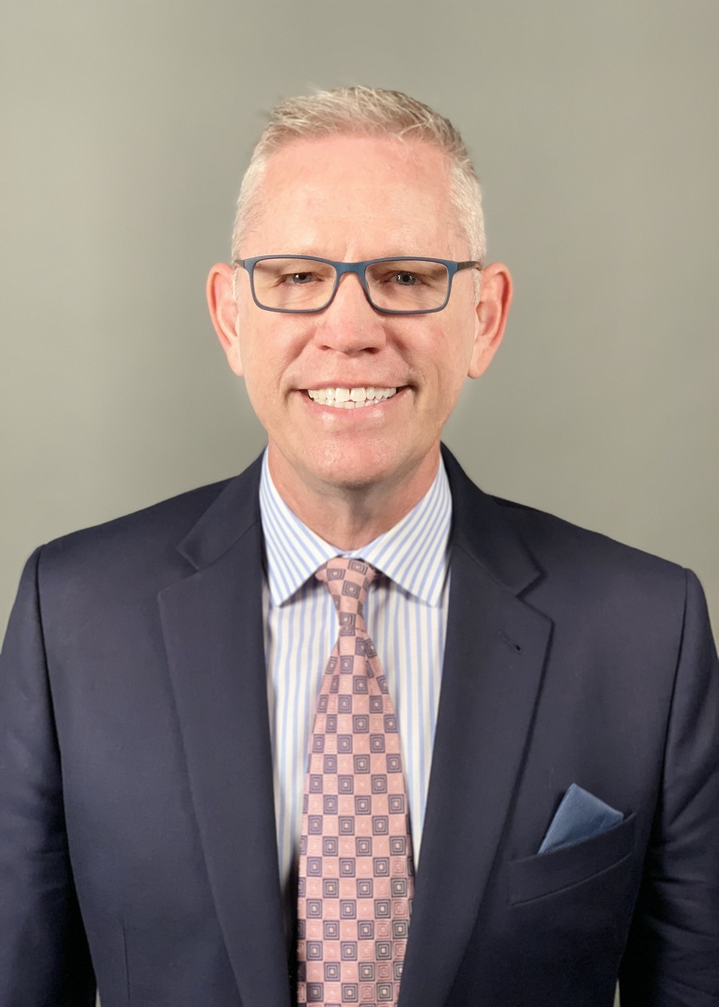

**David Reinhart, MSN, MBA, RN, CNOR**, is the specialty director of Perioperative Services at Emory Saint Joseph’s Hospital, Atlanta, Georgia. He earned an associate of science in nursing and an associate of science in surgical technology from Owens Community College, Toledo, Ohio; a bachelor of science in management from the University of Toledo, Ohio; a master of business administration from the University of Dallas, Texas; a master of science in nursing from the University of St. Francis, Joliet, Illinois; and is pursuing a doctorate in nursing from Georgia College & State University, Milledgeville.

Reinhart has been a perioperative nurse for 32 years and a member of AORN for 32 years. He is a member of:

* + AORN of Northwest Georgia (2017-present),
  + AORN of South Florida (2010-present), and
  + the Georgia State Council of Perioperative Registered Nurses (2019-present), and
  + the Leadership Specialty Assembly (2015-present).

Reinhart has attended Congress 10 times in the past 10 years, two times as a delegate.

Reinhart has received:

* + an AORN Outstanding Achievement in Perioperative Nursing Management Award (2018) and
  + a Mercy Care in Leadership Award from Emory Saint Joseph’s Hospital (2015).

Highlights of Reinhart’s service to AORN include that he is:

* + a member of the AORN Recruitment and Retention Task Force (2019-present) and
  + a member of the AORN Executive Roundtable (2010-present).

He has been:

* + a member of the AORN Bylaws Committee (2018-2019) and
  + president of AORN of South Florida (2012-2013).

In other leadership roles, Reinhart is:

* + a team captain for the metro Atlanta American Heart Association (2017-present).

He has been:

* + a moderator at the American Nurses Credentialing Center National Magnet Conference (2015) and
  + a moderator at the Unity Conference, United Advanced Practice Registered Nurses of Georgia (2018).

In his community, Reinhart has been:

* + a coordinator for Mercy Care of Atlanta Christmas Gift Drive (2018) and
  + a team captain for the 2019 Emory Saint Joseph’s Hospital Run for Mercy 5K (2019).

**Election Statement**

The OR nurse today faces many challenges: increased demand for OR efficiency, improving patient outcomes, tracking and trending safe reports, orienting travelers, orienting new employees, and maintaining competence with the latest technology. Although this environment sounds overwhelming, OR nurses share the passion to take care of surgical patients and believe in their hearts that the OR is the only place to work in the hospital. The Nominating Committee’s responsibility is to solicit and receive nominations for potential candidates for all elected positions. AORN members expect and deserve the best candidates in the market. Candidate characteristics require the understanding, passion, and knowledge of the present OR operations. I have been an OR nurse for 32 years and my career path has led me from the surgical technologist role to the RN circulator role to director of Perioperative Services. My experience as a director of Perioperative Services has prepared me to critically review and select the correct leaders for specific roles within my organization. I know the current issues facing AORN members and I offer my experience and passion to the Nominating Committee seat for all nurses that continue to depend on AORN for continued direction. AORN is the official voice of perioperative nurses and continues to be a powerful influence in practice. I am proud to be a member of AORN for 32 years and am humbled to be nominated by my peers for a Nominating Committee consideration. I would appreciate your vote in this election year. Thank you.

**Candidate’s Q&A**

**1. Member surveys indicate the most common reason they do not vote is they feel they “do not know the candidates”. To help the members get to know you better, describe something you are passionate about outside of your profession as a perioperative nurse.**

My passion is supporting the care of vulnerable populations such as the elderly as well as cat and dog rescues. Some society members, not all, have discarded them to no longer add value to a community. They are unable to help themselves and therefore demonstrate behaviors of depression and loneliness. The thought of them feeling discarded breaks my heart. I have volunteered at elder-care facilities and local animal shelters through donating time and resources needed to make them feel valued and wanted.

**2. Describe your most meaningful day in the OR, or in the office, and how it has impacted your current practice, or work, as a nurse.**

I scrubbed on a living related liver transplant the day before Thanksgiving several years ago. The donor was the Father and the recipient was his son. The operation was successful and the surgical team provided a true Thanksgiving gift of providing surgical talent, knowledge and passion for the family. Father and son were blessed with a promised future as the Mother awaited in the waiting room. It made me realize how valued an operating room nurse is to their surgical patient. After that case, I realized that I chose the correct career. I was so excited to be a part of the experience.

**3. Identify the two most important things you feel need to be a part of the candidate selection process.**

A resume shows a written timeline of experiences and may look very good on paper, however, digging deeper to find the true character of the candidate is key. A candidate should articulate how they personally affect patient safety in their operating room. Patient safety is what AORN is all about. A focused question would be to ask the candidate how they get others to be on board with patient safety. Investigating whether a candidate is in good standing with their state board is important as well. I am willing to take the time to dig deep and select the right AORN members for the ballot.