

**AANN Triad Chapter!**

**Next Meeting**

Dinner

Provided

When: Wednesday, February 19th, 2020

Time: 6-8pm

Where: Cone Health Urgent Care

At MedCenter Kernersville

1635 NC-66, Kernersville, NC 27284

For directions (336) 992-4800

Classroom- follow signs

Host: Cone Health

Information: 336-832-7873

**Topic:**

***“Comprehensive Stroke Care in the Piedmont TRIAD Area”***

**Speakers:**

[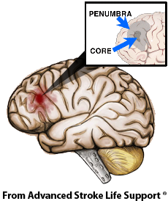](http://www.google.com/url?sa=i&rct=j&q=&esrc=s&source=images&cd=&cad=rja&uact=8&ved=0ahUKEwiLgaH8hpHVAhXGVz4KHen6Aq0QjRwIBw&url=http://www.asls.net/&psig=AFQjCNHAbuaCm65-WkNbzv3bpbXm6P46yQ&ust=1500406187888554)Rayetta Johnson, MSN, RN, CNRN

Stroke Program Manager, **Wake Forest Baptist Medical Center**

Karissa M. LaClair, DNP, APRN, FNP-C **Cone Health,** Stroke Program Manager

Karen B. Norman, MSN, RN-BC, CCRN

**Novant Health**, Manager of Stroke

