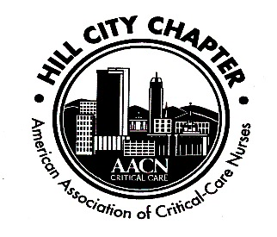

Hill City Chapter of the AACN
November 18, 2019
- Welcome
  - Unstoppable -“Unstoppable is knowing if we get knocked down, we get up again,” she says. “It’s using our unique talents to expose inefficiencies and celebrate positive, innovative solutions, no matter how small.”- Megan Brunson AACN President
- Secretary’s report-
  - Review October Minutes
    - Minutes approved:
      - Nicole 1st
      - Hillary 2nd
- Treasurer’s report – Nicole Reported on Balances
  - Balances:
    - Checking - $18,153.40
    - Savings - $1,613.81
    - CDs - $5,028.07
  - Chapter Dues - $15
    - National membership is prerequisite to local membership, even student memberships. Visit (www.aacn.org) to become a member.
      - We have national membership available for purchase via a voucher. We have vouchers available now.
    - Local dues may be paid on our website (www.aacnhillcity.com) or at meeting by cash or check to “Hill City AACN”
- Recognition
  - Recognition of new certifications
    - Who are our NEW certified nurses? Congrats!!!
    - Victoria Wiggins -CTICU
    - Our chapter plans to recognize newly certified nurses with a small gift and one year of free local chapter membership (for national AACN members only) **Have new certified nurse’s contact one of the chapter officers**
  - Chapter funds members’ application fee for CCRN, PCCN or other AACN certification exams
    - We can pay for two attempts – We ask that you reimburse chapter after success. Thank you for returning funds to chapter after being reimbursed by employer.
    - There is now a section on our website where you can download the application.
- Save the Dates: Hill City AACN Calendar
  - Dec – No meeting! Enjoy the Holidays!
  - Jan- to be announced
  - NTI -May 3, 2020-Indianapolis, Indiana-**Make sure to book your rooms**
- New Business-
  - Critical Care Conference- speaker compensation?
  - Let any officer know if you are interested in the President-Elect position.
  - Maria announced that the chapter was on probation until Feb 2020. Hillary explained why
  - Anne-Marie spoke about the Save the Soaps Campaign

Attendees
Hillary Yeatts – CCON
Nicole Rodriguez - CM
Maria Scott – BMH
Elizabeth Poole – MICU
Holly Puckett – CCON
Sonya Lipscomb – Centra
Cathy Hayes – PACU
Karen Briggs – CIMU
Cheryl Patterson – Cath Lab
Pearl Banks – Cath Lab
Michele Rakowski – Cath Lab
Anne-Marie Caylor – CTICU
Karen Harvey – CTICU
Sharon Kastner – MICU
Elena Stock –
Stephanie Stewart - STICU

