#### AORN Chapter 4432

#### Winter Seminar

***20/20 Vision, Creating our Future***

**Speakers:**

Lieutenant Robert Johnson, Sr.

*Civilian Response to Active Shooter*

Nancy Roper Willson RN, JD, MSN, MA

*License Disciplinary Action and Perioperative Nursing Practice*

Janet M. Davis MSN, RN, GNP, CWOCN

*Medical Adhesive Related Skin Issues*

Robert Leedy – Stryker

*Hip Fractures and Radiation Reduction*

**Seminar Goals:**

* + - 1. Provide information related to current issues, trends, and future challenges affecting perioperative nursing practice.
      2. Identify clinical, leadership, management, and education strategies to improve patient outcomes.
      3. Enhance the professional growth and development of each attendee.

Each education session will have separate educational objectives for session evaluation. Objectives will be presented at the start of the session.

## Saturday February 1, 2020

## Agenda

***7:30 a.m. Registration/Breakfast***

**7:45 a.m. Welcome**

**8:00 a.m.** **R. Johnson (1.0 CE)**

**9:00 a.m. N. Roper Willson (1.0 CE)**

***10:00 a.m. Break and Industry Fair***

**11:00 a.m. J. Davis (1.0 CE)**

***12:00 pm Lunch***

**12:30pm R. Leedy (1.0 CE)**

***1:30pm Adjournment*-Door Prize***

**





**Location: Medical City Plano**

**Bldg III, 3rd floor auditorium**

**4001 W. 15th Street, Plano, TX 75075**

**\*Evaluations and Certificates**

**Door Prize Drawings**

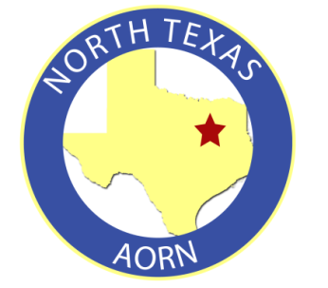**Registration Form**

**Name**:

**Hospital Affiliation: _______________**

**Address**:

**City, State, Zip**:

**Cell phone**:

**E-mail**:

**A member of Chapter 4432? Y or N**

**Text a copy of completed form or text information to 214-876-3895**

**Or email** [**kjc81812@gmail.com**](mailto:kjc81812@gmail.com)

**Seminar Free of Charge**