

2020 PAAOHN Annual State Conference – March 11-12, 2020

SUBHEAD HERE

Clinical Approaches to Maximize Employee Health

Enter Contact Information Here | 1127 Lombard Blvd. San Francisco, CA 59802 | phone 555.555.5555 | fax 555.555.5555

­

No

Speakers

Mental Health in the Occupational Health Setting

Functional Capacity Nuts and Bolts

Workplace Strategies to Reduce Interpersonal Conflict

Veterans in the Workplace

Travel Health

What is in Your DNA?

Civilian Response to Active Shooter Events

Empowering the Occupational Health Nurse as a Business Partner

Environment Assessment to Help Employees Manage Current and Future Health Risks

Jill Yurchak, MSN, COHN-S

Dennis A Martin, OTR/L, CHT

Laura Walters, PhD, RN

Crystal McFadden, LPC

Judge David Torrey

Attorney Kyle Black

Dr. Kimberly Subasic

James Decker

Amy Dailey, RN, MSN, COHN-S/CM, CHSP

Chad Rittle, DNP, MPH, RN, FAAOHN

**Mohegan Sun Pocono**

**1280 Highway 315**

**Wilkes-Barre, Pennsylvania 18702**

**570-831-2100**

**mohegansunpocono.com**

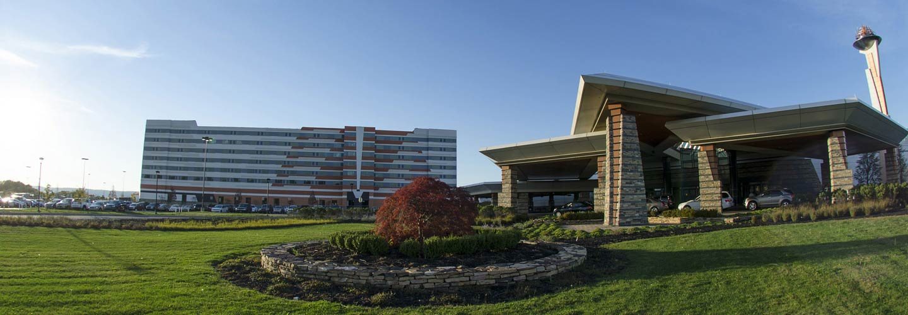

Please contact **Chad Rittle** at [rittle99@yahoo.com](mailto:rittle99@yahoo.com) or 412-366-9716 OR Troy Burd at [ptburd449@embarqmail.com](mailto:ptburd449@embarqmail.com) or 717-527-2340

Topics:

**Disclosure statement**

There are no conflicts of interest affecting this continuing education activity. Participation will be verified by sign-in roster, completion of evaluation tool and completion of self- reported attendance verification forms

There is no commercial support for this activity

There is no implied endorsement of any commercial product by PAAOHN

There is no discussion of off label uses of drugs as defined by the FDA

**This activity has been submitted to the Ohio Nurses Association (ONA) for approval to award contact hours. Ohio Nurses Association is an accredited approver of continuing education by the American Nurses Credentialing Centers Commission on Accreditation**

Name _____________________________

Credentials _________________________

Email ______________________________

Local Chapter _______________________

Company __________________________

Address ____________________________

Phone ____________FAX_____________

**REGISTRASTION FEES**

___ $300.00 for Full Conference

____ $100.00 Student Registration

____ $350.00 NON member

____ One Day Fee –$150.00 each day

**To register for the room – no later than 3/10/2020, please use this link:**

[**https://book.passkey.com/go/PEN320**](https://book.passkey.com/go/PEN320)

For more information, the Agenda of Speakers as well as full details of available awards and grants, please see our website below:

https://paaohn.nursingnetwork.com/

This event offers 12.5 CNE units Applicable to your RN license

This year we are providing registration online! Online Registration will be available at:

<https://paaohn.nursingnetwork.com/> starting in December. Please check the website for more information.

registration –

March 11 – 12, 2020

Registration fees include exhibitor reception, breakfast, lunch and CNE

**ALL HANDOUTS WILL BE ON LINE**

* https://paaohn.nursingnetwork.com/

Cancellations MUST be received by 2/28/20 and will be charged an administrative fee of $50.00

**Mohegan Sun Pocono**

Single Guest Room - $119

Double Guest Room - $129

Rate does not include applicable taxes and resort fees

**Please ensure you use PAAOHN when making the reservation.**

**Amenities**

**Fitness Facilities**

**Indoor Pool**

**Free Self and Valet Parking**

**Free Wireless Internet**

**Last day to register for the conference:**

**– Friday, March 1, 2020**

**We are accepting donations for our charity:**

**Ronald Macdonald House**