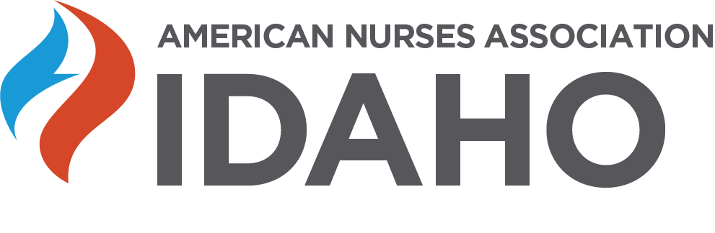I
LEGLISATIVE CONFERENCE 2020
Thursday, February 20, 2020
1 - 4 PM
Red Lion Boise Downtowner Hotel
1800 Fairview Avenue, Boise, Idaho
Agenda
1245PM-1:00PM—Welcome
1:00PM-1:45PM—Mike McGrane, MSN, RN, & Benn Brocksome, Lobbyists for NLI and ANAI—update on the current status of issues discussed at the Idaho Legislature
1:45PM-2:15PM-- Medicaid Expansion in Idaho.
2:15-2:45—30 minute dessert break
HOT TOPICS IN IDAHO
2:45-3:30—Marijuana and Opioids in Idaho, Idaho Office of Drug Policy
3:30- 4:00 -- How the 2020 census Impacts nursing --Juanita Risch, Regional Census Specialist
4:00-4:30—Education issues of faculty supply, faculty salaries, clinical experience, new schools coming to Idaho
TOTAL CNE applied for= 3.0 CNE

