AORN Chapter 4432

Winter Seminar

20/20 Vision, Creating our Future

Speakers:
Lieutenant Robert Johnson, Sr.
Civilian Response to Active Shooter

Nancy Roper Willson RN, JD, MSN, MA
License Disciplinary Action and Perioperative Nursing Practice

Janet M. Davis MSN, RN, GNP, CWOCN
Medical Adhesive Related Skin Issues

Robertr Leedy – Stryker
Radiology

Seminar Goals:
      - Provide information related to current issues, trends, and future challenges affecting perioperative nursing practice.
      - Identify clinical, leadership, management, and education strategies to improve patient outcomes.
      - Enhance the professional growth and development of each attendee.

Each education session will have separate educational objectives for session evaluation. Objectives will be presented at the start of the session.

Saturday February 1, 2020

Agenda

7:30 a.m. Registration/Breakfast
7:45 a.m. Welcome
8:00 a.m. R. Johnson (1.0 CE)
8:30 a.m. N. Roper Willson (1.0 CE)
9:30 a.m. Break and Industry Fair
10:30 a.m. J. Davis (1.0 CE)
12:00 pm Lunch
12:30pm R. Leedy (1.0 CE)
1:30pm Adjournment*-Door Prize







Location: Medical City Plano
Bldg III, 3rd floor auditorium
4001 W. 15th Street, Plano, TX 75075
*Evaluations and Certificates
Door Prize Drawings
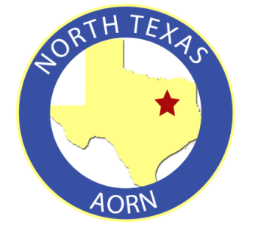
Registration Form
Name:
Hospital Affiliation: _______________
Address:

City, State, Zip:

Cell phone:

E-mail:

A member of Chapter 4432? Y or N

Text a copy of completed form or text information to 214-876-3895
Or email kjc81812@gmail.com

Seminar Free of Charge

