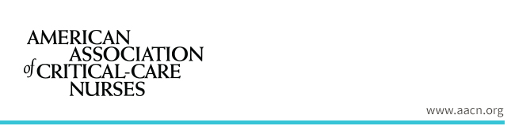
In keeping with our commitment to provide the most relevant resources for our community, the American Association of Critical-Care Nurses (AACN) would value your input on resources that would help you and your unit implement AACNs Healthy Work Environment standards.
To show our appreciation for your time, respondents who qualify and complete this survey will be entered in a drawing for one of 10 $25 Amazon gift cards. Ten winners will be chosen randomly from eligible entries.
The survey will take approximately 10 minutes or less and your responses are confidential. Click the mobile- and tablet-friendly link below to contribute your valuable insights, and please forward the link to other direct care nurses in your unit. The survey closes Nov.14, 2019, at midnight PT.
Thank you for supporting our community of exceptional nurses!
Sincerely,
AACN Clinical Content Team
Start AACN Survey »
Time : 6 Minutes

