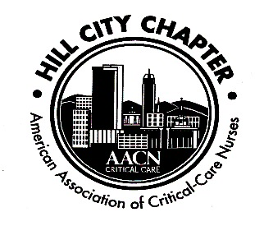**`**

**Hill City Chapter of the AACN**

**October 21, 2019**

1. Welcome: Meeting started at 1900
   1. Unstoppable – “Unstoppable is knowing if we get knocked down, we get up again,” she says. “It’s using our unique talents to expose inefficiencies and celebrate positive, innovative solutions, no matter how small.” – Megan Brunson, AACN President
2. Secretary’s report – Larisa Kerrigan
   1. Review August Minutes
      * Minutes approved:
3. Hillary Yeatts
4. Anne Marie Caylor
5. Treasurer’s report
   1. Treasurer position is now empty; Nicole Rodriguez has volunteered to serve as treasurer for the remainder of the fiscal year – vote was held and all members are in favor
   2. Balances: as of September 30, 2019
      * Checking - $18,747.67
      * Savings - $1,613.80
      * CDs - $5,028.07
   3. Chapter Dues - $15
      * National membership is prerequisite to local membership, even student memberships. Visit (www.aacn.org) to become a member.
        1. We have national membership available for purchase via a voucher. We have vouchers available now.
      * Local dues may be paid on our website (www.aacnhillcity.com) or at meeting by cash or check to “Hill City AACN”
6. Recognition
   1. Recognition of new certifications
      * Who are our NEW certified nurses? Congrats!!!
        1. Jennifer Yates – CCRN
        2. Julie Steel – CMC
      * Our chapter plans to recognize newly certified nurses with a small gift and one year of free local chapter membership (for national AACN members only) **Have new certified nurses contact one of the chapter officers**
   2. Chapter funds members’ application fee for CCRN, PCCN or other AACN certification exams
      * We can pay for two attempts – We ask that you reimburse chapter after success. Thank you for returning funds to chapter after being reimbursed by employer.
      * There is now a section on our website where you can download the application.
7. Save the Dates: Hill City AACN Calendar
   1. November 18, 2019 – Shoemaker’s
   2. December - no meeting to be held. Enjoy the break/holidays!
   3. NTI – May 3, 2020 – Indianapolis, IN
8. New Business
   1. Scholarship for nursing students
      * Still working on a scholarship application.

Attendance:

1. Hillary Yeatts – CCON

2. Cheryl Patterson – Cardiac Cath Lab

3. Larisa Kerrigan – MICU

4. Sharon Basso – CTICU

5. Keith Basso – AHA, Sim Center

6. Elena Stock – CNS, PCP

7. Holly Puckett – CCON

8. Cathy Hayes – PACU

9. Kathy King – STICU

10. Anne Marie Caylor – CTICU

11. Nicole Rodriguez – Case Manager

12. Maria Scott – Bedford ICU

13. Megan Brumfeld – Cardiac Pavilion