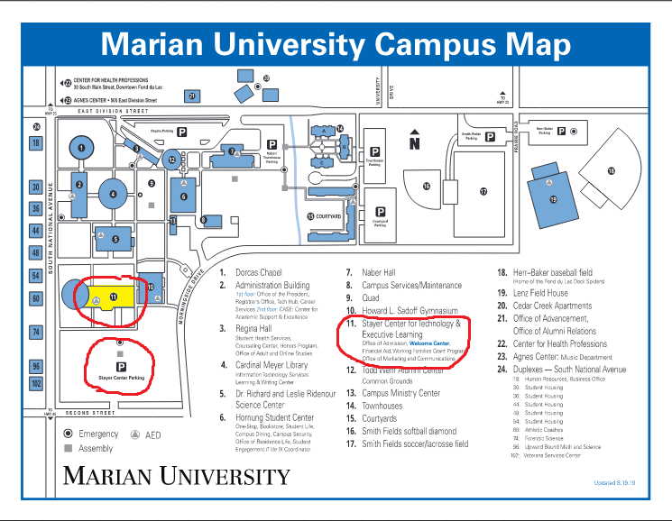

Wisconsin League for Nursing Fall Conference
October 5, 2019
Parking is available in a large lot adjacent to the Stayer Center building (number 11 on the map).
Doors open for vendors and poster presenters at 7:30 AM
Registration begins at 8:00 AM. Continental breakfast is served.
Conference begins at 9:00 AM in the Stayer Auditorium.

