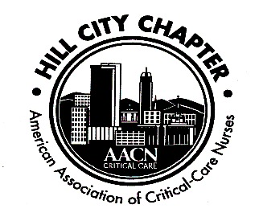**`**

**Hill City Chapter of the AACN**

**August 19, 2019**

1. Welcome: Meeting started at 1910
   1. Unstoppable – “Unstoppable is knowing if we get knocked down, we get up again,” she says. “It’s using our unique talents to expose inefficiencies and celebrate positive, innovative solutions, no matter how small.” – Megan Brunson, AACN President
2. Secretary’s report – Larisa Kerrigan
   1. Review July Minutes
      * Minutes approved:
3. Hillary Yeatts
4. Cheryl Patterson
5. Treasurer’s report – Kathy King
   1. Balances:
      * Checking - $17,509.89
      * Savings - $1,613.78
      * CDs - $5,028.07
   2. Chapter Dues - $15
      * National membership is prerequisite to local membership, even student memberships. Visit (www.aacn.org) to become a member.
        1. We have national membership available for purchase via a voucher. We have vouchers available now.
      * Local dues may be paid on our website (www.aacnhillcity.com) or at meeting by cash or check to “Hill City AACN”
6. Recognition
   1. Recognition of new certifications
      * Who are our NEW certified nurses? Congrats!!!
        1. Larisa Kerrigan - CCRN
      * Our chapter plans to recognize newly certified nurses with a small gift and one year of free local chapter membership (for national AACN members only) **Have new certified nurses contact one of the chapter officers**
   2. Chapter funds members’ application fee for CCRN, PCCN or other AACN certification exams
      * We can pay for two attempts – We ask that you reimburse chapter after success. Thank you for returning funds to chapter after being reimbursed by employer.
      * There is now a section on our website where you can download the application.
7. Conferences
   1. Annual Chapter Conference – Friday, September 6th
      * Registration open – Be sure to tell your colleagues!
8. Save the Dates: Hill City AACN Calendar
   1. October 21, 2019 – location to be determined
      * No meeting in September due to chapter conference
   2. NTI – May 3, 2020 - Indianapolis
9. New Business
   1. Scholarship for nursing students
      * Still working on a scholarship application.
   2. We would still like to fill our Treasurer- and President-Elect positions. Please let any officer know if you are interested!

Attendance:

1. Anne Marie Caylor – CTICU

2. Kathy King – STICU

3. Maria Scott – Bedford ICU

4. Cheryl Patterson – Cardiac Cath Lab

5. Hillary Yeatts – CCON/MICU

6. Larisa Kerrigan – MICU  
7. Megan Brumfield – CPRU

8. Janice Sinoski – University of Lynchburg

9. Cathy Hayes – PACU

10. Alexis King – CCON

11. Jordan Vance – EDO

12. Mary Kovach – CTICU

13. Frankie Wooten – CTICU