Midwest hpna self care retreat
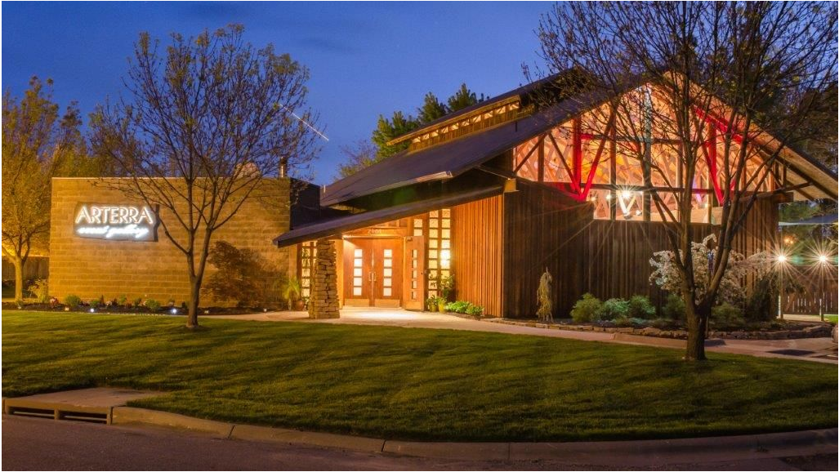  Arterra Event Gallery, Lawrence, Kansas |  | Join Midwest HPNA for a self-care retreat featuring:  - Art therapy  - Music therapy  - Meditation  - Yoga  - Healthy lunch and networking  Save the date! On-line registration will open in late September. Limited to 25 seats. Cost of event will be determined based on allocation of grant funds.
November 9, 2019 8:00-1:00
Arterra Event Gallery
2161 Quail Creek Drive,
Lawrence, KS
 |  | Midwest HPNa  Janelle Williamson, President  785-554-8036  midwestHPNA@gmail.com  https://midwesthpna.nursingnetwork.com

