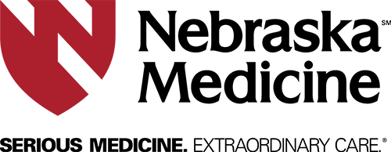

**End-of Life Nursing Education Consortium (ELNEC)**

**Target Audience:**  Nurses and other healthcare professionals working with patients at the end of life.

**Description:**  The End-of-Life Nursing Education Consortium (ELNEC) is a national education initiative to improve nursing education on end-of-life care. The project is administered by the American Association of Colleges of Nursing and City of Hope. Building collaboration with interdisciplinary team members will be included in the education.

**Questions about Content:** Please contact Carri Siedlik, 402-552-6255

**Presenter:** Carri Siedlik, APRN, ACHPN

Nurse Practitioner

Advanced Certified Hospice and Palliative Nurse

Palliative Care Program, Nebraska Medicine

**Date:** October 24, 2019

**Times:** 8:00am-4:00pm

**Location:** Buffett Cancer Center, room 7.12.330

**Cost:** None

**Registration:** Employees of Nebraska Medicine register at Apollo on Nebraska Medicine Intranet Home Page

All others email [jsiebels@nebraskamed.com](mailto:jsiebels@nebraskamed.com)

**Minimum:** 5 **Maximum:** 30

**6.5 Contact Hours awarded to participants who attend the entire activity**

Nebraska Medicine is an approved provider of continuing nursing education by the Midwest Multistate Division, an accredited approver by the American Nurses Credentialing Center’s Commission on Accreditation.

**No partial credit will be awarded**