
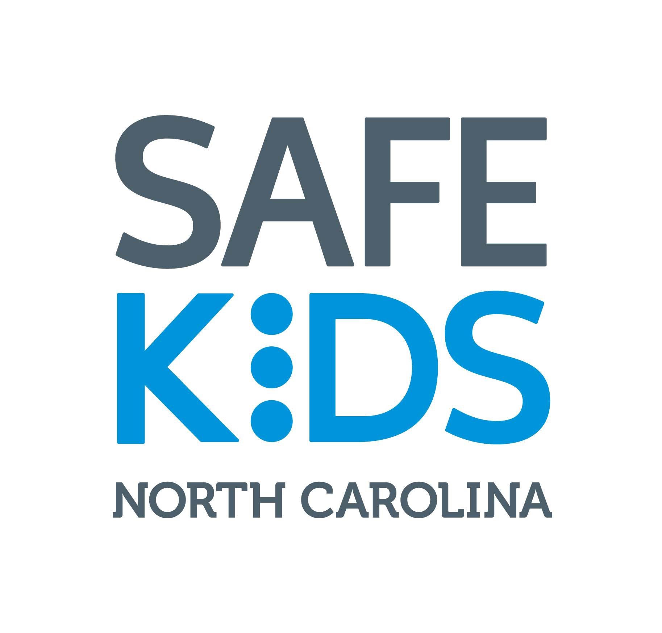
Travel Scholarship Information and Application
North Carolina Child Passenger Safety
Technician Certification Training

The North Carolina Governor's Highway Safety Program (GHSP) is offering a limited number of scholarships to help students with travel expenses (limited to lodging and meal expenses for overnight stays) for North Carolina classes sponsored or co-sponsored by GHSP / OSFM. These scholarships are administered by and available through the NC Department of Insurance, Office of State Fire Marshal (OSFM). Eligibility criteria for these scholarships are as follows:
- Training class must be located at least 35 miles from the individual’s home for non-state employees. For state employees, the training class must be located at least 35 miles from the individual’s home or duty station, whichever is less.
- Travel must involve an overnight stay.
- Travel expenses are not available through the student’s agency.
Unless the applicant is retired, self-employed or unemployed, the signature of the applicant’s supervisor is required for confirmation that the applicant meets these criteria.

What the Scholarship covers and how expenses are reimbursed:
Meals and lodging will be reimbursed at the prevailing state rates. As of July 1, 2015, these rates are as follows: Hotel: $67.30 + tax, Breakfast: $8.30, Lunch: $10.90, and Dinner: $18.70.
Allowable expenses will be reimbursed after the class, upon completion of a travel reimbursement request form (with all required receipts attached), and after your attendance for the entire class is confirmed by OSFM. It is the responsibility of the scholarship recipient to notify an on-site instructor or Injury Prevention Specialist that scholarship reimbursement is needed prior to the conclusion of the class. NC DOI-OSFM reserves the right to forfeit any scholarship request after the class has taken place even if prior approval was received.

Scholarships DO NOT Cover:
NC CPS Technician certification training scholarships do not cover class registration fees (Safe Kids CPS certification class fee and any applicable local fees), mileage for personal or agency vehicles, or any other costs associated with attending a CPS certification training class.

If Awarded a Scholarship:
- You will receive an e-mail confirmation with additional reimbursement information.
You will be responsible for making your own hotel reservation, paying for your room and meals, and keeping your receipt for lodging with a $0.00 balance. You are not required to save meal receipts. Note that in accordance with state of NC travel reimbursement guidelines, meals cannot be reimbursed unless an overnight stay is involved.
- You will be responsible for registering and paying for the class through the Safe Kids CPS Certification website cert.safekids.org before the first day of class.
- An individual on scholarship who does not pass the certification class can be reimbursed for expenses for that class, but will not be eligible for another scholarship for another class.
- Scholarships approved by OSFM are valid only for the class for which it is approved. If your registration is transferred to another class for any reason, you must submit a revised scholarship application.

Contact Allison.Cummings@ncdoi.gov to verify if scholarships are still available for a particular class prior to emailing your application.

Scholarship Application
NC Child Passenger Safety Technician Certification Training

Name: First |  | Last |  |  |  |  | State Employee: Yes No
Agency:
Work Address:
City: |  | State: |  | Zip: |  | County:
Home Address:
City: |  | State: |  | Zip: |  | County:
E-mail: |  |  | (required)
Phone: | ( )

Class Location*: |  |  | Class Dates*:
Traveling Distance: |  | miles one way
*If your registration is transferred to another class for any reason, you must submit a revised scholarship application.
Reimbursement Request: | Meals and Lodging Lodging only Meals only**  **Allowable only with overnight stays (includes sharing a hotel room and the other person pays the hotel bill).

Briefly explain why you are attending the class and how you plan to use your certification to benefit your agency and your community (attach additional page if necessary):

Requestor Name:
Signature:
The signature of the applicant’s supervisor is required below for confirmation that the applicant meets eligibility criteria listed on Page 1 OR the applicant must confirm that a supervisor’s signature is not applicable due to being retired, self-employed, or unemployed:
Not applicable; I am retired, self-employed, or unemployed
Supervisor Name:
Signature:

Email your completed scholarship application form with signatures to:
Allison.Cummings@ncdoi.gov

