

Northern Virginia Chapter needs you! We have now looking for people to fill the 2020 Board.

Courtney Elliott will be serving as President for 2020.

We need YOU! Please send Bio’s to northernvaena@gmail.

We MUST seat a President-elect, treasurer, and secretary. All nominations should be received to me by the 8/13 meeting so that voting can occur by members in September. Submission required by National by October.

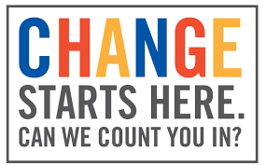

If you have any questions please don’t hesitate to reach out. The roles are not difficult and you will not be alone, we are one team. It’s been an awesome two years and I’m happy to answer any questions, my email is above.

Stephanie Fitch BSN, RN, CEN, TCRN

<http://nursingnetwork-groupdata.s3.amazonaws.com/ENA/Northern_VA_ENA/file/BoD-Roles-and-respsonsiblities-2013rev.pdf>