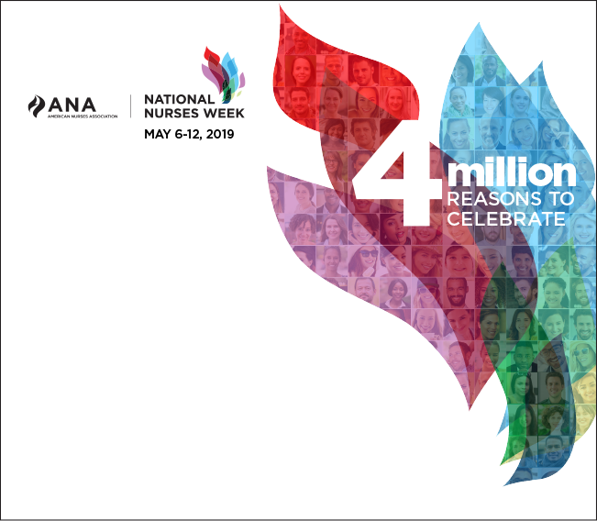

During National Nurses Week,

ANA-NY and GVNA would like

to extend a special thanks

to you, our nurses, as you

continue to provide the

highest level of quality care

to your patients. You deserve

special recognition for your

vast contributions and the

positive impact you make

every day!

