Pennsylvania League for Nursing
Nominating Committee Information

General Information and Purpose of the Constituent League (Source, 2011 Constituent League Bylaws)

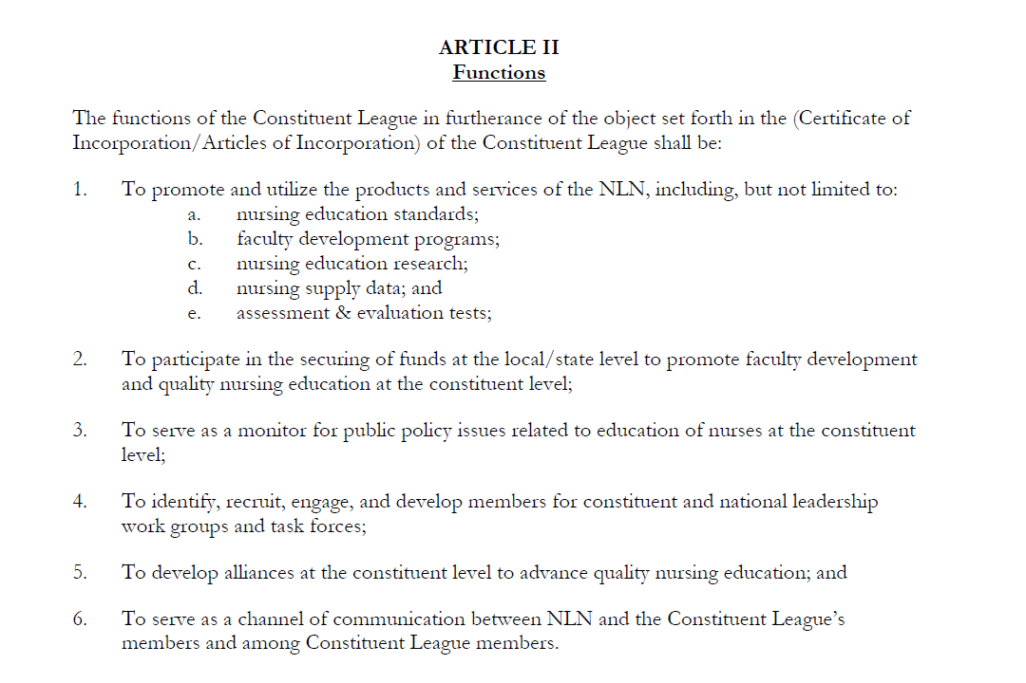

Specific Information on the Nominating Committee (Source, 2011 Constituent League Bylaws)

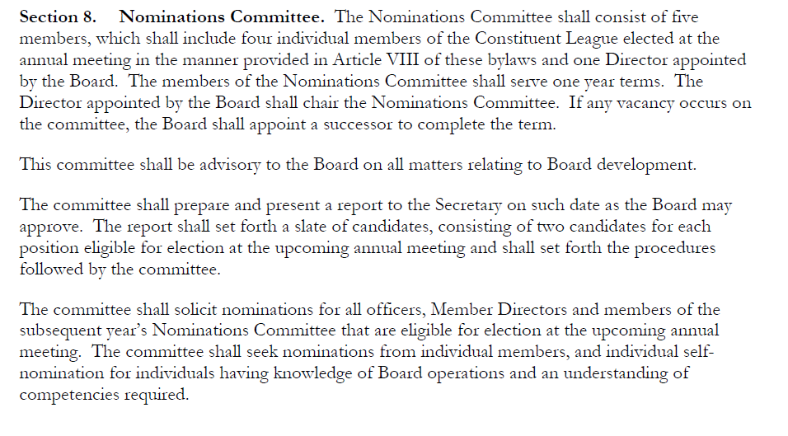

Qualifications and Responsibilities (Source: Nominating Committee Manual)
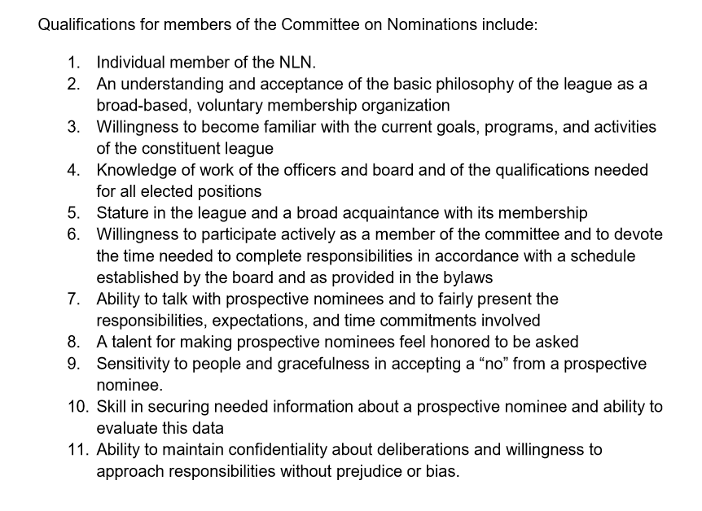
The Constituent League meets via Zoom/phone monthly. There is a requirement of one face-to-face meeting in the summer months. Monthly meetings last approximately one hour.

Additional links:
Uniform Bylaws http://www.nln.org/docs/default-source/recognition-programs/uniform-cl-bylaws.doc?sfvrsn=2
Nominating Committee Manual http://www.nln.org/docs/default-source/member-services/manual-nominations.pdf?sfvrsn=4

^{April 2019, PS}

