
St. Vincent de Paul Center
420 W. Watkins Road
Phoenix, Arizona 85002

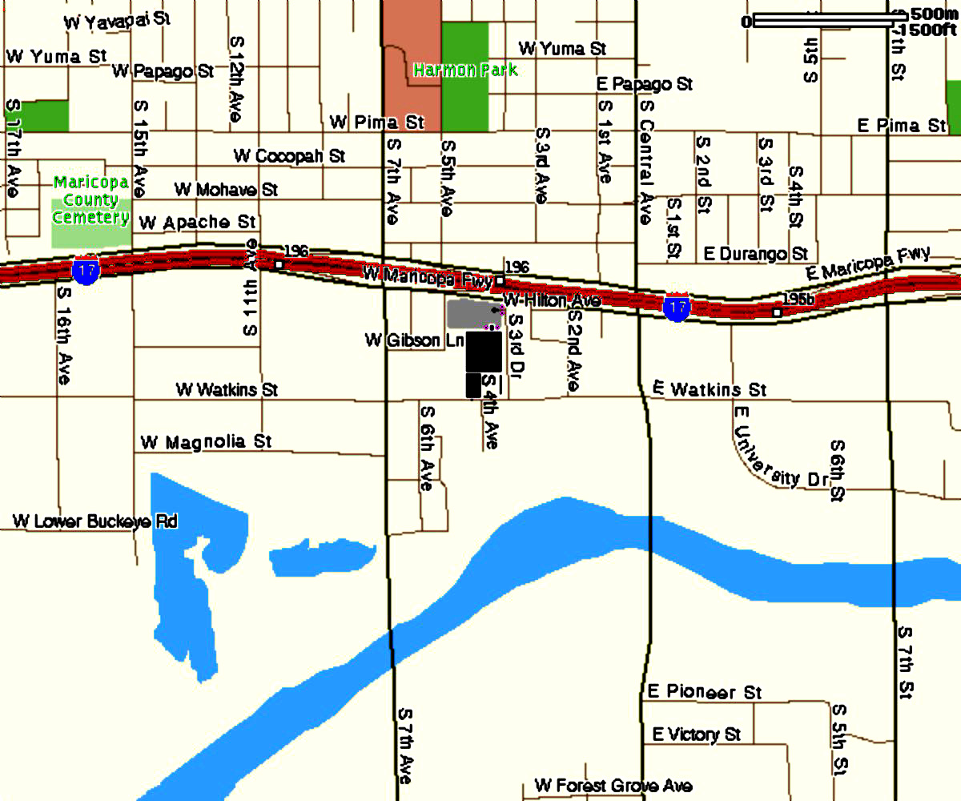
North
Entrance
South
Entrance

Directions:
* South of I-17, between 7th Ave. and Central Ave.
* Volunteers and Visitors enter from S. 3rd Dr. into the north parking lot.
* The entrance to the north parking lot is indicated by 2 pink pillars.

For help with driving directions please call Security at: (602) 261-6864

