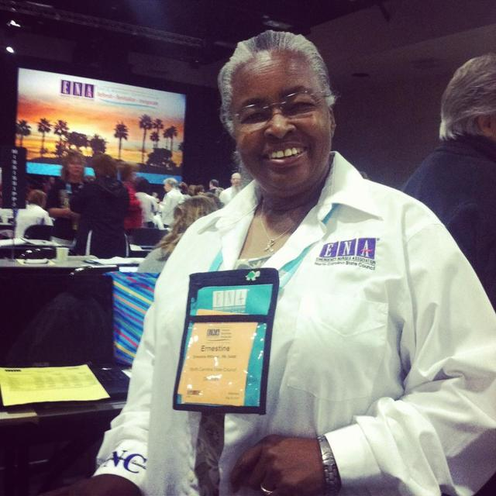

Ernestine Williams is a familiar face to ENA. She obtained her Practical Nursing Degree in August of 1967 from Fayetteville Technical Institute and her Associate Nursing Degree in August of 1979 from Pitt Community College.
As an LPN, Ernestine worked twelve years as a staff nurse in all hospital department except the OR. As a RN, she worked 35 of the past 40 years in the Emergency Department. Ernestine officially retired from Vidant Medical Center (then known as Pitt County Memorial) sixteen years ago but continues to work part-time there. She has also had multiple travel assignments across the country over the past 14 years.
An energetic member of the ENA since 1984, Ernestine has served as a NC delegate to the General Assembly 33 times. She has been very active in the Eastern Tarheel chapter, assisting in re-enacting the chapter 34 years ago and serving as a chapter leader since that time. She continues to serve on the state level as the ISQIP chair and travels across NC to attend state meetings and state sponsored conferences.
Ernestine receive the 2003 ENA Barbara Foley Award for teaching nurses and presenting to the public the Emergency Nurses to Cancel Alcohol related Emergencies (ENCARE) program throughout NC. In 2009, she received the NCENA Lifetime Achievement Award.
Ernestine remains committed to teaching as evidenced by maintaining ENPC instructor. She is also current in TNCC, ACLS and PALS provider. Through the years, she has mentored many by her presence and participation in ENA on the national, state and chapter level as well as being a familiar face within her community. Ernestine continues to be a key player in the planning of the Eastern Tarheel chapter education symposiums.

