**REGISTRATION**

**Register On-line with credit card**

**Go to** [**www.raom.org**](http://www.raom.org)

**On the home page, click onto programs and find the title of this event. Click the *register* button.**

***OR***

**Registration by mail/check**

**Checks payable to Rochester Academy of Medicine at Rochester Academy of Medicine, 1441 East Avenue, Rochester, NY 14610. Include this registration form.**

**Student/Resident**

**$10 x ______= $______________**

**RAOM/Friends of the Archives Members**

**$20 x_______ = $_____________**

**All Others**

**$25 x ______ =$ _____________**

**Total amount enclosed = $ ________**

**Name: _______________________________**

**Address: _____________________________**

**_____________________________________**

**Phone: _______________________________**

**Email: ________________________________**

**Rochester Medical Museum & Archives**

**And**

**Rochester Academy of Medicine**

**EVA ALLERTON NURSING HISTORY LECTURE SERIES**

**Rochester’s Greatest Generation: Science, Technology, and Nurses’ Work, 1940-1968**

c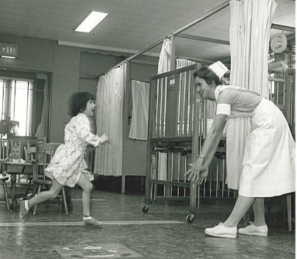

**April 25, 2019**

**Rochester Academy of Medicine**

**1441 East Avenue**

**Rochester, New York 14610**

**5:30PM registration, refreshments and networking**

**6:30-8:00PM program**

**Guest Speaker**

John C. Kirchgessner, PhD, RN, PNP, Associate Professor, Director of DNP Program of Wegmans School of Nursing, St. John Fisher College, Rochester, NY. Professor Kirchgessner is also the Assistant Director, University of Virginia School of Nursing Eleanor Crowder Bjoring Center of Nursing Historical Inquiry.

By attending this program, attendees in the greater Rochester area will gain an appreciation for the rich history of the nursing profession and its Rochester roots.

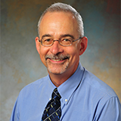

**Continuing Education Credits**

Application for nursing CE is pending from Rochester Regional Health. Rochester Regional Health Nursing Institute is an approved provider of continuing nursing education by ANA Massachusetts, an accredited approver by the American Nurses Credentialing Center’s Commission on Accreditation. Completion of this program will award 1.0 continuing nursing education credits.

**Program**

6:30 Welcome and introduction by Kathy H. Rideout, EdD, PPCNP-BC, FNAP, Dean, University of Rochester School of Nursing

6:45 – Introduction of Keynote Speaker, John C. Kirchgessner, PhD, RN, PNP

***Rochester’s Greatest Generation: Science, Technology, and Nurses’ Work, 1940-1968***

7:30 - Question & Answer Session

7:45 Closing Remarks – Dianne Cooney-Miner, PhD, RN, FAAN, FFNMRCS, Dean, St. John Fisher College Wegmans School of Nursing

*TOURS of house at conclusion of program upon request*

**Planning Committee**

Georgianna Becker, RN

Kathleen Britton, MA

Stephanie Brown Clark, MA, MD, PhD

Dianne Cooney-Miner, PhD, RN, FAAN, FFNMRCS

John C. Kirchgessner, PhD, RN, PNP

David Kluge, MD

Maria A. Marconi, EdD, RN, CNE

Kathy H. Rideout, EdD, PPCNP-BC, FNAP

Jennifer H.B. Simson, RN

Donna Tydings, DNP, RN, CNS-BC, NEA-BC

**History of the Rochester** **Academy of Medicine**

The Rochester Academy of Medicine was founded in 1900 and has been a place for education, collegiality, and community service ever since. When the Lyon family donated their house on 1441 East Avenue, in 1939, the Academy became a home for professional events, social gatherings, and collaborations for generations of clinicians from all the healthcare institutions and private practices in the community

**History of Rochester Medical Museum & Archives**

Rochester General Hospital was the original museum site. As the collection continued to grow and more space was needed, the Rochester Academy of Medicine became the new site for the museum and archives in 2014. This move made it ideal for collaboration between the Rochester Academy of Medicine and the Rochester Medical Museum & Archives. The Museum & Archives now preserves historical collections of Rochester Regional Health affiliates’ medical and nursing programs and disciplines of several other local institutions and agencies.

**ADA Compliant: Wheelchair accessible and Auditorium and Living Room are fitted with Hearing Loop**