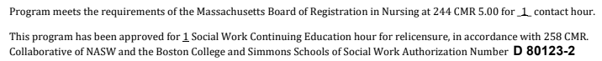

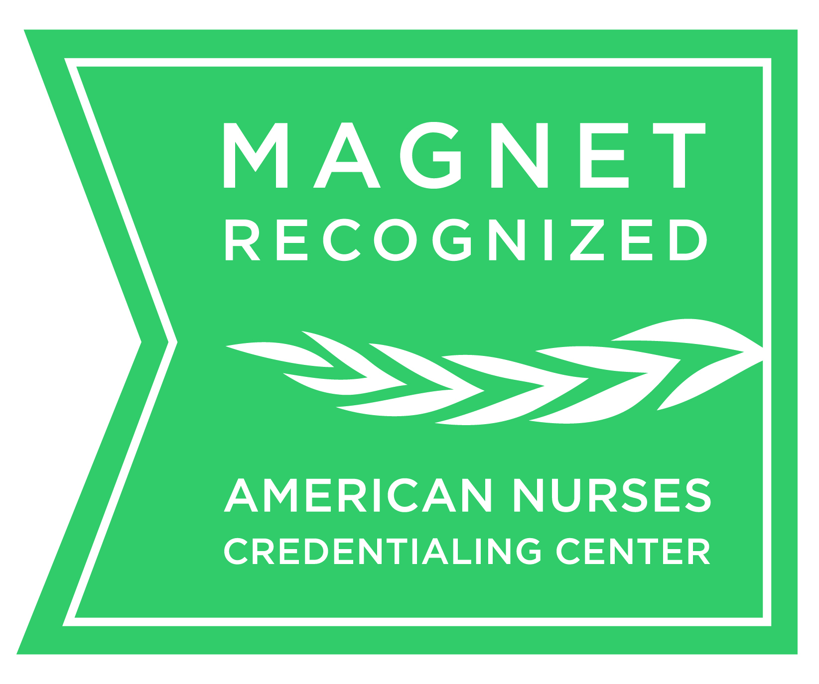

The Academy of Medical-Surgical Nurses, Greater Boston Chapter,
in collaboration with Care Dimensions, invites you to our next meeting with
*free* educational program:

“Care of the Dying Patient”
One free contact hour for nursing and social work
Register online: https://bostonamsn.nursingnetwork.com
Drop-ins are welcome!

For questions contact Joy Stepinski,
Greater Boston Chapter President at jstepinski@melrosewakefield.org

If you are an AMSN national member, please join our local chapter!
Yearly dues are ONLY $25

The Academy of Medical Surgical Nurses
is offering a free contact hour program on End of Life Care
Details:

Monday,
March 25, 2019
Educational program (open to all): 4:30 to 5:30 p.m.
Members-only meeting:
5:30 to 6:30 p.m.
Location:
Melrose Wakefield Hospital
585 Lebanon Street
Melrose, MA
Perkins Lecture Hall

