2019 Conference Planning Meeting

2/18/2019

Meeting started at 1915

September 6, 2019 for meeting

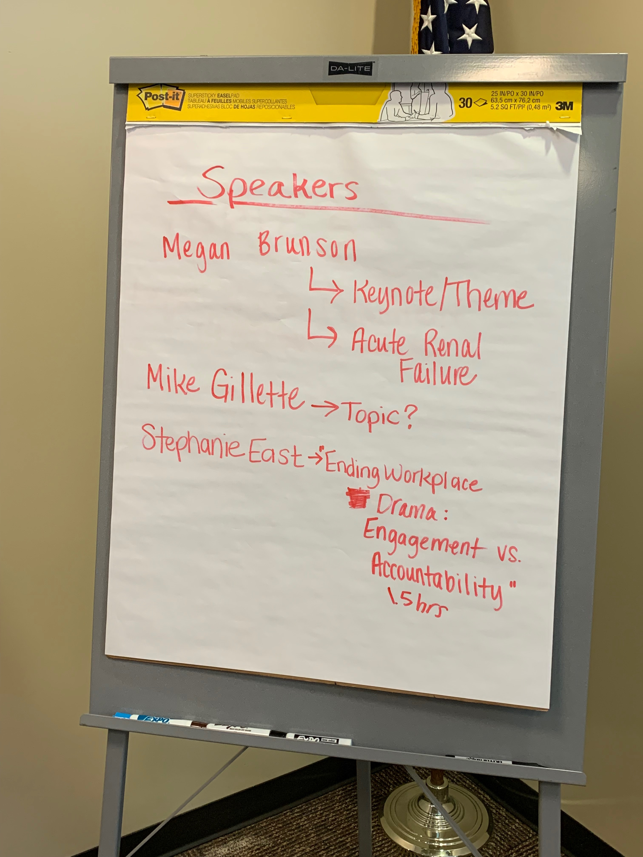Speakers for next year

Most of these are confirmed

Failed to ask for topics from last year

Need Analysis: Possibly from nursing education since we do not have any feedback from last conference

Possibly develop a focus group or other initiative to develop topics

Some topics for next year

* Legal Nurse Consultant (Possibly Holly Trent) – Jordan will try to make contact
  + How does Cerner work with staffing and charting
  + Things to be aware of EHR
* Possible floor unit managers to discuss current initiatives
* Palliative Care
  + Clareen Wiencek: Nicole will try to contact her
* Another topic fo Mike Gillette
  + Vulnerable Population
  + Transgender topics
* Jeff Duncan
* Dr. Plankeel
* Maybe something Nursing Educatioin/ Student
* Pregnancy related issues/ complications
  + Debra Acors
* Hillary will make a survey for topics for nurse through Survey Monkey
* AACN Certified Nurse Day
  + New people who pass their certification get a free year membership
  + Maybe a badge holder, lapel pin or water bottle (this would for members only)
  + March 19th is the Day

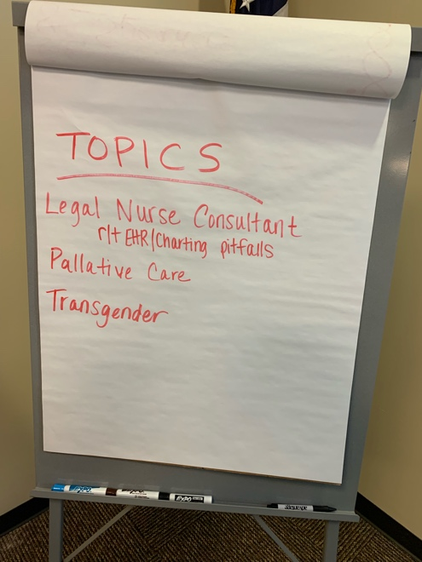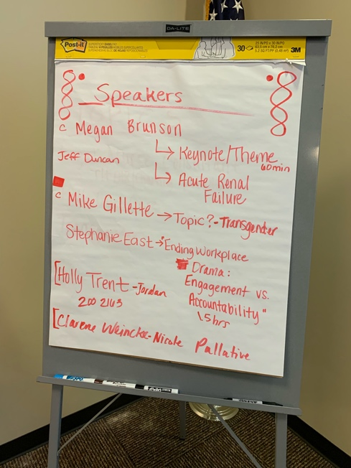

Members Present:

1. Nicole Rodriguez
2. Cheryl Patterson
3. Larisa Kerrigan
4. Jordan Vance
5. Karen Harvey
6. Anne-Marie Caylor
7. Frankie Wooten