***Healthy Nurse, Healthy Nation Conference***

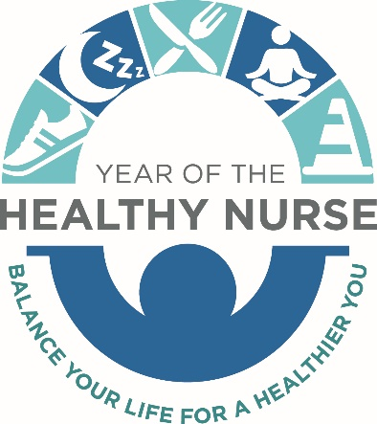

Presented by

***April 5, 2019 7:30-4:30 Staybridge Suites – Grand Forks, ND***

7:30-8:30 Registration & Speaker set up – Silent Auction opens!

8:30-8:35 Welcome- by NDNA VP of Practice, Education, Administration & Research – Jerico G. Alicante, BSN, RN, FISQua

8:35-9:30 Diversity & Differences: Connecting with Others, Yourself, and Your Creativity – David Bergstrom, MDiv, BA

9:30-9:45 BREAK (Stretching offered) – Michelle Massie, AND, CLC

9:45-11:00 Music and Expressive Therapies: A Bridge to Inclusivity – Leslie Saulsbury - MT-BC/L

11:00-12:00 LUNCH (Yoga offered) – Leslie Saulsbury

12:00-1:00 Ethics for World Class Care – Mark Ellingson, MDiv, BCC

1:00-2:30 Overcoming a Cultural Clash: A Medical and Ethical View – J. Senti, PhD & M. Ellingson, Mdiv, BCC

2:30-2:45 BREAK (Networking), Silent Auction closes

2:45-3:45 Heart Centered Healing – Michelle Massie, ADN, CLC

3:45-4:30 Closing, Evaluations, Contact Hours Certificate Disbursement, and Silent Auction winners announced!

**There is no conflict of interest for any planner or presenter involved with this activity.

**Criteria for successful completion: Must attend the entire event and complete evaluation to receive full contact hours certificate. Exact contact hours to be finalized.

**This continuing nursing education activity was approved by Montana Nurses Association, an accredited approver with distinction by the American Nurses Credentialing Center’s Commission on Accreditation (ANCC).

Thank you all for your attendance and for supporting the North Dakota Nurses Association!