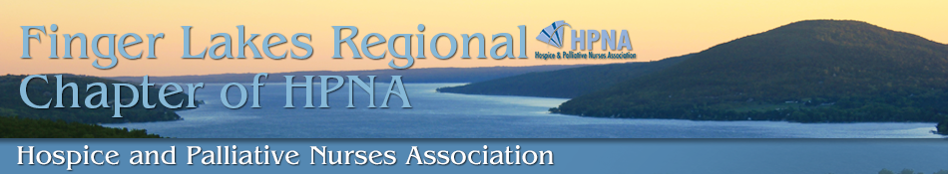
Membership Application

Name _____________________________________________
Degree/Credentials/Certification __________________________________
Address ___________________________________________ City _____________________________
State ________________________ Zip Code _____________
Phone (_____) ________________ Circle one: Cell/Work/Home
Email ______________________________________________
Place of Employment ___________________________________________________________________
Membership Information__________________________________________________________________
Membership tiers, choose one:
- Full Member ($25/one year). Members of National HPNA. Full members are allowed to hold office, volunteer on Chapter committee, and vote on Chapter business.
National HPNA member # _______________________ Expiration date ____________________
- Associate/Local Member ($35/one year). Those who are not a National HPNA member. Provides benefits of local chapter; member unable to hold office and no voting privileges.
- Students (free) Name of school and graduation date ___________________________________
Yes, I am interested in volunteering on a Chapter committee
- Education
- Website/Media
- Community service
- Nominating
- Not at this time
Yes, I am interested in a Chapter Board position
- President-Elect
- Treasurer
- Secretary
- Not at this time
Page 1 of 2

Please send check made payable to Finger Lakes Regional Chapter of HPNA to:
Christie Drury
62 Heather Dale Chase
Henrietta, NY 14467

For office use only________________________________________________________________________
Local dues received __ Yes __ No Date received ______________ __Check __ Cash
Page 2 of 2

