  
 Northern Virginia Chapter   
Northern VA ENA Meetings 2019

This list is subject to change. Locations will be finalized two weeks prior to the meeting date. Registration will be posted when meeting location has been secured. We will be moving the NoVENA meetings around the area, so stay tuned for new locations, and get involved!

Feb 12, 2019 6:00-8:00p-TBD

Apr 9, 2019 6:00-8:00p-Child Abuse prevention month

Jun 11, 2019 6:00p-8:00p-

August 13, 2019 6:00p-8:00p-TBD

October 1st-Oct 25th 2019 Board of Directors Elections voting. All votes will have to be entered and board has to be selected by 10/31/19. Must Seat COMPLETE board to prevent chapter from closing in upcoming year.

October 8, 2019 - 1:00-3:00-Domestic Violence topic, National Re-cap, Board of Directors Elections

Dec 10, 2018 - 6:00p-8:00p-End of year celebration for all the great things we’ve done for Emergency nurses everywhere as well as inductions.

Spread the word and watch for exciting things in 2018.

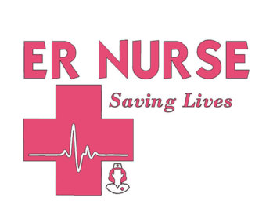

Please feel free to contact Stephanie Fitch with meeting location, suggestions or topics at [NorthernVAENA@gmail.com](mailto:NorthernVAENA@gmail.com)