Our Voice Our Strength – Ludy Santiago-Rotchford
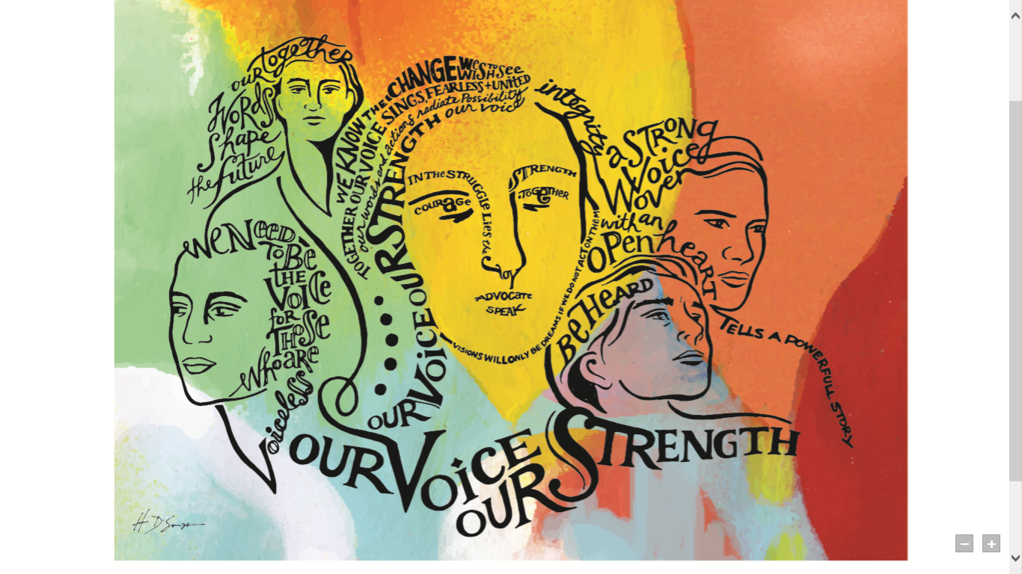
As a nurse I have always tried to comfort families who lose a loved one despite all efforts. In my own mind many times I have felt that my words were useless since all that person wants is for someone to say “we were able to bring them back-they are still with us.” My nursing career started as an oncology nurse. I loved my patients, my co-workers, … my job. Nurturing and helping others has always fed my soul. A trait that I believe I inherited from my mother. One day I had a patient who was a young woman, mother of 2 young children, with metastatic stomach cancer who had just been told that there was no other treatment to offer and that she should consider Hospice. Her response was “I can’t die, who will take care of my babies.” As we scrambled to call her family to come she took her last breath before they got there. That day after my shift I put in my resignation. I felt as though I had failed her and helpless because in my mind there was nothing that I could do to console her family. I failed to get her children there in time to hear her voice one last time. Over time I have begun to view things with a different lens and have realized that there is more than one way that nurses provide support to people who have suffered this type of loss . This year’s President’s theme of our voice our strength speaks to what we as nurses do every day. Our voice derives from what we witness, what we live. I have learned that avoiding pain and avoiding those who are suffering does not help anyone. Even if it is to just stand in silence and holding the hand of a grieving person can at least provide assurance to remind that person that they are not alone. It is alright to be sad, it is alright to be angry, it is alright to hold on to that loved one after their soul has passed with all the love in your heart… this is what will help them draw the strength to live, this is what helps me to have the strength to be a voice for them.

