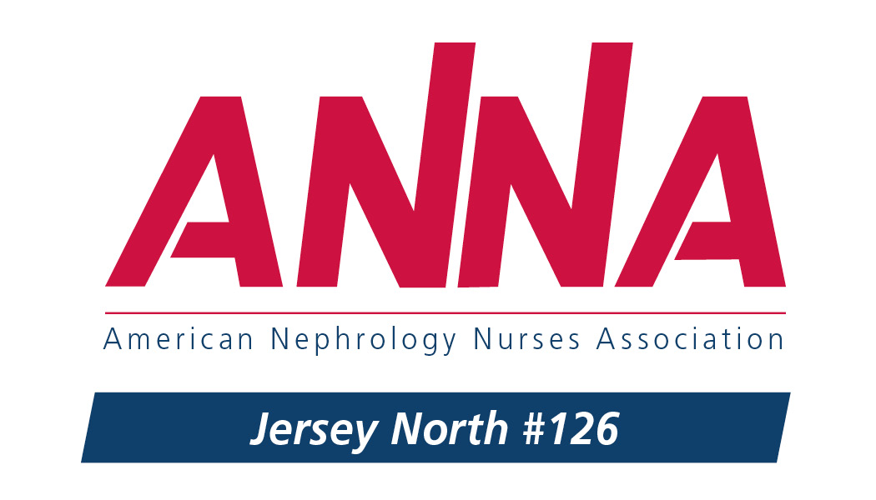

**ANNA Jersey North Chapter 126**

Presents

**Renal Issues 2019**

**Thursday, March 28, 2019**

**Ravello Banquets**

138 Eagle Rock Ave.

East Hanover, NJ 07936

Brochure and details to follow soon!