Save the Date!
March 27-28, 2019
Sheppard Pratt Conference Center,
Towson, Maryland
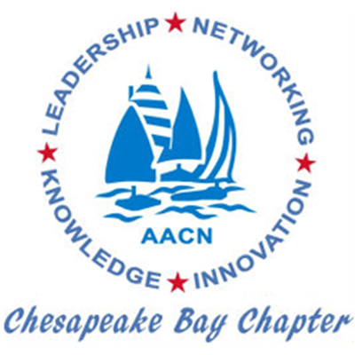
30th Annual Conference:
Critical Care Nursing: The Future is Now!

Topics include:
AACN National Update: Our Strength our Voice,
Making Sense of Medicine, Nightshift: Adapting to the Dark,
Balloon Pump Hands-on Workshop, Ventilator Workshop,
Diabetic Ketoacidosis, Managing the Aggressive and Combative Patient,
Hemodynamic Monitoring Trends, Resuscitation After Cardiac Surgery, Critical Care Transport: Care in the Wild! Malignant Hyperthermia,
Hi Flow Oxygen Therapy, Improving Sepsis Outcomes,
Implementing the Updated Stroke Guidelines,
Not on my shift: Progressive Care Emergencies
Heart Failure: New Guidelines and Strategies
Alternatives to Opioids in Surgery
and an Interactive Patient Panel: ICU Care…What Mattered?

Check out the website: aacncbc.nursingnetwork.com

