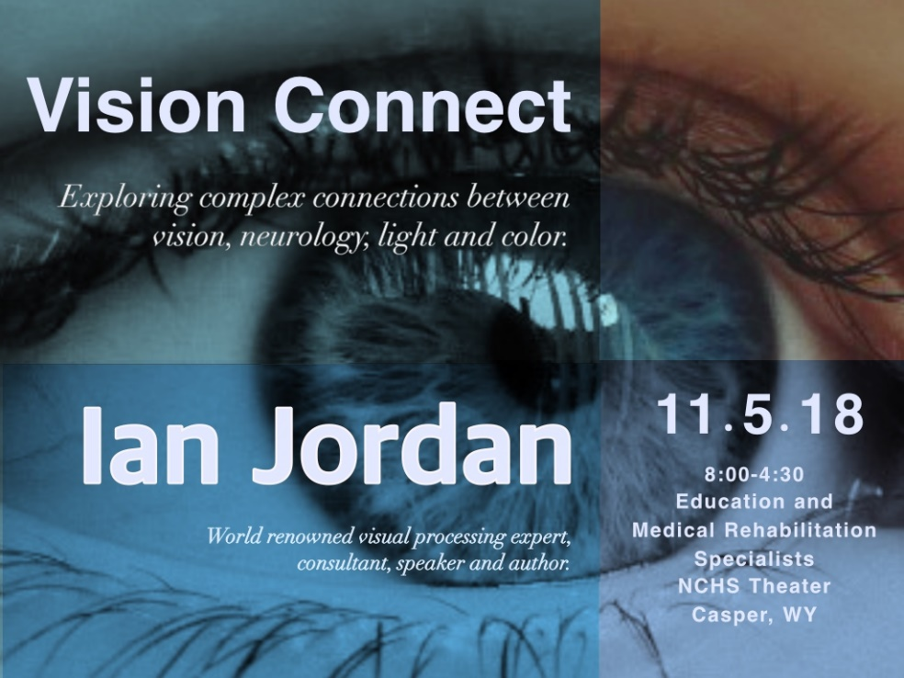

November 5, 2018

8:00am-4:30pm

Casper College Music Building Theater

Cost $80

A full day Professional Development Opportunity featuring Ian Jordan, world renown visual processing specialist, consultant, author and speaker. Ian’s work over the past 33 years is opening a new world of understanding of visual processing and the significant impact lighting and color can have among individuals with various neurologic conditions including Cortical Visual Impairment. With understanding comes the opportunity to investigate solutions which improve visual processing, sensory integration and reduce some of the symptoms an individual may be experiencing. Ian will share numerous videos documenting the immediate, clear and obvious effects custom filters offer.



Sneak Peek Videos

http://l.ead.me/Solutions

To sign up go to <http://www.eventbrite.com>

Search **Vision Connect 2018** in **Casper, WY**

Participants will learn about:

* Visual stress, its connection with other neurologic disorders and how it can significantly impact virtually every area of performance both in and out of the classroom.
* Low cost strategies and techniques which can easily be utilized within the classroom and therapy setting in order to investigate the benefits of custom lighting for individual students and dramatically improve their visual functioning.
* Local, regional and national resources available for families desiring further testing and information regarding custom filters.
* Educational benefit verses the medical nature of custom filters (worn as glasses).
* The custom filter prescription process. From Optometrist to Visual Processing Specialist, building understanding and sharing information with families.
* Information and strategies to help families understand their roll in acquiring custom filters.

Participants will leave with:

* A new understanding of the power and impact vision and Visual Stress has on every aspect of student performance.
* Cost and time effective strategies they can utilize to evaluate and support student needs to reduce the impact of visual stress in the classroom and across all school settings.
* Instructions needed to build a low cost Sensory3 space for use in their classroom or work area.
* Sample documents such as data collection sheets, a check list style of simple cost effective accommodations, and sample letter/documents for use when reporting findings.
* Links to online information and resources.

Potential Audience:

* All Certified Special Education Staff
* All Special Education Support Staff Working with Students
* Regular Education Staff
* Reading
* Tutors
* 504 Coordinators
* Refocus – Reboot Coordinators and Behavior Support Staff
* School Nurses

Morning Session 8:00-11:30:

* Topics:
  + Brief History of Filters/Tints in the US and UK
  + Overview of visual processing and neurologic function
    - Visual stress
  + Reading and Math Difficulties and Visual Distortions
  + ADD/ ADHD – Behavior and Visual Stress
  + Chronic Headache, Migraine and vision
* Whole Body
  + Gluten
  + Lactose
  + Asthma
  + Immune System
  + Environmental Lighting, Eye Vizz, Sensory3 Cube and filters

Afternoon 1:00-4:30:

* Visual Stress and the link to other Neurologic Conditions
* The impact of visual processing difficulties on the following:
  + Gross and Fine Motor coordination
    - navigation and depth perception
    - balance
  + Auditory Processing
    - tolerance of typical environmental sounds
    - understanding speech with background noise
  + Speech 
    - improved control of speech related muscles
    - ability to look at faces and copy mouth movements
  + Touch
    - normalized tactile sensitivity
    - better tolerance of clothing, tags, hair brushing
  + Smell and Taste
    - normalized perception of smells and tastes
  + Vision 
    - Visual distortions resolved
    - Ability to see an entire face when looking at the nose
    - Ability to comfortably look at faces
    - Normalized light sensitivity
    - improved visual stamina
    - improved depth perception
* Autism – Asperger’s and Vision, It’s not what you think
  + Prosopagnosia – facial blindness
  + Facial Distortions
  + Visual Field
  + Sensory Integration
* Sensory3 
  + Cognitive comfort through color
  + Application within the Classroom
  + Data collection – samples