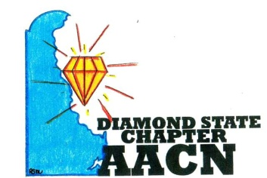 Est.2006 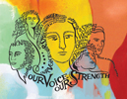
“Shine Bright Like A Diamond”
Agenda October 9, 2018
- Welcome and recognition
- Introductions of any new members
- Recognition of newly certified or any other professional accomplishments of chapter members
- Thank you to chapter for helping Ludy
- Reports
- Review of September minutes
- Treasurer report
- New/Old Business
  - “Our Voice, Our Strength” – Michelle Weeks
  - Quarterly Education “ICU Sleep Protocol” presentation by Dannette Mitchell
  - Best Practice Knowledge Sharing “Falls” led by Ryan Miller
  - Region 3 Updates by Desiree Hodges
  - Business Cards/New member welcome gift – Updates from Ryan Miller and Michelle Weeks
  - Ronald McDonald Dinner – 11/25
  - Christmas Community Service/Dinner meeting
    - Location – Cantwell’s Tavern
    - Sponsor/Vendor
  - Membership Drive – Bayhealth/Beebe/Christiana
    - Update from Nanticoke? Point of Contact?
- Roundtable
Next meeting November 13, 2018 at 6pm @ Christiana, Newark, DE

