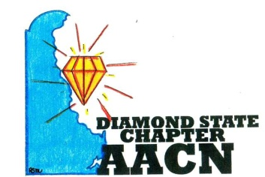 Est.2006 
“Shine Bright Like A Diamond”
Agenda September 18, 2018
- Welcome and recognition
- Introductions of any new members
- Welcome and recognition of new chapter officers
- Recognition of newly certified or any other professional accomplishments of chapter members
- Reports
- Review of August minutes
- Treasurer report
- Old Business
  - “Our Voice, Our Strength” – Sidione Salmon
  - Noah’s Ark flyer/collection
  - Quarterly Education – Danette Mitchell
  - Best Practice Knowledge Sharing – Ryan Miller
- New Business
  - Region 3 Collaborative – October 4-5 Pittsburgh, PA
  - Business Cards/New member welcome gift
  - Ronald McDonald Dinner Prep Dates December 2018 (Available dates as of 9/11 are 12/1, 12/9, 12/22, 12/16, 12/29, 12/30)
  - Christmas Community Service/Dinner meeting?? Where?? Sponser??
- Roundtable
Next meeting October 9, 2018 at 6pm @ Bayhealth in Dover, DE

