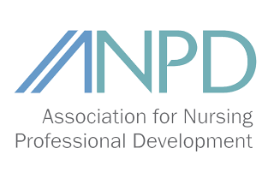
Fort Worth Affiliate
September 13, 2018
12:00-1:00 PM

Agenda

- Welcome
- Old Business
- July meeting minutes approved electronically
- Website: https://anpdfw.nursingnetwork.com/

- New Business
- Propose to move November meeting
- NPD Week September 23-29
- ANPD Convention 2019

- Presentation by Dr. Patricia Newcomb
- Using Published Tools to Help Appraise Research Reports


- Next Meeting: TBD

