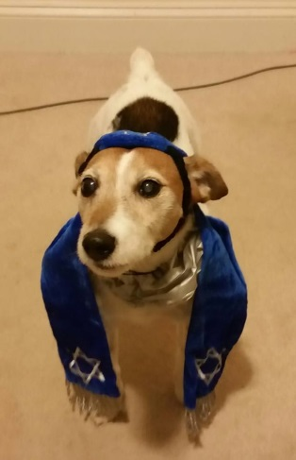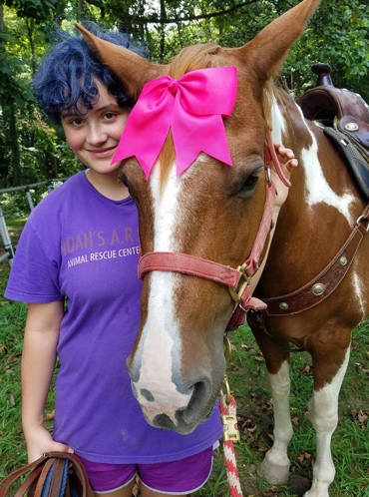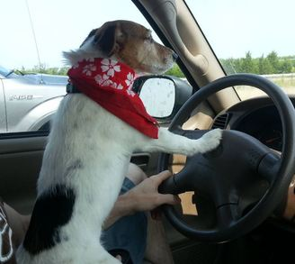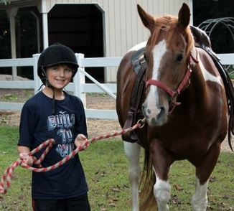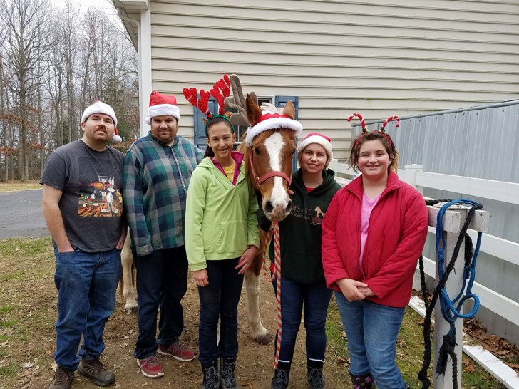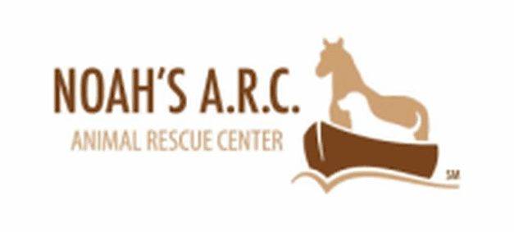

Please consider donating some money or toys to help aid the horses and dogs. The money will go towards medical bills, supplies and toys needed. This company helps people in need by offering their animals for service. Noah's Animal Rescue Center seeks to share the love of God by rescuing, rehabilitating, and re-homing animals. Additionally, we have rescue animals that help rescue people through therapy and educational programs.

F

U

N

D

R

A

I

S

E

R