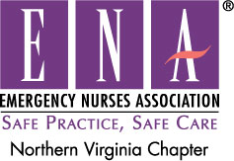

**Join Our 2019 Board!**

We are looking for members to be a part of our 2019 Board. There are many perks for being on the Northern VA Board...We are the largest Chapter in VA, Come be part of the revitalization! You gain insight on how ENA works, and financial support to attend the ENA State and Chapter Leaders Conference as well as the ENA Annual Conference (available for first position listed below). Listed below are the available positions of the board, as well as a brief description for each.

**Treasurer**: Collects all money, pays bills in timely fashion, produces monthly financial statements for the board and produces year-end financial report.  
**State Council Representative**: Attends minimum of 50% of state council meetings, reports on state and national activities and represents Northern VA ENA's concerns to state council and votes accordingly.  
All board members are required to attend at minimal of 50% of board meetings, to be active in board and chapter meetings/activities and carry out position duties and responsibilities in a timely manner.

If you would like to get more involved and feel you can meet these duties and responsibilities, please submit a self-nomination to [NorthernVaENA@gmail.com](mailto:NorthernVaENA@gmail.com) by 9/15/18.

We look forward to working with you!   
Stephanie Fitch RN, BSN, CEN, TCRN  
2019 Northern VA ENA President