Our Voice Our Strength

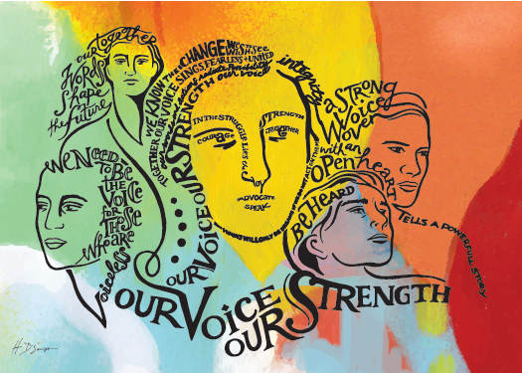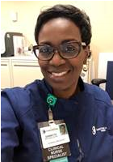

Dannette A. Mitchell, MSN, APRN, ACNS-BC, CCRN

Clinical Nurse Specialist

Christiana Care Health System

I did not attend NTI this year. As I have done in previous years, sitting at my computer anxiously checking the site to see what the next theme would be, there I was this year. The positive energy and reinvigoration that the unveiling of the theme evokes is unlike any other. It sparks something new in many of us to then go out and make the words come alive through our work. As soon as it hit the site, I watched and listened to the powerful words spoken by Lisa Riggs that gave me strength as I sat at my desk, so I knew what it must have done for those in the room. If you were there, I hope you felt it.

*“It is easier to act your way into a new way of thinking than it is to*

*think your way into a new way of acting” LR*

I have been a critical care nurse for over 25 years. I attended my first NTI in 2008 and was amazed! The theme that was unveiled that year by then president- elect David Hansen, CNS was Reclaiming Our Priorities. From that speech that year in the presence of 8,999 critical care nurses just like me, I found my AAAAHHHHHHH. I realized that I was at that conference listening to that speech delivered by a CNS for a reason. I used the time thereafter as a spring board for the work I was to do. In essence to find my voice because it would become my strength and that of others I may impact along the way.

*“We need to be the voice for those*

*who are voiceless” LR*

At that time in May of 2008, I had been a nurse in my ICU for 12 years. I was a great nurse by most accounts. I was charge, preceptor, RNIII, educator, leading many successful initiatives with our great team: yes doing many things, but there was still more to do. I was able to use my voice in my local setting and we were able to make changes that not only fueled my passion, but others’ as well. The more we “spoke” either with voice or with action, the more powerful we were and doing great work, improving patient outcomes, creating a healthy work environment became contagious. We got things done. That year, I also returned to school to work toward my MSN. I wanted to add education to the professional experience credentials I already had.

Over time, as I have transitioned into the CNS role, I have used my voice. I have used my voice to comfort patients and families, to teach students, to speak at conferences, to educate nurses. I have said yes to things that were uncomfortable. I have used my voice to ask why and why not and then share those learnings with others. I have used my voice to ask how, and have shared those learnings as well. I have added more evidence to what I say, I have changed my tone a bit, I have selected when to speak, but I am not silent and thus I am stronger. *Our Voice Our Strength*

*“Our deepest fear is that we are powerful beyond measure” MW*

How will you use your voice as your strength?