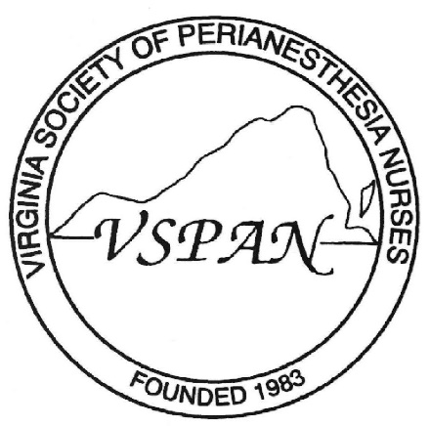

**Dear Perianesthesia Colleague,**

**VSPAN would like to share with you our updated scholarship program. Please visit our website at** [**www.virginiaspan.org**](http://www.virginiaspan.org)**.**

**The names of the scholarship winners will be announced on our website as well as at annual state conference. VSPAN is excited to be able to extend this opportunity for our fellow Perianesthesia nurses and nursing students. We invite you to join us in networking, professional development, community service, advancing our specialty and participation in lifelong learning.**

**Please feel free ask any questions or contact any board members on our website.**

**Again, we are excited to offer our fellow Perianesthesia VSPAN members this opportunity.**

**Sincerely,**

**Sally Schermer, RN, BSN, MBA, CCRN, CPAN, CAPA**

**VSPAN Membership Chairperson**