*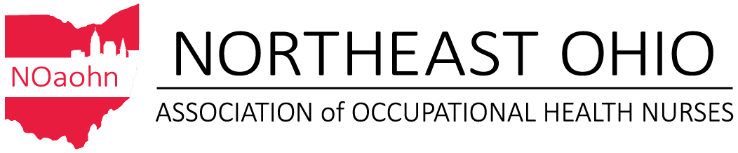And*

*The Western Reserve Chapter of The Ohio Association of Occupational Health Nurses*

*Cordially Invite you to Attend our Annual Meeting*

*Complimentary & Alternative Medicine in the Workplace*

[](https://www.google.com/url?sa=i&rct=j&q=&esrc=s&source=images&cd=&cad=rja&uact=8&ved=2ahUKEwjDm8rq-KjcAhUH3IMKHVBIDWIQjRx6BAgBEAU&url=https://www.espressoeducation.com/complementaryalternative-medicine-peoples-choice/&psig=AOvVaw3sk8fAKdm47Me-jVpf9d2m&ust=1532013353239201)

Speaker: Dr. Haidy Kamel

September 13, 2018

The Lincoln Electric Company

22801 St. Clair Ave.

Euclid, Ohio 44117

11:30 a.m. – 1:00 p.m.

Lunch Provided

**Please RSVP Fran Borrows @ 216-280-6301 or** [**Fran@projectteach.com**](mailto:Fran@projectteach.com) **by Sept. 5, 2018**

This continuing education activity is pending by the Ohio Nurses Association, an accredited approver by the American Nurses Credentialing Center’s Commission on Accreditation. (OBN-001-91)