Support GAPAN
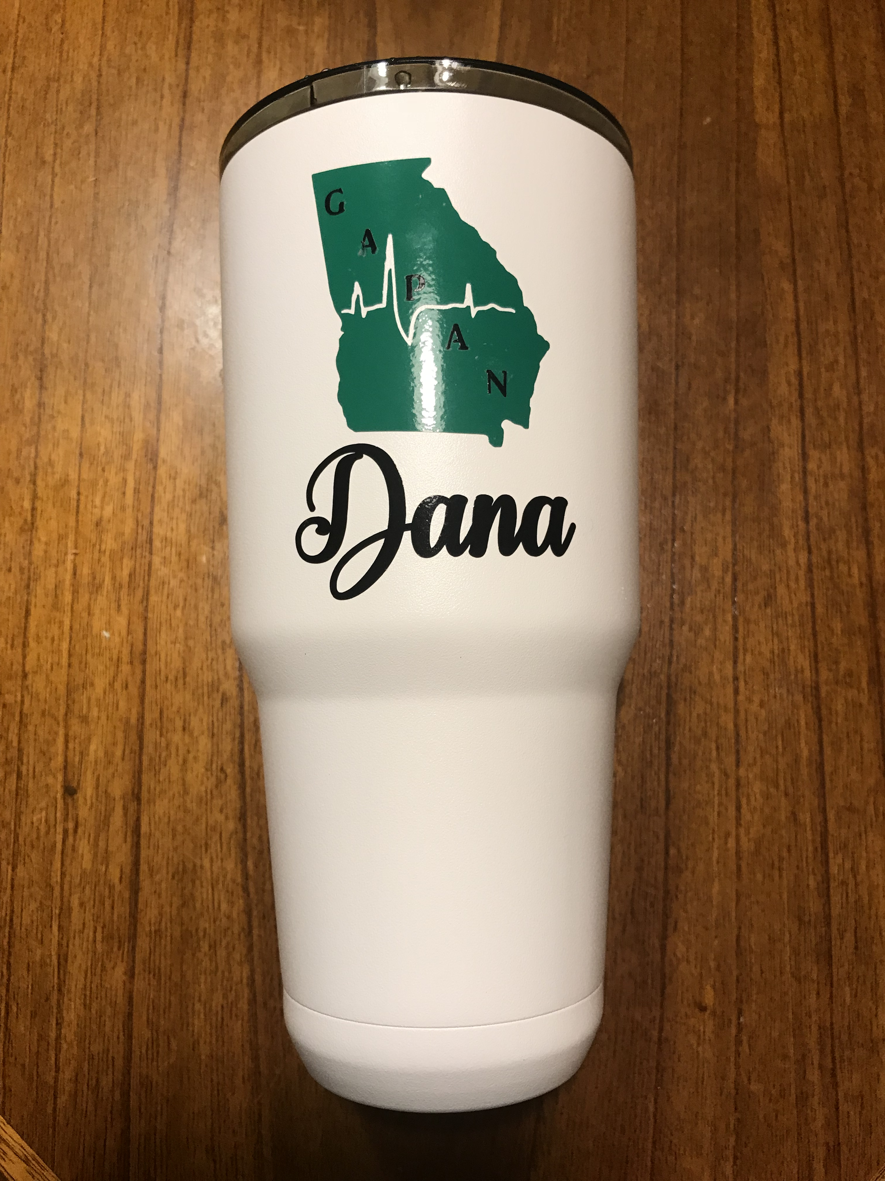 |  | White 30 oz. Yeti-Style Cup  GAPAN logo  - Your name  $35 each  (includes shipping)
Number of cups __________ x $35.00 each = _______________ (Total)

Name as it will appear on the cup: __________________________________
__________________________________

Ship to:

Name _____________________________________________________
Address___________________________________________________
City____________________________________ State ____________
Phone Number __________________________________________

Payment:
Please make check payable to GAPAN
Mail to:
4010 Hamilton Cove Ct
Cumming, GA 30028

