**Just in Time**: Pirate Nurses Report from Guatemala 2018

By Kim Larson, PhD, MPH, RN, FNAP

Associate Professor

In case you were wondering, seven nursing students and I returned from Guatemala the day before **Volcan de Fuego** erupted on June 3, 2018. We just made it out of the country before the airport was closed and villages were entombed in volcanic ash. Volcan de Fuego is located 9.5 miles from where we lived and worked for the prior three weeks. Most mornings we woke to the volcano puffing a plume of smoke and the villagers reassuring us that puffs of smoke meant NO eruption. This is not geologically sound thinking, but we were comforted by the illusion. We have since talked with our host families and partner organization and no one we know was hurt. Still, hundreds of people died, were injured, or lost their homes. The **Consulate of Guatemala in Raleigh, NC** (that opened June, 2017) has a disaster relief effort that will get to the people if you want to help (www.consraleigh.minex.gob.gt).

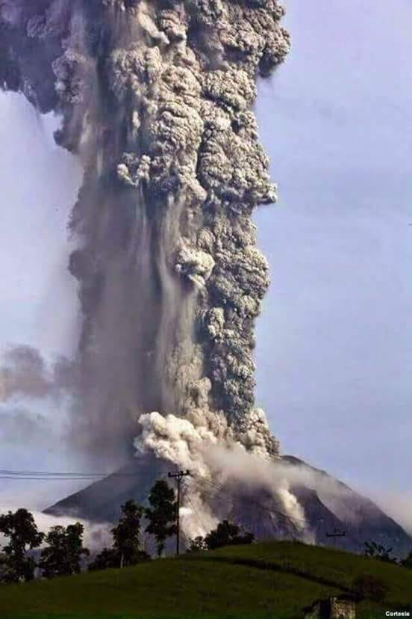

Julio Gonzalez, the community leader we worked with, took this photo of **Volcan de Fuego**. He was 9.5 miles away at the time.

This was the worst eruption in over 100 years because the explosion caused a mixture of burning lava, pumice, ash, and volcanic gas, to shoot 6 miles into the atmosphere. Known as a **pyroclastic flow,** when the mixture fell down to earth it moved at a speed of 450 mph, making evacuation impossible. It covered a 12-mile radius around the volcano. The government officially announced that 1.7 million people have been affected.

***New Travel Advisory*.** This year the US State Department revised the International Travel Advisory and designated Guatemala a **Level III country** indicating that people should “reconsider travel” (Level IV is a “do not go” country). I have held this course for the past 11 years in Guatemala with over 120 students returning safely. I consulted our partner organization who confirmed the crime rate in Guatemala was lower than in previous years. Still, we signed the necessary warning forms. While in Guatemala, our host organization scheduled a special session with the students and the US Embassy to discuss the new travel advisory and immigration. The students learned of the complexity around these advisories which include crime, as well as health (e.g. Zika), natural disasters, civil unrest, and even how an election or sporting event may pose a safety risk. The travel advisory affected some humanitarian efforts. Hundreds of people in Habitat for Humanity groups cancelled travel to Guatemala.

One goal of the US Embassy is to address the underlying drivers of illegal migration, which they do with the help of the US Agency for International Development (USAID). The students had an opportunity to talk with staff at USAID and learn about a project to educate and job-train girls and boys age 15 to 24 years in areas of health and agriculture to mitigate migration to the US. ECU students learned how the 36-year civil war that ended in 1996 still influences the daily lives of many Guatemalans. Related to this, one student reflected on an observation when he was there,

The final thing that really got me today was when we were leaving, there were two handicapped individuals, one in a power wheelchair and one in a standard wheelchair. The first was pulling the latter down the street. They were connected, though I can’t remember how exactly. This was really moving. On one hand I hated to watch them go down the cobblestone street, bouncing around in traffic, and on the other I was happy that they were working together to do what they wanted to do. They were empowered and making the most of their situation. It makes me wonder what services they have available to the handicapped population here. I know from just what I’ve seen that buildings and even sidewalks are rarely handicap accessible. I wonder what challenges that presents for them, their families, and their friends. I don’t always think about it in the US because we have laws that protect those with disabilities, ensuring accessible facilities. I wonder if the Guatemalan government has any such regulations, particularly since people with disabilities must have increased after a three decade civil war. Ben Miller, nursing student

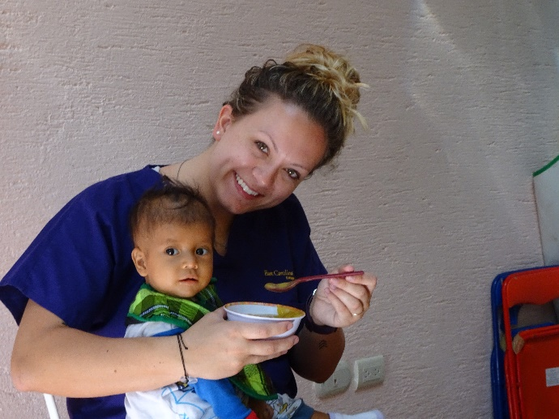 ***Community Clinical***. It was the rainy season when we arrived and at our annual primary care clinic in Vuelta Grande, with Doctora Cuyan, we saw 15 people before the torrential rains drowned out the student’s “charlas” or health talks and prevented others from leaving their homes. **Beta Nu provided funds for essential medicine at this clinic.** A 17-year-old first time mother initiated prenatal care that day. She was given prenatal vitamins, referred to the health department, and instructed on public transportation. Students thought the clinic was valuable for her alone. The remaining medicine was donated to Corazones de los Niños, a non-profit community-based organization that provides free or reduced-cost primary health care services in nearby villages. Other **Beta Nu funds** went to a *comadrona* (lay midwife) training program that has effectively reduced maternal mortality in the country.

Students spent a total of 28 hours working at Casa Jackson, a residential nutrition rehabilitation center. Children are admitted to Casa Jackson from either a health department or hospital after being diagnosed with moderate or severe malnutrition. Some have lost the desire to eat, so feeding these children is not easy. They stay anywhere from 2 weeks to 2 months and return home with a water filter, a concrete floor, and a flock of chickens. One student reflected on the lasting impression of Casa Jackson,

All of the employees at Casa Jackson were phenomenal at their job and especially at getting the kids to eat. I am so grateful to know that I was able to help these amazing women and that amidst these 3 short weeks I was able to sense the children placed some of their trust in me as well. From now on, I will always remember Estelita’s little giggle, Karla’s sass, Eduardo’s head and finger shaking, Rosario’s kind eyes, Kimberly’s sweet smile, Santo’s furrowed brow, Tania’s laugh of pure and unrestrained joy, and Christopher’s hug that seemed to envelop my entire body. Graziella Dominado, nursing student

***ECU-CON Clean Water Project***. More than 90% of the water sources in Guatemala used for drinking are contaminated. A $35.00 table-top water filter can save a child’s life. For the 5th consecutive year, we have purchased, instructed, and distributed table-top water filter systems for households without access to safe drinking water. Students stretched their Spanish skills giving “charlas” on safe drinking water, nutrition, and oral health. The Clean Water Project began in Vuelta Grande, our partner village, where we have distributed 85 water filters. In 2017, we expanded to a second Maya village, where we distributed 20 water filters. This year, 2018, we expanded to three new villages, where we distributed 40 water filters. The ECU-CON Clean Water Project has purchased a total of 147 water filters for households in five Mayan villages, improving the lives of over 1100 people. With our long-standing community partnership, we have several on-going studies in Guatemala evaluating the acceptance and use of water filters and the perceptions of health and illness in relation to water filters. A total of nine honors students have either completed or are in the early stages of their senior honors project in Guatemala. One student presented her research at the STTI Rising Stars Poster Session at the 32nd STTI Biennium Conference in October, 2017.

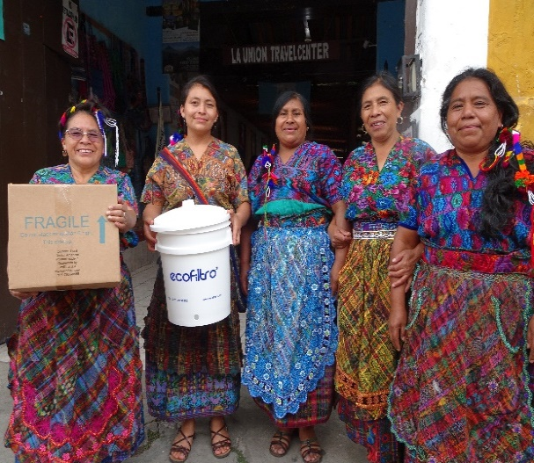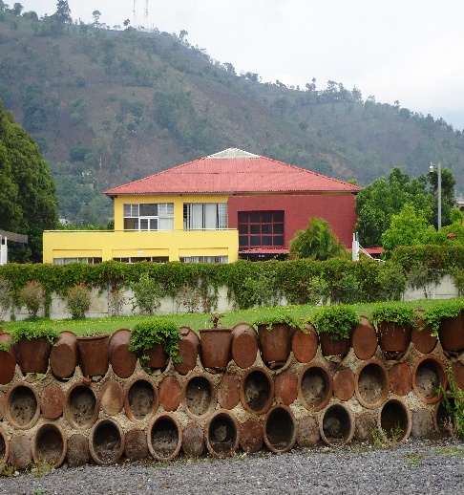

Every two years the families replace the filters. In this photo, old filters have been recycled to build attractive, community fences.

This program could not have been possible without the financial support and material donations from **STTI Beta Nu Chapter**, ECU and CON international travel awards, Wells Elementary School in Wilson, NC, local churches, and family and friends. We admire the fortitude of the Guatemalan people in their everyday struggle with adversity and are thankful to partner with them each year.