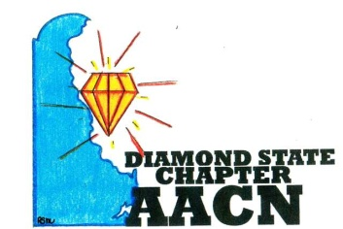 Est.2006 
“Shine Bright Like A Diamond”
Agenda July 10, 2018
- Welcome and recognition
- Introductions of any new members
- Welcome and recognition of new chapter officers
- Recognition of newly certified or any other professional accomplishments of chapter members
- Reports
- Review of June minutes
- Treasurer report
- Old Business
  - Memberships – student/multi-year memberships
  - Guided By Why – Angel Dewey
- New Business
  - Community Service Project – volunteer @ Magnolia farm
  - Education/CEU’s quarterly offered for meetings
  - Conference 2019
  - Certification mentorship project/certification book collection
- Roundtable
Next meeting August 13, 2018 at 6pm @ Christiana

