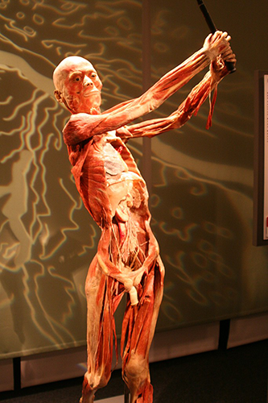**Greater Phoenix Area Chapter of AACN invites you to**

**Bodies Revealed Exhibit**

When

July 12th, 2018

5:15pm – 6:00pm gathering at The Views for tickets and appetizers

6:00pm – 8:00pm: Bodies Revealed Exhibit

Where

The OdySea – The Views restaurant

9500 East Via de Ventura, Scottsdale AZ 85286

**Must Pre-register at gpaaacn.nursingnetwork.com.**

Discounted tickets are available for GPAC members.