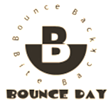

BOUNCE DAY 2014

*Bounce Back. Bite Back.*

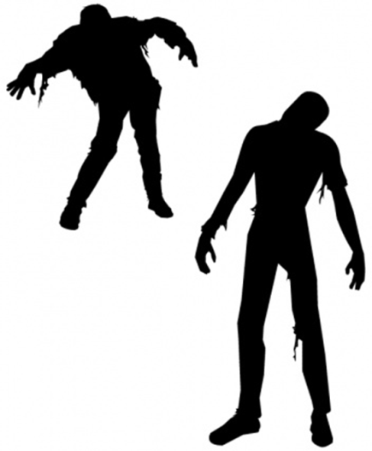

**REGISTER AT:**

**www.BounceDay.blogspot.com**

@BounceDay #BounceBackBiteBack

RochesterBounceDay@gmail.com

**A Zombie Apocalypse Simulation to train medical students and community members to respond to disasters and emergencies**

**We need YOU to volunteer as an actor, healthcare professional, emergency response team member or community member for the 4th Annual Rochester Bounce Day.**

**Did you know?**

* Zombie drills are recommended by the CDC
* They allow the practice not only of infectious disease management, but also all of the other emergencies that happen when society collapses.
* 95% of disaster victims are rescued by “neighbors,” not “disaster” agencies
* 85% of critical infrastructure is private, not government
* Events that seek to engage the community more broadly will likely improve individual and, therefore, community resilience
* The historical paradigm of community preparedness has been government/public safety-centric…not citizen-centric, not whole community in nature
* Individuals who understand how and what government agencies do during a disaster are better able to accept direction and trust their officials during a disaster
* Individuals who experience a disaster drill are better able to understand the complexities of a disaster and the importance of personal preparedness

**Saturday, September 13th**

8:00am to 2:30pm

Gamehaven Scout Camp

5015 Simpson Rd SE, Rochester, MN