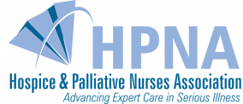



Nominations are Open to Recognize
Outstanding Contributors to the Profession
Five National Awards Presented by HPNA for 2019

Nominations are welcome for HPNA's 2019 Awards to recognize outstanding contributors to the profession. HPNA awards recognize the work and achievements of hospice and palliative care nurses and other professionals. The nominating period is open until June 17, 2018. Awards will be given during the Annual Assembly for Hospice and Palliative Care, presented by HPNA and AAHPM in Orlando, March 13-16, 2019.

It's easy to nominate a deserving colleague for one of five national awards:
- Vanguard Award
- Distinguished Career Achievement Award
- Distinguished Nursing Practice Award
- Distinguished Nursing Researcher Award
- New Investigator Award
Please refer to the criteria and eligibility for each award and find the application form at advancingexpertcare.org/awards-recognition.

Hospice and Palliative Nurses Association
412.787.9301 | Email | Website

