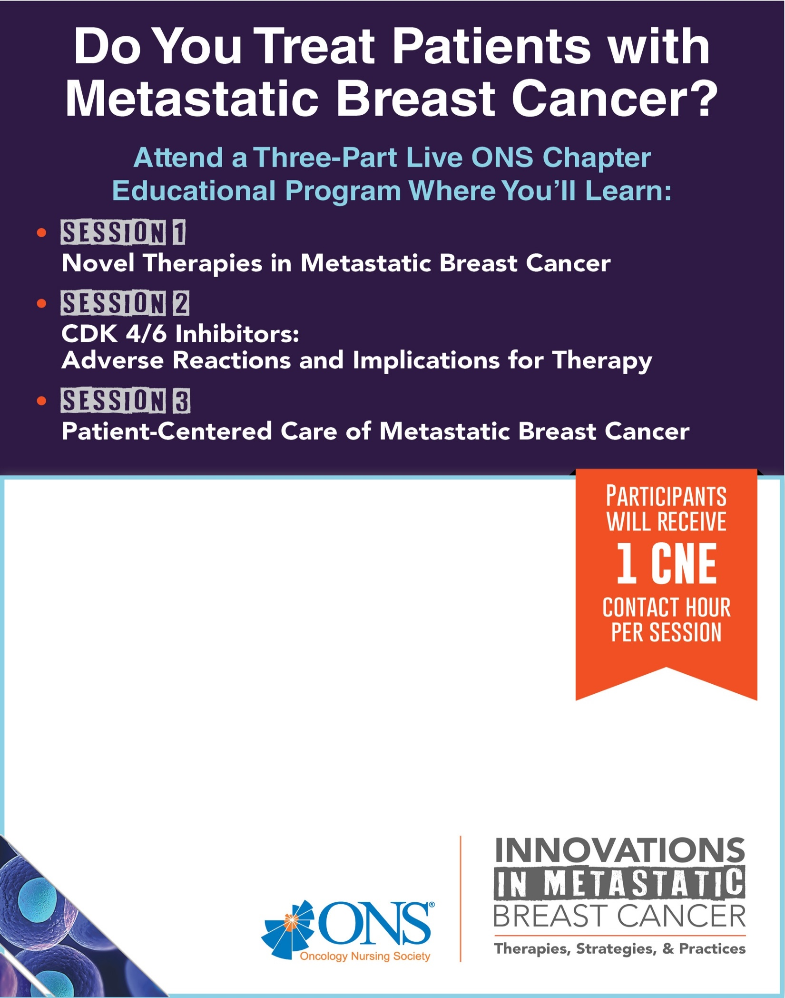

Session 1: May 24th Session 2: August 23rd

Session 3: TBD

**Educational Evenings with Lowcountry ONS**

Time: Doors open at 5:30 Pre-session begins at 5:45 with CNE program at 6:30

Location: The Ashley Venue @ Andolini’s 1940 Sam Rittenburg West Ashley 29407

RSVP to [lmmoellerrn@aol.com](mailto:lmmoellerrn@aol.com) or [laura.gallagher@rsfh.com](mailto:laura.gallagher@rsfh.com)

*This project is being supported by an educational grant through Pfizer.*

*.*