
  Having trouble viewing this email? Click here

HPCC Certification Newsletter * April 2018 * Volume 10, Issue 2

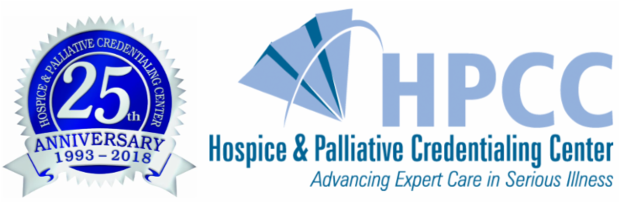

2018 Certificant & Employer of the Year Awards

The Certificant and Employer of the Year Awards were presented at the HPCC Certification Recognition Luncheon during this year's Annual Assembly in Boston, Massachusetts, on Thursday, March 15, 2018. Donna Morgan, BSN, RN, CHPN, CHPCA, spoke on "25 Years of Celebrating Certification: Engagement, Achievement, and Recognition" and you can read a synopsis of her presentation by following the link. Our award winners are listed below:


Deborah Medakovich, MSN, RN, CNS, ACHPN, is the 2018 recipient of the Advanced Certified Hospice and Palliative Nurse (ACHPN) of the Year Award. She has been in the nursing field for 36 years, ACHPN certified since 2006 and an HPNA member since 2003. She has been involved in veteran careand currently leads the Life Sustaining Treatment Decision Initiative at the U.S. Department of Veterans Affairs in western New York, which provides standardized practices for veterans with serious illness. She is a member of six professional associations and has received nearly 20 awards.

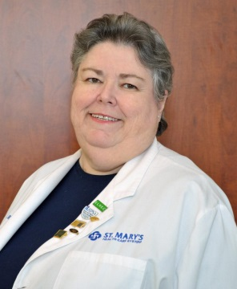
Petti-Jeanne Sheldon, RN, CHPN, is the 2018 recipient of the Certified Hospice and Palliative Nurse (CHPN) of the Year Award. She has been CHPN certified since 2011 and an HPNA member since 2008. She is an End-of-Life Nursing Education Consortium (ELNEC) faculty member and founder of the Piedmont, GA Chapter for HPNA. She has been in the nursing field for over 40 years and is board certified in nephrology, medical-surgical, and critical care nursing. She has been a member and officer in various organizations and has received over 15 awards during her career.


Deborah LaFond,
DNP, PPCNP-BC, CPON, CHPPN,
is the 2018 recipient of the Certified Hospice and Palliative Pediatric Nurse (CHPPN) of the Year Award. She has been CHPPN certified since 2012 and a member of HPNA since 2003. She is an End-of-Life Nursing Education Consortium (ELNEC) faculty member and certified pediatric oncology nurse. She has multiple awards, honors, and publications. She currently co-leads the palliative care system at Children's National Health System in the Washington DC area.


Audrey Boylan, HNA, STNA, CHPNA, is the 2018 recipient of the Certified Hospice and Palliative Nursing Assistant (CHPNA) of the Year Award. She has been a nursing assistant since 2001, and has been certified as a CHPNA and a member of HPNA since 2016. Audrey has shown leadership potential through her time at her workplace, the Hospice of the Western Reserve in Cleveland, Ohio. She successfully completed a formal preceptor program and is the lead preceptor for the in-house orientation of all new HNAs.


Richard Pessagno, DNP, CRNP, FT, FAANP, CPLC, is the 2018 recipient of the Certified in Perinatal Loss Care (CPLC) of the Year Award. He has been certified since 2015 and a member of HPNA since 2000. He has six certifications and is an ELNEC educator. Rich has a private practice as a psychiatric advanced practice nurse and is an adjunct faculty for the DNP program in the school of nursing at Chatham University in Pittsburgh, PA. He is active in various review boards, professional organizations, and community activities, and has over 20 presentations and publications in nursing and hospice.


Main Line Health System in Radnor, Pennsylvania, is the recipient of the 2018 Employer of the Year Award. This system has 73% of their staff certified through HPCC. The company supports certification financially by paying for the initial exam as well as renewal of certification, HPNA membership, exam preparation materials, and a differential or bonus to certified individuals. The company also demonstrates formal recognition of certification annually at luncheons and during National Nurses Week in May. All hospice and palliative nurses have also completed communication skills and symptom management programs.

Nominate Today for the 2019 Awards!

HPCC offers Certificant of the Year Awards for all seven of our credentials (ACHPN, CHPN, CHPPN, CHPNA, CHPLN, CHPCA, and CPLC). Winning recipients receive their awards at the HPCC Certification Recognition event held each year at the Annual Assembly of Hospice and Palliative Care. Nominate a deserving individual or yourself for one of these prestigious awards. All nominations are due to the national office by July 1, 2018.

Nominations for Certificant of the Year Awards

March 2018 Certification Exam Results

Successful candidates for certification testing from the March 2018 testing window includes 588 additional cerificants, including 75 ACHPNs, 367 CHPNs, 11 CHPPNs, 128 CHPNAs, and 7 CPLCs. As of April 1, 2018, the Hospice and Palliative Credentialing Center certifies over 17,000 individuals. Congratulations to all of our candidates.

Application Window Opens for June Testing

The remaining 2018 testing windows are in June, September, and December. Online applications for June will be accepted now through May 15. The testing schedule with application deadlines and instructions are posted in each candidate handbook, which is available under the certification tab on our website at advancingexpertcare.org.

Be sure to view the application fee schedule. Members of members continue to receive substantial exam discounts, and you'll need to keep your membership current to receive these and other benefits. For more details, visit the HPNA web site at advanceingexpertcare.org/membership. HPNA members who apply are also eligible for certification scholarships that cover some of the costs.

Testing  Window | Application  Start Date | Paper Application Deadline | Online Application Deadline
March 1-31 | December 1 | January 15 | February 15
June 1-30 | March 1 | April 15 | May 15
September 1-30 | June 1 | July 15 | August 15
December 1-31 | September 1 | October 15 | November 15



Call for 2019 HPCC Board of Directors

The HPCC Governance Committee is seeking applicants to serve on the HPCC Board of Directors in 2019. The board is responsible for the affairs of the organization, and major responsibilities include supervision of business and financial affairs and our strategic plan. We are seeking experienced, energetic, and passionate professionals who will lead certification in hospice and palliative care into the future. Potential applicants include individuals who hold an HPCC certification, other professional certifications, or have great interest in certification, however, applicants are not required to hold a current HPCC certification.

To review full details of the process and competencies, or to complete an application, visit our web site at advancingexpertcare.org/hpcc-board. Contact our national office at hpcc@gohpcc.org or 412-787-1057 if you have further questions. The deadline for board applications is July 1, 2018.

Resources for Recertification - Finding
Acceptable Continuing Education Programs

Continuing education must be offered by providers that are recognized by an accredited approver of nursing, medical, or other health care disciplines. In addition to HPNA, ANCC, and state nurses associations, a full list of acceptable providers of continuing education contact hours can be found in each credential's HPAR packet. A few examples of providers that offer online CE activities include:
- HPNA (free for members)
- American Association of Critical Care Nurses
- American Nurses Association
- Association of Rehabilitation Nurses
- CAPC
- Elite CME
- Lippincott's Nursing Center
- MyFree CE
- NHPCO
- NetCE
- Nurse.com
- NurseCE4less
- Oncology Nursing Society
- OnCourse Learning
- Relias Learning
- Western Schools
- Wild Iris Medical Education

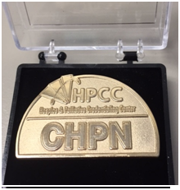
Certification Pins On Sale
Now Through May 31

In recognition of the HPCC 25th anniversary, and to celebrate National Nurses Week from May 6-12, certification pins will be $5 off through May 31, 2018. Certification pins are available for each credential: ACHPN, CHPN, CHPPN, CHPLN, CHPNA, CHPCA, and CPLC. Be recognized by your colleagues and patients as being certified in your specialty. These pins showcase your credential and dedication to your profession. Order a pin today and display your credential with pride. Order today through the HPNA Shop or through our website at advancingexpertcare.org/certification-pins.

Pin Description: Size is 1.5 in., with a 1.2mm thick solid metal base. It is a die struck gold plated pin, with an 8mm post, butterfly clutch, and an acrylic case.

Member Portal & Website Updates Coming Soon

Updates to both our member portal and our website will be coming to you in the next few weeks. These updates will make it easier for you to find what you need and to take advantage of all the member benefits we offer. We will be providing more details closer to our launch date later next month, but for now, keep an eye on the HPCC newsletter and advancingexpertcare.org for details.

Briefly Speaking...
- If you or someone you know is certified, a current HPNA member, and interested in serving the profession, consider applying for a position on one of our Exam Development Committees. Candidates are selected from both hospice and palliative care backgrounds, representing various geographic areas, and have clinical, management, and academic expertise. Completed application packets are due by July 1, 2018. For more, visit advancingexpertcare.org/apply-for-exam-development.
- Learn more about item writing by taking the free course, "Secrets of Competency Testing: Writing Items for Hospice and Palliative Certification Exams." The workshop is offered as a three part course, with the first two parts online and the last part as a live webinar. Submit your applications before May 31 to be able to participate in the next live webinar session on Thursday, June 14, from 10:30 am - 12:00 pm ET. For details visit advancingexpertcare.org/item-writer-workshops.
- Practice exams are learning tools available to evaluate the strengths and weaknesses of individuals who are interested in the certification and recertification process in hospice and palliative nursing. Exams include those for the ACHPN, CHPN, CHPPN, and CHPNA credentials. To learn more visit advancingexpertcare.org/practice-exams.
- In celebration of our 25th anniversary this year, HPCC will decrease our reactivation fee to $25 through December 2018. This is the amount paid in addition to your recertification fee. The decrease is a savings of $150 off our normal rate, as an incentive for reactivating your credential this year. Be sure to take advantage of this offer while it lasts, and spread the word! Contact us at 412-787-1057 to discuss this offer.

Hospice and Palliative Nurses Association News
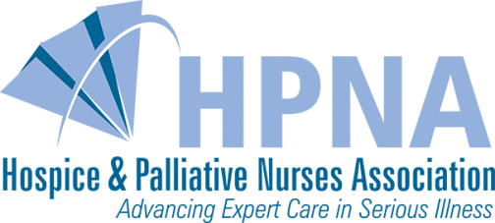

Check Out Our Employer Partner Program

Support your nursing care team with the professional development and educational opportunities available through our Employer Partner Program. It is a great way to get your entire team trained quickly and efficiently. We offer volume pricing on 10 or more HPNA memberships, HPCC certification exams, educational materials, sponsorships, and even HPNA Career Center listings. Organizations can get a single code company access, increase their employee retention through training and education, and take advantage of any strategic advocacy opportunities. For more information on our Employer Partner Program, visit our website at advancingexpertcare.org/employer-partner.

Hospice and Palliative Nurses Foundation News
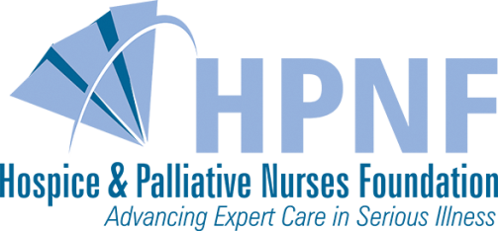

$20,000 Meet the Match Campaign
Continues Through September 30

In celebration of its 20th anniversary, the Hospice and Palliative Nurses Foundation was presented with a $20,000 "Meet the Match" challenge. If members, certificants, supporters, and other stakeholders can raise a minimum of $20,000 in unrestricted donations now through September 30, HPNF will unlock an additional matching gift of $20,000. This wonderful opportunity has been provided from a generous anonymous donor, a longtime member of HPNA who feels passionately about the importance of palliative nursing care who wants to strengthen the legacy of the organization.

This opportunity will create additional unrestricted resources for HPNF's many programs including scholarships, grants, and awards including certification scholarships that support the professional development of nurses and other members of the interdisciplinary team. Please consider your gift now by visiting advancingexpertcare.org under give now to help us unlock our challenge. Watch for progress reports as we move closer to September.

Thank you for reading the latest issue of the HPCC Certification Newsletter and for your continued support of certification.

Now in a mobile and tablet friendly format!

Hospice and Palliative Credentialing Center
412.787.1057 | Email | Website

STAY CONNECTED:


