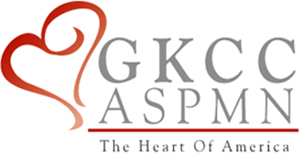

Greater Kansas City Chapter of the American Society for Pain Management Nursing

Presents

Jason S. Kim, PharmD, MAJ, MS United States Army

Sondra Johnson, BSN, RN

**Drug Diversion Awareness**

**Thursday, May 3rd, 2018**

**5:30 p.m. – Chapter meeting and dinner**

**6:00 p.m. – Program**

University of Kansas Medical Center Westwood Campus,

2650 Shawnee Mission Pkwy, Westwood KS 66205 Atrium Conference Room

Register on our Website www.**gkccaspmn**.org

ASPMN Members: Free Non-Members: $10 Students: $5

**Objectives:**

1. Discuss the prevalence and impact of drug diversion.
2. Explore recognition of peer drug diversion and reporting protocols.
3. Discuss steps used to identify and prevent diversion.

Greater Kansas City Chapter of the American Society of Pain Management Nursing is approved as a provider of continuing education by the Kansas State Board of Nursing. This course offering is approved for 1.2 contact hours applicable for RN, LPN, or LMHT relicensure. Kansas State Board of Nursing provider number #LT0279-0412GKCC160.