*If there are problems with how this message is displayed, this news release can be viewed* [*online*](http://www.dir.ca.gov/DIRNews/2014/2014-75.pdf)*.*

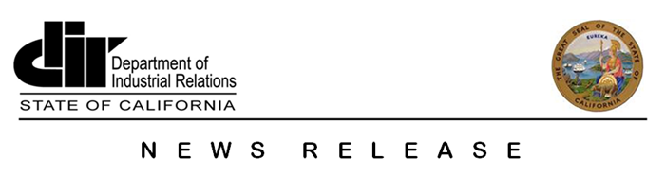

|  |
| --- |
| **News Release No.:** 2014-75                                                   **Date:** August 25, 2014  **California Department of Industrial Relations Honors Labor Rights Week, Signs Alliance Promoting Worker Safety and Health**  **San Francisco**—The California Department of Industrial Relations (DIR) joined the United States Department of Labor today to launch this year’s Labor Rights Week at San Francisco’s Mexican Consulate. The opening ceremony included the signing of an alliance with DIR’s Cal/OSHA, Federal OSHA and the Mexican Consulates in California to assist in educating Mexican workers on their labor rights.  The OSHA Alliance Program is an annual agreement that provides for the establishment of cooperative relationships for purposes such as training and education, outreach and communication, and promotion of public dialogue on workplace safety and health.  “Every worker in California is protected by state laws governing the right to be paid correctly, be safe at work and receive benefits if they are injured on the job,” said Christine Baker, DIR Director. “As the State Designee for Cal/OSHA, I welcome the opportunity to continue to enrich our collaboration with the Mexican Consulates and Federal OSHA, to educate Spanish-speaking workers on their labor rights and to exercise them.”  Labor Rights Week is celebrated annually around Labor Day. The theme for this year’s initiative is *Todos tenemos derechos en el trabajo* (We all have workplace rights).  For the sixth year, DIR and its representatives from Cal/OSHA, the Labor Commissioner’s Office and Division of Workers’ Compensation are participating in Labor Rights Week seminars at all 10 Mexican Consulates across the state this week. DIR additionally attends seminars at Consulates throughout the year to provide information and answer workers’ questions on labor rights and how to report problems. Last year, DIR attended 56 Consulate-sponsored seminars and outreach events.  DIR, established in 1927, protects and improves the health, safety and economic well-being of over 18 million wage earners and helps their employers comply with state labor laws. DIR administers and enforces laws governing wages, hours and breaks, overtime, retaliation, workplace safety and health, apprenticeship training programs, and medical care and other benefits for injured workers.  Additional information on workers’ rights in California and [DIR](http://www.dir.ca.gov/default.html) is posted online and on DIR’s [Facebook](https://www.facebook.com/CaliforniaDIR) and [Twitter](https://twitter.com/ca_dir) pages.  Employees with work-related questions or complaints may call the toll-free California Workers’ Information Line at (866) 924-9757 for recorded information, in English and Spanish, on a variety of work-related topics.  For media inquiries, contact Erika Monterroza at (510) 286-1164 or Peter Melton at (510) 286-7046.  ### |

**P.O. Box 420603 · San Francisco, CA · 94142-0603 ·** [**www.dir.ca.gov**](http://www.dir.ca.gov)