AGENDA

0700-0750 Breakfast and Registration
0750-0800 Opening Remarks
Jennefer Nichol, BSN, RN, CGRN
President Heartland Regional SGNA
0800-0900 Inflammatory Bowel Disease
Fadi Hamid, MD
Saint Luke’s Hospital GI Consultants
Kansas City, MO
0900-1000 Role of Genetic Testing in Management of Gastrointestinal Malignancies
Ajay Bansal, MD
University of Kansas Medical Center/Health
System
Kansas City, KS
1000-1045 Break with Vendors
1045-1145 Unusual Case Presentations in
Gastroenterology
Donald J. Clement, MD
Consultants in Gastroenterology, P.C.
Kansas City, MO
1145-1215 Lunch
1215-1315 Infection Control
James Collins, BS, RN, CNOR
Cleveland Clinic Faculty Department of
Gastroenterology and Hepatology Digestive
Disease Institute
Cleveland, OH
1315-1430 pH Manometry
Ervin Y Eaker, JR, MD
WestGlen Gastrointestinal Consultants
Shawnee, KS
1430-1530 Endoscopic Advances in Bariatrics
C. Phillip Pattison, MD
Kansas City, MO
1530-1545 Evaluations
1545-1630 Heartland Business Meeting

This educational activity has been submitted to the Greater Kansas City Chapter of the American Society for Pain Management Nursing an approved provider of continuing nursing education by the Kansas State Board of Nursing. This course offering is approved for 7.5 contact hours applicable for RN, LPN, LMHT relicensure and 1.2 contact hours in pharmacology for APN. Kansas State Board of Nursing provider number LT0279-0412 GKCC153.
This offering has been submitted to the American Board of Certified Gastroenterology Nurses (ABCGN) for GI Specific contact hour approval.

Certificates will be distributed at end of seminar. No partial credit is given.

Hotel Accommodations
Courtyard Kansas City Downtown/Convention Center: 1535 Baltimore, Kansas City, MO 64108
1-816-221-7400
A special group rate of $179 has been reserved. Book your group rate under Heartland Regional SGNA.

Please use valet parking and tell them you are attending the Heartland Regional SGNA Fall Conference.

Community Service Project
Heartland SGNA continues to help Hope House, a safe haven for abused spouses and their children, through monetary donations and household goods. Any type of household goods are appreciated.

HEARTLAND REGIONAL SGNA HAS GONE GREEN
Syllabus is available online only
Go to www.hrsgna.org under the Education tab.
We regret that we are not able to provide for special dietary needs.
Wi-Fi Available
TEMPERATURE IN MEETING ROOM MAY VARY, PLEASE BRING A SWEATER.

Planning Committee

Afton Becker, BSN, RN, CGRN
Cass Regional Medical Center, Harrisonville, MO

Debra Fieth, RN, CGRN
Consultants in Gastroenterology, Independence, MO

Laura Habighorst, BSN, RN, CAPA, CGRN
North Kansas City Hospital, North Kansas City, MO

Deborah Mercer, RN, BSN, CGRN
University of Kansas Hospital, Kansas City, KS

Lisa McKay, BS, MA, EDS, RN, CGRN, SGRN, CRNO
Guardian Anesthesia Services, Kansas City, MO

Aline Moore, MSN, RN, CGRN
North Kansas City Hospital, North Kansas City, MO

Jennefer Nichol, BSN, RN CGRN
Saint Luke’s Northland Hospital, Kansas City, MO

Melissa Priest, BSN, RN CGRN
North Kansas City Hospital, North Kansas City, MO

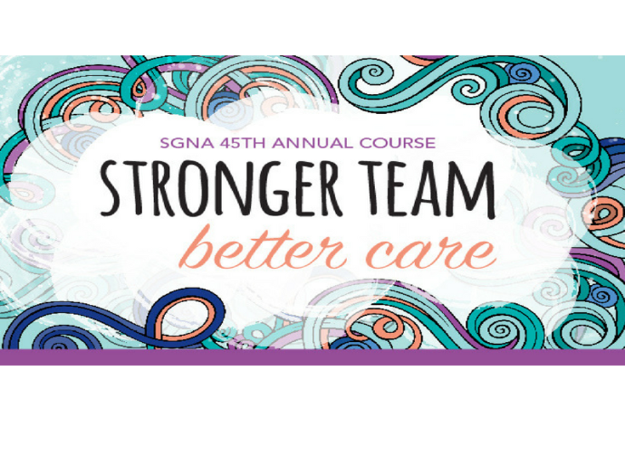

Registration
Name____________________________________
Address____________________________________________________________________________________________________________________
Employer_________________________________
_________________________________________
Phone Number____________________________
Email Address_____________________________
Please Include my email on website: Yes / No

RSVP for business meeting (please circle):
I will or will not attend business meeting

SGNA #____________________

SGNA Member $60
Non-member $75
GI Tech $40
Walk-in $80

Registration and payment may be completed online at https://hrsgna.nursingnetwork.com (there is a $3.50 surcharge when paying online)
or by check and mail to:

Heartland Regional SGNA
P.O. Box 25822
Overland Park, KS 66225

Copy of SGNA membership card MUST accompany registration for member discount.

Fees for returned checks: $25. For cancellation policy and refunds contact Deborah Mercer at DSchmRNBSN@aol.com or 816-258-1100

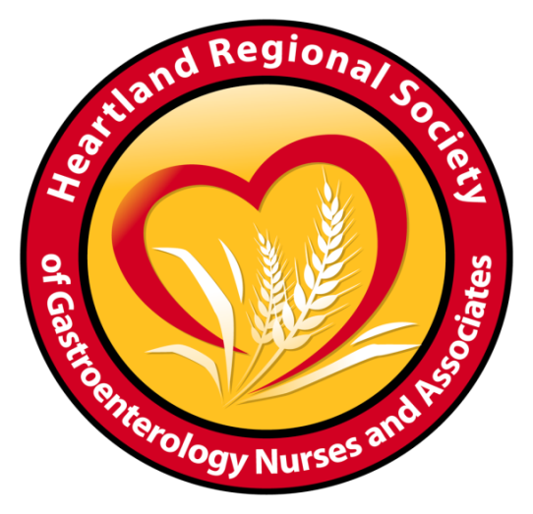

Heartland Regional SGNA

Fall 2018 Conference

Saturday, September 22, 2018
0700-1630

Courtyard Kansas City Downtown/Convention Center
1535 Baltimore
Heartland Regional SGNA
P.O. Box 25822
Overland Park, KS 66225

Kansas City, MO 64108

Please use valet parking and tell them you are attending the Heartland Regional SGNA Fall Conference – PARKING IS FREE!

